7-1-flagship Write Equations Flagship
Equation Detective Agency | Standard: 6.EE.6 | Color-by-Number Practice

Learning Goal: I can write an equation to represent a real-world situation. | Directions: Solve each problem. Match each answer to the Color Code. On the next page, color every box with that problem number using the matching color.

Vocabulary: variable, equation, equal sign | Explain one: I solved problem ___ by ___. Because ___, my answer is ___.

Solve First
1. Write an equation: A number plus 11 is 42.  Work: ________________________________________  Answer: ________________ | 2. Write an equation: A number minus 14 is 23.  Work: ________________________________________  Answer: ________________
3. Write an equation: 7 times a number is 84.  Work: ________________________________________  Answer: ________________ | 4. Write an equation: A number divided by 9 is 6.  Work: ________________________________________  Answer: ________________
5. Write an equation: 18 more than a number is 65.  Work: ________________________________________  Answer: ________________ | 6. Write an equation: 22 less than a number is 41.  Work: ________________________________________  Answer: ________________
7. Write an equation: 12 times a number is 144.  Work: ________________________________________  Answer: ________________ | 8. Write an equation: A number divided by 8 is 13.  Work: ________________________________________  Answer: ________________
9. Write an equation: Three times a number is 75.  Work: ________________________________________  Answer: ________________ | 10. Write an equation: A number plus 29 is 100.  Work: ________________________________________  Answer: ________________
11. Write an equation: A number minus 37 is 58.  Work: ________________________________________  Answer: ________________ | 12. Write an equation: 15 times a number is 180.  Work: ________________________________________  Answer: ________________

Quick check: Before coloring, make sure every answer appears in the Color Code on the next page.

7-1-flagship Mystery Picture: Detective Badge Mosaic
Solve a problem, match the answer to a color, then color every box with that problem number.
Color Code | Color Code | Color Code | Color Code
x + 11 = 42 = red | x - 14 = 23 = orange | 7x = 84 = yellow | x/9 = 6 = green
x + 18 = 65 = blue | x - 22 = 41 = purple | 12x = 144 = pink | x/8 = 13 = brown
3x = 75 = gray | x + 29 = 100 = teal | x - 37 = 58 = black | 15x = 180 = light blue

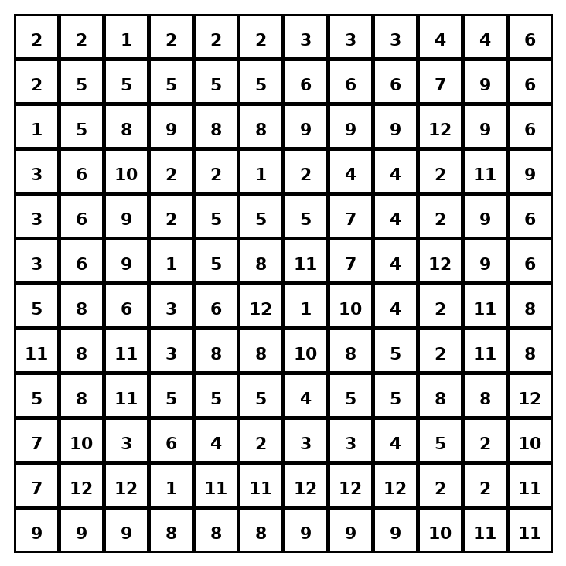

Early finisher writing: Choose one problem and explain your thinking in one complete sentence: Because ___, I ___.
____________________________________________________________________________________________

Teacher Answer Key
# | Answer | Color | Teacher Tip
1 | x + 11 = 42 | red | Use a variable for the unknown.
2 | x - 14 = 23 | orange | Use a variable for the unknown.
3 | 7x = 84 | yellow | Use a variable for the unknown.
4 | x/9 = 6 | green | Use a variable for the unknown.
5 | x + 18 = 65 | blue | Use a variable for the unknown.
6 | x - 22 = 41 | purple | Use a variable for the unknown.
7 | 12x = 144 | pink | Use a variable for the unknown.
8 | x/8 = 13 | brown | Use a variable for the unknown.
9 | 3x = 75 | gray | Use a variable for the unknown.
10 | x + 29 = 100 | teal | Use a variable for the unknown.
11 | x - 37 = 58 | black | Use a variable for the unknown.
12 | 15x = 180 | light blue | Use a variable for the unknown.

Use note: This file is original practice aligned to the lesson skill. It is designed for low-prep review, centers, sub plans, or early finishers.

