7-1 Write Equations
Equation Detective Agency | Standard: 6.EE.6 | Color-by-Number Practice

Learning Goal: I can write an equation to represent a real-world situation. | Directions: Solve each problem. Match each answer to the Color Code. On the next page, color every box with that problem number using the matching color.

Vocabulary: variable, equation, equal sign | Explain one: I solved problem ___ by ___. Because ___, my answer is ___.

Solve First
1. Write an equation: A number plus 7 is 15.  Work: ________________________________________  Answer: ________________ | 2. Write an equation: A number minus 5 is 12.  Work: ________________________________________  Answer: ________________
3. Write an equation: 3 times a number is 24.  Work: ________________________________________  Answer: ________________ | 4. Write an equation: A number divided by 4 is 9.  Work: ________________________________________  Answer: ________________
5. Write an equation: 8 more than a number is 20.  Work: ________________________________________  Answer: ________________ | 6. Write an equation: 6 less than a number is 11.  Work: ________________________________________  Answer: ________________
7. Write an equation: 5 times a number is 45.  Work: ________________________________________  Answer: ________________ | 8. Write an equation: A number divided by 6 is 7.  Work: ________________________________________  Answer: ________________
9. Write an equation: Twice a number is 18.  Work: ________________________________________  Answer: ________________ | 10. Write an equation: A number plus 13 is 30.  Work: ________________________________________  Answer: ________________
11. Write an equation: A number minus 9 is 16.  Work: ________________________________________  Answer: ________________ | 12. Write an equation: 10 times a number is 90.  Work: ________________________________________  Answer: ________________

Quick check: Before coloring, make sure every answer appears in the Color Code on the next page.

7-1 Mystery Picture: Detective Badge Mosaic
Solve a problem, match the answer to a color, then color every box with that problem number.
Color Code | Color Code | Color Code | Color Code
x + 7 = 15 = red | x - 5 = 12 = orange | 3x = 24 = yellow | x/4 = 9 = green
x + 8 = 20 = blue | x - 6 = 11 = purple | 5x = 45 = pink | x/6 = 7 = brown
2x = 18 = gray | x + 13 = 30 = teal | x - 9 = 16 = black | 10x = 90 = light blue

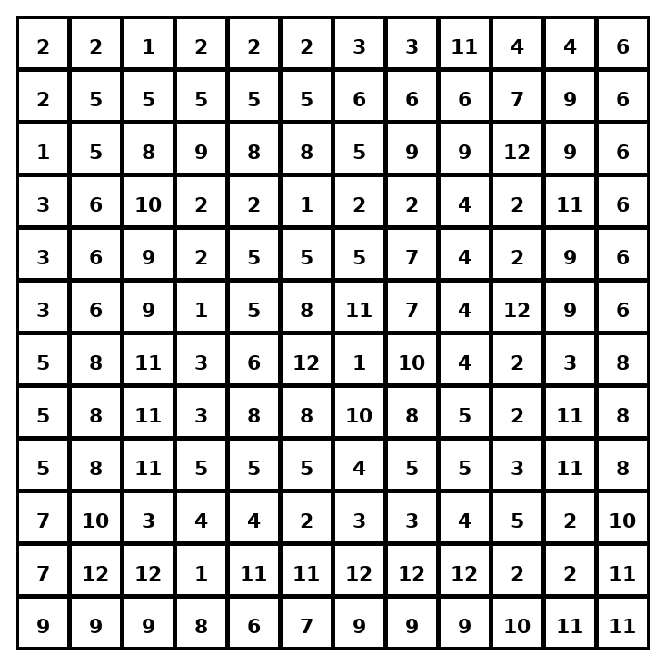

Early finisher writing: Choose one problem and explain your thinking in one complete sentence: Because ___, I ___.
____________________________________________________________________________________________

Teacher Answer Key
# | Answer | Color | Teacher Tip
1 | x + 7 = 15 | red | Use a variable for the unknown.
2 | x - 5 = 12 | orange | Use a variable for the unknown.
3 | 3x = 24 | yellow | Use a variable for the unknown.
4 | x/4 = 9 | green | Use a variable for the unknown.
5 | x + 8 = 20 | blue | Use a variable for the unknown.
6 | x - 6 = 11 | purple | Use a variable for the unknown.
7 | 5x = 45 | pink | Use a variable for the unknown.
8 | x/6 = 7 | brown | Use a variable for the unknown.
9 | 2x = 18 | gray | Use a variable for the unknown.
10 | x + 13 = 30 | teal | Use a variable for the unknown.
11 | x - 9 = 16 | black | Use a variable for the unknown.
12 | 10x = 90 | light blue | Use a variable for the unknown.

Use note: This file is original practice aligned to the lesson skill. It is designed for low-prep review, centers, sub plans, or early finishers.

