7-2 Solve One-Step Addition and Subtraction Equations
Equation Detective Agency | Standard: 6.EE.7 | Color-by-Number Practice

Learning Goal: I can solve one-step addition and subtraction equations using inverse operations. | Directions: Solve each problem. Match each answer to the Color Code. On the next page, color every box with that problem number using the matching color.

Vocabulary: inverse operation, solution, equation | Explain one: I solved problem ___ by ___. Because ___, my answer is ___.

Solve First
1. Solve: x + 7 = 15.  Work: ________________________________________  Answer: ________________ | 2. Solve: x - 5 = 12.  Work: ________________________________________  Answer: ________________
3. Solve: a + 9 = 22.  Work: ________________________________________  Answer: ________________ | 4. Solve: n - 8 = 14.  Work: ________________________________________  Answer: ________________
5. Solve: y + 13 = 30.  Work: ________________________________________  Answer: ________________ | 6. Solve: m - 6 = 19.  Work: ________________________________________  Answer: ________________
7. Solve: p + 4 = 21.  Work: ________________________________________  Answer: ________________ | 8. Solve: q - 11 = 9.  Work: ________________________________________  Answer: ________________
9. Solve: r + 15 = 40.  Work: ________________________________________  Answer: ________________ | 10. Solve: s - 20 = 15.  Work: ________________________________________  Answer: ________________
11. Solve: t + 18 = 50.  Work: ________________________________________  Answer: ________________ | 12. Solve: z - 7 = 28.  Work: ________________________________________  Answer: ________________

Quick check: Before coloring, make sure every answer appears in the Color Code on the next page.

7-2 Mystery Picture: Detective Badge Mosaic
Solve a problem, match the answer to a color, then color every box with that problem number.
Color Code | Color Code | Color Code | Color Code
8 = red | 17 = orange | 13 = yellow | 22 = green
25 = blue | 20 = purple | 35 = pink | 32 = brown

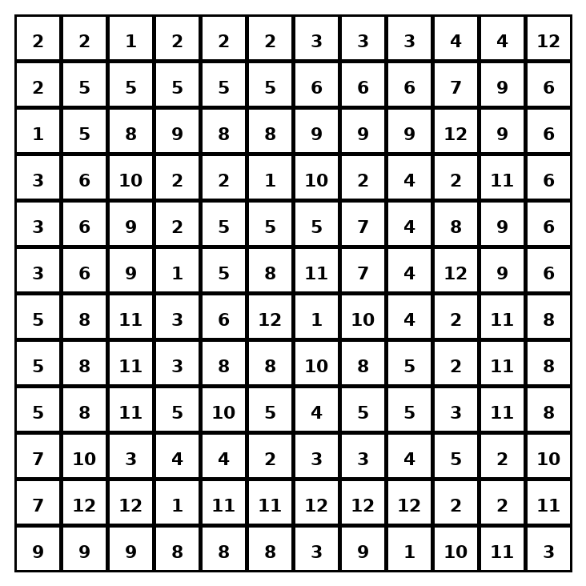

Early finisher writing: Choose one problem and explain your thinking in one complete sentence: Because ___, I ___.
____________________________________________________________________________________________

Teacher Answer Key
# | Answer | Color | Teacher Tip
1 | 8 | red | Use the inverse operation.
2 | 17 | orange | Use the inverse operation.
3 | 13 | yellow | Use the inverse operation.
4 | 22 | green | Use the inverse operation.
5 | 17 | orange | Use the inverse operation.
6 | 25 | blue | Use the inverse operation.
7 | 17 | orange | Use the inverse operation.
8 | 20 | purple | Use the inverse operation.
9 | 25 | blue | Use the inverse operation.
10 | 35 | pink | Use the inverse operation.
11 | 32 | brown | Use the inverse operation.
12 | 35 | pink | Use the inverse operation.

Use note: This file is original practice aligned to the lesson skill. It is designed for low-prep review, centers, sub plans, or early finishers.

