7-3 Solve Multiplication and Division Equations
Equation Detective Agency | Standard: 6.EE.7 | Color-by-Number Practice

Learning Goal: I can solve one-step multiplication and division equations using inverse operations. | Directions: Solve each problem. Match each answer to the Color Code. On the next page, color every box with that problem number using the matching color.

Vocabulary: inverse operation, solution, equation | Explain one: I solved problem ___ by ___. Because ___, my answer is ___.

Solve First
1. Solve: 3x = 24.  Work: ________________________________________  Answer: ________________ | 2. Solve: 5x = 45.  Work: ________________________________________  Answer: ________________
3. Solve: x/4 = 7.  Work: ________________________________________  Answer: ________________ | 4. Solve: x/6 = 9.  Work: ________________________________________  Answer: ________________
5. Solve: 7a = 63.  Work: ________________________________________  Answer: ________________ | 6. Solve: n/8 = 6.  Work: ________________________________________  Answer: ________________
7. Solve: 9y = 81.  Work: ________________________________________  Answer: ________________ | 8. Solve: m/5 = 11.  Work: ________________________________________  Answer: ________________
9. Solve: 12p = 96.  Work: ________________________________________  Answer: ________________ | 10. Solve: q/3 = 14.  Work: ________________________________________  Answer: ________________
11. Solve: 4r = 52.  Work: ________________________________________  Answer: ________________ | 12. Solve: s/10 = 12.  Work: ________________________________________  Answer: ________________

Quick check: Before coloring, make sure every answer appears in the Color Code on the next page.

7-3 Mystery Picture: Detective Badge Mosaic
Solve a problem, match the answer to a color, then color every box with that problem number.
Color Code | Color Code | Color Code | Color Code
8 = red | 9 = orange | 28 = yellow | 54 = green
48 = blue | 55 = purple | 42 = pink | 13 = brown
120 = gray

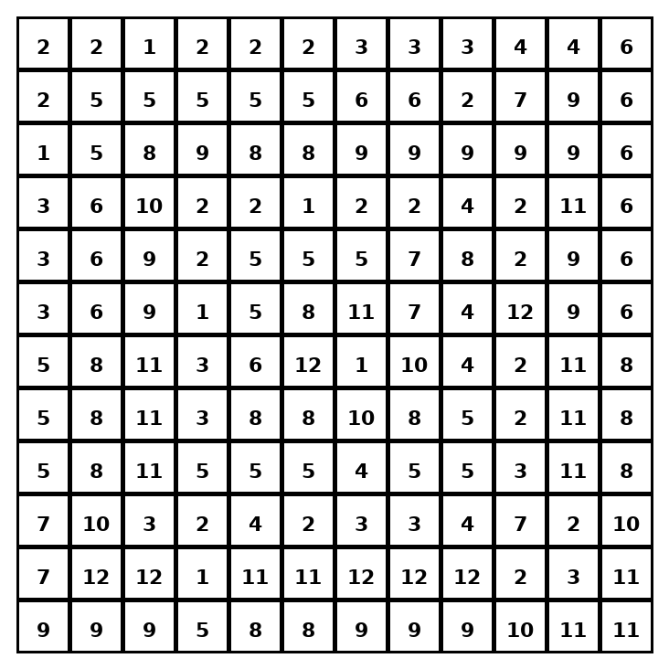

Early finisher writing: Choose one problem and explain your thinking in one complete sentence: Because ___, I ___.
____________________________________________________________________________________________

Teacher Answer Key
# | Answer | Color | Teacher Tip
1 | 8 | red | Use the inverse operation.
2 | 9 | orange | Use the inverse operation.
3 | 28 | yellow | Use the inverse operation.
4 | 54 | green | Use the inverse operation.
5 | 9 | orange | Use the inverse operation.
6 | 48 | blue | Use the inverse operation.
7 | 9 | orange | Use the inverse operation.
8 | 55 | purple | Use the inverse operation.
9 | 8 | red | Use the inverse operation.
10 | 42 | pink | Use the inverse operation.
11 | 13 | brown | Use the inverse operation.
12 | 120 | gray | Use the inverse operation.

Use note: This file is original practice aligned to the lesson skill. It is designed for low-prep review, centers, sub plans, or early finishers.

