7-4 Write Inequalities
Equation Detective Agency | Standard: 6.EE.8 | Color-by-Number Practice

Learning Goal: I can write inequalities to represent real-world situations. | Directions: Solve each problem. Match each answer to the Color Code. On the next page, color every box with that problem number using the matching color.

Vocabulary: inequality, at least, at most, greater than | Explain one: I solved problem ___ by ___. Because ___, my answer is ___.

Solve First
1. Write an inequality: A number is greater than 9.  Work: ________________________________________  Answer: ________________ | 2. Write an inequality: A number is at most 12.  Work: ________________________________________  Answer: ________________
3. Write an inequality: A number is less than 4.  Work: ________________________________________  Answer: ________________ | 4. Write an inequality: A number is at least 15.  Work: ________________________________________  Answer: ________________
5. Write an inequality: You need more than 20 points.  Work: ________________________________________  Answer: ________________ | 6. Write an inequality: You can spend no more than $30.  Work: ________________________________________  Answer: ________________
7. Write an inequality: The height is under 60 inches.  Work: ________________________________________  Answer: ________________ | 8. Write an inequality: The age is 13 or older.  Work: ________________________________________  Answer: ________________
9. Write an inequality: Fewer than 8 students are absent.  Work: ________________________________________  Answer: ________________ | 10. Write an inequality: At least 25 tickets were sold.  Work: ________________________________________  Answer: ________________
11. Write an inequality: More than 100 people came.  Work: ________________________________________  Answer: ________________ | 12. Write an inequality: No more than 5 minutes remain.  Work: ________________________________________  Answer: ________________

Quick check: Before coloring, make sure every answer appears in the Color Code on the next page.

7-4 Mystery Picture: Detective Badge Mosaic
Solve a problem, match the answer to a color, then color every box with that problem number.
Color Code | Color Code | Color Code | Color Code
x > 9 = red | x <= 12 = orange | x < 4 = yellow | x >= 15 = green
x > 20 = blue | x <= 30 = purple | x < 60 = pink | x >= 13 = brown
x < 8 = gray | x >= 25 = teal | x > 100 = black | x <= 5 = light blue

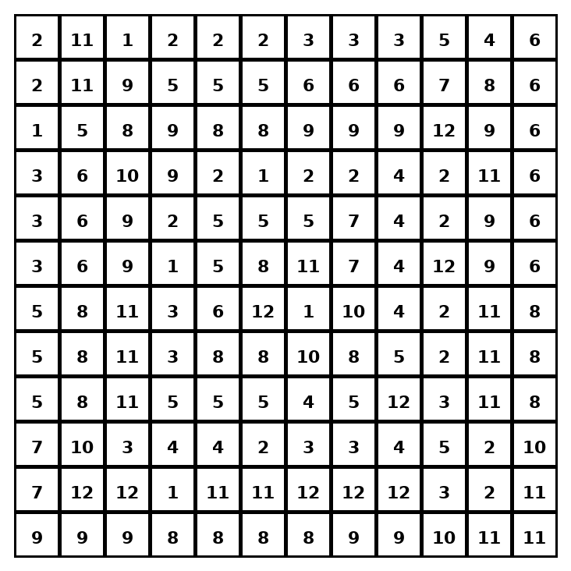

Early finisher writing: Choose one problem and explain your thinking in one complete sentence: Because ___, I ___.
____________________________________________________________________________________________

Teacher Answer Key
# | Answer | Color | Teacher Tip
1 | x > 9 | red | Choose the inequality symbol that matches the words.
2 | x <= 12 | orange | Choose the inequality symbol that matches the words.
3 | x < 4 | yellow | Choose the inequality symbol that matches the words.
4 | x >= 15 | green | Choose the inequality symbol that matches the words.
5 | x > 20 | blue | Choose the inequality symbol that matches the words.
6 | x <= 30 | purple | Choose the inequality symbol that matches the words.
7 | x < 60 | pink | Choose the inequality symbol that matches the words.
8 | x >= 13 | brown | Choose the inequality symbol that matches the words.
9 | x < 8 | gray | Choose the inequality symbol that matches the words.
10 | x >= 25 | teal | Choose the inequality symbol that matches the words.
11 | x > 100 | black | Choose the inequality symbol that matches the words.
12 | x <= 5 | light blue | Choose the inequality symbol that matches the words.

Use note: This file is original practice aligned to the lesson skill. It is designed for low-prep review, centers, sub plans, or early finishers.

