7-5 Graph Inequalities
Equation Detective Agency | Standard: 6.EE.8 | Color-by-Number Practice

Learning Goal: I can graph the solutions of an inequality on a number line. | Directions: Solve each problem. Match each answer to the Color Code. On the next page, color every box with that problem number using the matching color.

Vocabulary: open circle, closed circle, shade | Explain one: I solved problem ___ by ___. Because ___, my answer is ___.

Solve First
1. Describe the graph of x > 5.  Work: ________________________________________  Answer: ________________ | 2. Describe the graph of x < 8.  Work: ________________________________________  Answer: ________________
3. Describe the graph of x >= 3.  Work: ________________________________________  Answer: ________________ | 4. Describe the graph of x <= 10.  Work: ________________________________________  Answer: ________________
5. Describe the graph of x > -2.  Work: ________________________________________  Answer: ________________ | 6. Describe the graph of x < -4.  Work: ________________________________________  Answer: ________________
7. Describe the graph of x >= -1.  Work: ________________________________________  Answer: ________________ | 8. Describe the graph of x <= 0.  Work: ________________________________________  Answer: ________________
9. Describe the graph of x > 12.  Work: ________________________________________  Answer: ________________ | 10. Describe the graph of x < 15.  Work: ________________________________________  Answer: ________________
11. Describe the graph of x >= 7.  Work: ________________________________________  Answer: ________________ | 12. Describe the graph of x <= -6.  Work: ________________________________________  Answer: ________________

Quick check: Before coloring, make sure every answer appears in the Color Code on the next page.

7-5 Mystery Picture: Detective Badge Mosaic
Solve a problem, match the answer to a color, then color every box with that problem number.
Color Code | Color Code | Color Code | Color Code
open at 5, shade right = red | open at 8, shade left = orange | closed at 3, shade right = yellow | closed at 10, shade left = green
open at -2, shade right = blue | open at -4, shade left = purple | closed at -1, shade right = pink | closed at 0, shade left = brown
open at 12, shade right = gray | open at 15, shade left = teal | closed at 7, shade right = black | closed at -6, shade left = light blue

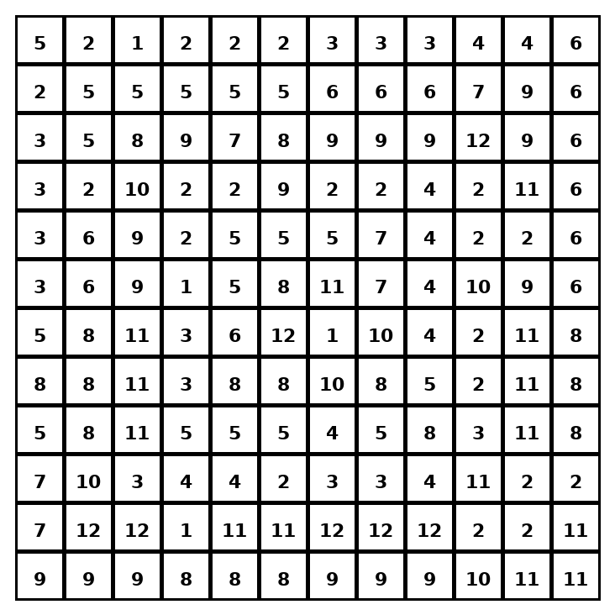

Early finisher writing: Choose one problem and explain your thinking in one complete sentence: Because ___, I ___.
____________________________________________________________________________________________

Teacher Answer Key
# | Answer | Color | Teacher Tip
1 | open at 5, shade right | red | Open circle for < or >; closed circle for <= or >=.
2 | open at 8, shade left | orange | Open circle for < or >; closed circle for <= or >=.
3 | closed at 3, shade right | yellow | Open circle for < or >; closed circle for <= or >=.
4 | closed at 10, shade left | green | Open circle for < or >; closed circle for <= or >=.
5 | open at -2, shade right | blue | Open circle for < or >; closed circle for <= or >=.
6 | open at -4, shade left | purple | Open circle for < or >; closed circle for <= or >=.
7 | closed at -1, shade right | pink | Open circle for < or >; closed circle for <= or >=.
8 | closed at 0, shade left | brown | Open circle for < or >; closed circle for <= or >=.
9 | open at 12, shade right | gray | Open circle for < or >; closed circle for <= or >=.
10 | open at 15, shade left | teal | Open circle for < or >; closed circle for <= or >=.
11 | closed at 7, shade right | black | Open circle for < or >; closed circle for <= or >=.
12 | closed at -6, shade left | light blue | Open circle for < or >; closed circle for <= or >=.

Use note: This file is original practice aligned to the lesson skill. It is designed for low-prep review, centers, sub plans, or early finishers.

