7-6 Solve and Graph Inequalities
Equation Detective Agency | Standard: 6.EE.5 | Color-by-Number Practice

Learning Goal: I can solve an inequality and graph its solution set on a number line. | Directions: Solve each problem. Match each answer to the Color Code. On the next page, color every box with that problem number using the matching color.

Vocabulary: solution set, inequality, inverse operation | Explain one: I solved problem ___ by ___. Because ___, my answer is ___.

Solve First
1. Solve: x + 3 > 10.  Work: ________________________________________  Answer: ________________ | 2. Solve: x - 5 < 9.  Work: ________________________________________  Answer: ________________
3. Solve: 2x >= 12.  Work: ________________________________________  Answer: ________________ | 4. Solve: x/4 <= 8.  Work: ________________________________________  Answer: ________________
5. Solve: x + 6 <= 15.  Work: ________________________________________  Answer: ________________ | 6. Solve: x - 8 > 1.  Work: ________________________________________  Answer: ________________
7. Solve: 3x < 21.  Work: ________________________________________  Answer: ________________ | 8. Solve: x/5 >= 6.  Work: ________________________________________  Answer: ________________
9. Solve: x + 10 > 25.  Work: ________________________________________  Answer: ________________ | 10. Solve: x - 4 <= 11.  Work: ________________________________________  Answer: ________________
11. Solve: 4x >= 40.  Work: ________________________________________  Answer: ________________ | 12. Solve: x/6 < 7.  Work: ________________________________________  Answer: ________________

Quick check: Before coloring, make sure every answer appears in the Color Code on the next page.

7-6 Mystery Picture: Detective Badge Mosaic
Solve a problem, match the answer to a color, then color every box with that problem number.
Color Code | Color Code | Color Code | Color Code
x > 7 = red | x < 14 = orange | x >= 6 = yellow | x <= 32 = green
x <= 9 = blue | x > 9 = purple | x < 7 = pink | x >= 30 = brown
x > 15 = gray | x <= 15 = teal | x >= 10 = black | x < 42 = light blue

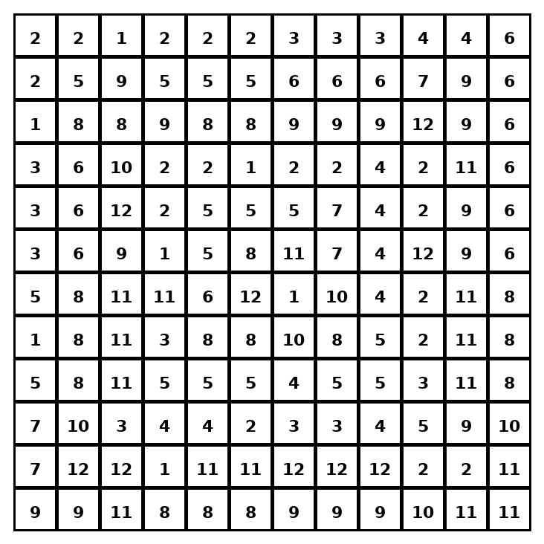

Early finisher writing: Choose one problem and explain your thinking in one complete sentence: Because ___, I ___.
____________________________________________________________________________________________

Teacher Answer Key
# | Answer | Color | Teacher Tip
1 | x > 7 | red | Use inverse operations, then keep the inequality direction for positive numbers.
2 | x < 14 | orange | Use inverse operations, then keep the inequality direction for positive numbers.
3 | x >= 6 | yellow | Use inverse operations, then keep the inequality direction for positive numbers.
4 | x <= 32 | green | Use inverse operations, then keep the inequality direction for positive numbers.
5 | x <= 9 | blue | Use inverse operations, then keep the inequality direction for positive numbers.
6 | x > 9 | purple | Use inverse operations, then keep the inequality direction for positive numbers.
7 | x < 7 | pink | Use inverse operations, then keep the inequality direction for positive numbers.
8 | x >= 30 | brown | Use inverse operations, then keep the inequality direction for positive numbers.
9 | x > 15 | gray | Use inverse operations, then keep the inequality direction for positive numbers.
10 | x <= 15 | teal | Use inverse operations, then keep the inequality direction for positive numbers.
11 | x >= 10 | black | Use inverse operations, then keep the inequality direction for positive numbers.
12 | x < 42 | light blue | Use inverse operations, then keep the inequality direction for positive numbers.

Use note: This file is original practice aligned to the lesson skill. It is designed for low-prep review, centers, sub plans, or early finishers.

