7-7 Equations and Inequalities Problem Solving
Equation Detective Agency | Standard: 6.EE.7 | Color-by-Number Practice

Learning Goal: I can model and solve real-world problems using equations and inequalities. | Directions: Solve each problem. Match each answer to the Color Code. On the next page, color every box with that problem number using the matching color.

Vocabulary: model, equation, inequality, solution | Explain one: I solved problem ___ by ___. Because ___, my answer is ___.

Solve First
1. A game costs $7. You have $42. How many games can you buy?  Work: ________________________________________  Answer: ________________ | 2. You need at least 30 points and have 18. How many more points do you need?  Work: ________________________________________  Answer: ________________
3. A box holds 8 books. How many boxes for 56 books?  Work: ________________________________________  Answer: ________________ | 4. You spent $15 from $50. How much is left?  Work: ________________________________________  Answer: ________________
5. Each ticket costs $6. How much for 9 tickets?  Work: ________________________________________  Answer: ________________ | 6. You need more than 25 stickers and have 11. How many more to reach 26?  Work: ________________________________________  Answer: ________________
7. A ride lasts 4 minutes. How many minutes for 8 rides?  Work: ________________________________________  Answer: ________________ | 8. A student read 12 pages each day for 5 days. How many pages?  Work: ________________________________________  Answer: ________________
9. There are 72 chairs in rows of 9. How many rows?  Work: ________________________________________  Answer: ________________ | 10. A score increased by 14 to become 41. What was the start?  Work: ________________________________________  Answer: ________________
11. Each team has 6 players. How many teams from 48 players?  Work: ________________________________________  Answer: ________________ | 12. You need at least 100 cans and have 67. How many more?  Work: ________________________________________  Answer: ________________

Quick check: Before coloring, make sure every answer appears in the Color Code on the next page.

7-7 Mystery Picture: Detective Badge Mosaic
Solve a problem, match the answer to a color, then color every box with that problem number.
Color Code | Color Code | Color Code | Color Code
6 = red | 12 = orange | 7 = yellow | 35 = green
54 = blue | 15 = purple | 32 = pink | 60 = brown
8 = gray | 27 = teal | 33 = black

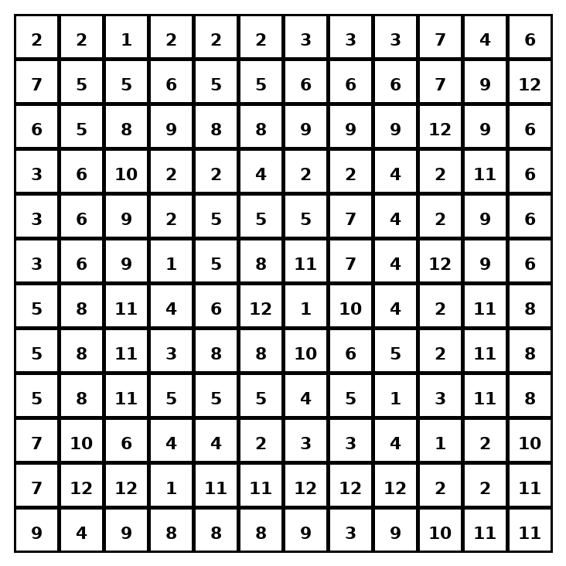

Early finisher writing: Choose one problem and explain your thinking in one complete sentence: Because ___, I ___.
____________________________________________________________________________________________

Teacher Answer Key
# | Answer | Color | Teacher Tip
1 | 6 | red | Write an equation or inequality first.
2 | 12 | orange | Write an equation or inequality first.
3 | 7 | yellow | Write an equation or inequality first.
4 | 35 | green | Write an equation or inequality first.
5 | 54 | blue | Write an equation or inequality first.
6 | 15 | purple | Write an equation or inequality first.
7 | 32 | pink | Write an equation or inequality first.
8 | 60 | brown | Write an equation or inequality first.
9 | 8 | gray | Write an equation or inequality first.
10 | 27 | teal | Write an equation or inequality first.
11 | 8 | gray | Write an equation or inequality first.
12 | 33 | black | Write an equation or inequality first.

Use note: This file is original practice aligned to the lesson skill. It is designed for low-prep review, centers, sub plans, or early finishers.

