8-1 Statistical Questions and Data
Sports Analytics Lab | Standard: 6.SP.1 | Color-by-Number Practice

Learning Goal: I can tell the difference between a statistical question and a non-statistical question. | Directions: Solve each problem. Match each answer to the Color Code. On the next page, color every box with that problem number using the matching color.

Vocabulary: statistical question, variability, data | Explain one: I solved problem ___ by ___. Because ___, my answer is ___.

Solve First
1. Decide: statistical or not statistical? How many minutes do 6th graders usually spend on homework?  Work: ________________________________________  Answer: ________________ | 2. Decide: statistical or not statistical? What is my math teacher’s room number?  Work: ________________________________________  Answer: ________________
3. Decide: statistical or not statistical? How many pets do students in this class have?  Work: ________________________________________  Answer: ________________ | 4. Decide: statistical or not statistical? What is the school address?  Work: ________________________________________  Answer: ________________
5. Decide: statistical or not statistical? How many points did each player score this season?  Work: ________________________________________  Answer: ________________ | 6. Decide: statistical or not statistical? What time does lunch start today?  Work: ________________________________________  Answer: ________________
7. Decide: statistical or not statistical? How many books did students read this month?  Work: ________________________________________  Answer: ________________ | 8. Decide: statistical or not statistical? What is the name of our principal?  Work: ________________________________________  Answer: ________________
9. Decide: statistical or not statistical? How tall are the students in our class?  Work: ________________________________________  Answer: ________________ | 10. Decide: statistical or not statistical? What is 6 x 7?  Work: ________________________________________  Answer: ________________
11. Decide: statistical or not statistical? How many siblings do students in grade 6 have?  Work: ________________________________________  Answer: ________________ | 12. Decide: statistical or not statistical? What color is my backpack?  Work: ________________________________________  Answer: ________________

Quick check: Before coloring, make sure every answer appears in the Color Code on the next page.

8-1 Mystery Picture: Scoreboard Mosaic
Solve a problem, match the answer to a color, then color every box with that problem number.
Color Code | Color Code | Color Code | Color Code
Statistical = red | Not statistical = orange

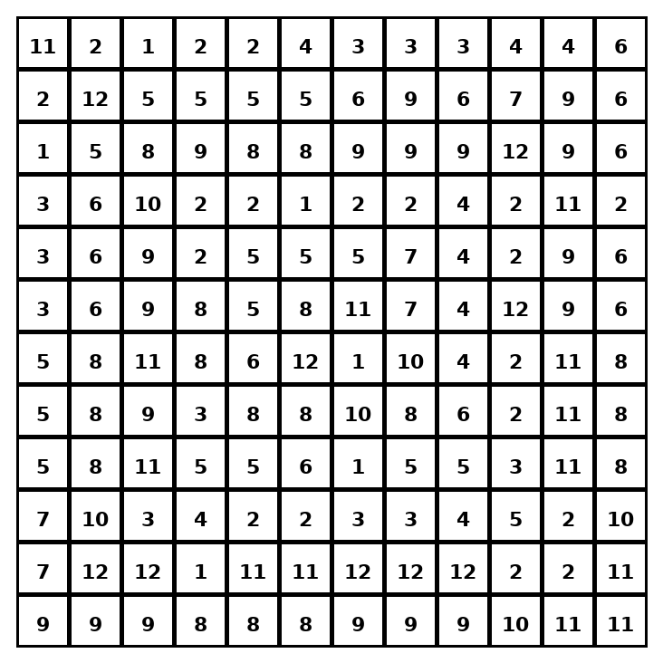

Early finisher writing: Choose one problem and explain your thinking in one complete sentence: Because ___, I ___.
____________________________________________________________________________________________

Teacher Answer Key
# | Answer | Color | Teacher Tip
1 | Statistical | red | A statistical question expects variability in the answers.
2 | Not statistical | orange | A statistical question expects variability in the answers.
3 | Statistical | red | A statistical question expects variability in the answers.
4 | Not statistical | orange | A statistical question expects variability in the answers.
5 | Statistical | red | A statistical question expects variability in the answers.
6 | Not statistical | orange | A statistical question expects variability in the answers.
7 | Statistical | red | A statistical question expects variability in the answers.
8 | Not statistical | orange | A statistical question expects variability in the answers.
9 | Statistical | red | A statistical question expects variability in the answers.
10 | Not statistical | orange | A statistical question expects variability in the answers.
11 | Statistical | red | A statistical question expects variability in the answers.
12 | Not statistical | orange | A statistical question expects variability in the answers.

Use note: This file is original practice aligned to the lesson skill. It is designed for low-prep review, centers, sub plans, or early finishers.

