8-2 Mean, Median, and Mode
Sports Analytics Lab | Standard: 6.SP.3 | Color-by-Number Practice

Learning Goal: I can find the mean, median, and mode of a data set. | Directions: Solve each problem. Match each answer to the Color Code. On the next page, color every box with that problem number using the matching color.

Vocabulary: mean, median, mode, range | Explain one: I solved problem ___ by ___. Because ___, my answer is ___.

Solve First
1. Find the mean of: [4, 5, 6, 7, 8].  Work: ________________________________________  Answer: ________________ | 2. Find the mode of: [2, 2, 3, 5, 8].  Work: ________________________________________  Answer: ________________
3. Find the median of: [9, 4, 7, 3, 5].  Work: ________________________________________  Answer: ________________ | 4. Find the range of: [10, 12, 15, 20, 23].  Work: ________________________________________  Answer: ________________
5. Find the mode of: [3, 6, 6, 9, 11].  Work: ________________________________________  Answer: ________________ | 6. Find the mean of: [8, 8, 10, 12, 17].  Work: ________________________________________  Answer: ________________
7. Find the median of: [1, 5, 9, 12, 13].  Work: ________________________________________  Answer: ________________ | 8. Find the mean of: [20, 22, 24, 26, 28].  Work: ________________________________________  Answer: ________________
9. Find the range of: [7, 8, 9, 10, 11].  Work: ________________________________________  Answer: ________________ | 10. Find the median of: [6, 6, 7, 8, 10].  Work: ________________________________________  Answer: ________________
11. Find the mode of: [12, 15, 15, 16, 20].  Work: ________________________________________  Answer: ________________ | 12. Find the mean of: [2, 4, 6, 8, 10].  Work: ________________________________________  Answer: ________________

Quick check: Before coloring, make sure every answer appears in the Color Code on the next page.

8-2 Mystery Picture: Scoreboard Mosaic
Solve a problem, match the answer to a color, then color every box with that problem number.
Color Code | Color Code | Color Code | Color Code
6 = red | 2 = orange | 5 = yellow | 13 = green
11 = blue | 9 = purple | 24 = pink | 4 = brown
7 = gray | 15 = teal

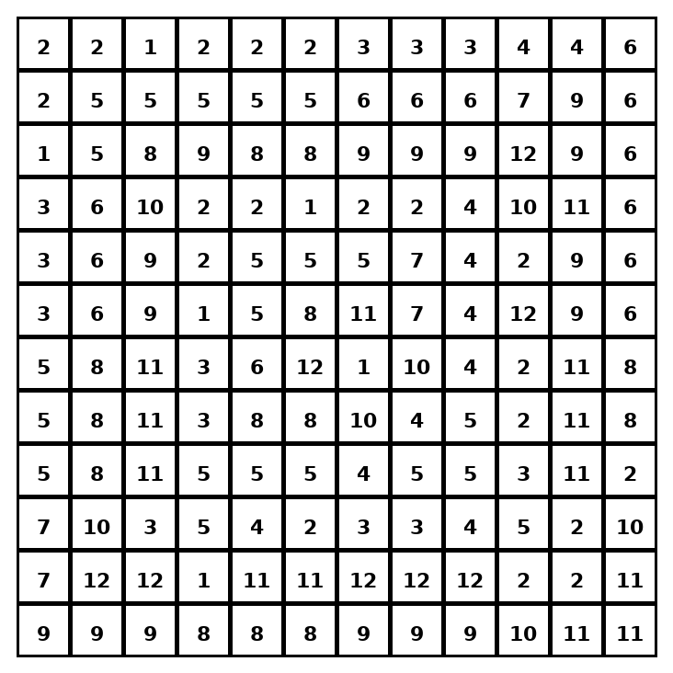

Early finisher writing: Choose one problem and explain your thinking in one complete sentence: Because ___, I ___.
____________________________________________________________________________________________

Teacher Answer Key
# | Answer | Color | Teacher Tip
1 | 6 | red | Use the correct measure: mean.
2 | 2 | orange | Use the correct measure: mode.
3 | 5 | yellow | Use the correct measure: median.
4 | 13 | green | Use the correct measure: range.
5 | 6 | red | Use the correct measure: mode.
6 | 11 | blue | Use the correct measure: mean.
7 | 9 | purple | Use the correct measure: median.
8 | 24 | pink | Use the correct measure: mean.
9 | 4 | brown | Use the correct measure: range.
10 | 7 | gray | Use the correct measure: median.
11 | 15 | teal | Use the correct measure: mode.
12 | 6 | red | Use the correct measure: mean.

Use note: This file is original practice aligned to the lesson skill. It is designed for low-prep review, centers, sub plans, or early finishers.

