8-3 Mean Absolute Deviation
Sports Analytics Lab | Standard: 6.SP.5c | Color-by-Number Practice

Learning Goal: I can find the mean absolute deviation (MAD) to describe how spread out data is. | Directions: Solve each problem. Match each answer to the Color Code. On the next page, color every box with that problem number using the matching color.

Vocabulary: mean, distance, average, MAD | Explain one: I solved problem ___ by ___. Because ___, my answer is ___.

Solve First
1. Find the MAD of: [2, 4, 6, 8].  Work: ________________________________________  Answer: ________________ | 2. Find the MAD of: [3, 5, 7, 9].  Work: ________________________________________  Answer: ________________
3. Find the MAD of: [4, 6, 8, 10].  Work: ________________________________________  Answer: ________________ | 4. Find the MAD of: [5, 7, 9, 11].  Work: ________________________________________  Answer: ________________
5. Find the MAD of: [6, 8, 10, 12].  Work: ________________________________________  Answer: ________________ | 6. Find the MAD of: [1, 3, 5, 7].  Work: ________________________________________  Answer: ________________
7. Find the MAD of: [2, 5, 8, 11].  Work: ________________________________________  Answer: ________________ | 8. Find the MAD of: [10, 12, 14, 16].  Work: ________________________________________  Answer: ________________
9. Find the MAD of: [4, 8, 12, 16].  Work: ________________________________________  Answer: ________________ | 10. Find the MAD of: [5, 10, 15, 20].  Work: ________________________________________  Answer: ________________
11. Find the MAD of: [6, 9, 12, 15].  Work: ________________________________________  Answer: ________________ | 12. Find the MAD of: [7, 11, 15, 19].  Work: ________________________________________  Answer: ________________

Quick check: Before coloring, make sure every answer appears in the Color Code on the next page.

8-3 Mystery Picture: Scoreboard Mosaic
Solve a problem, match the answer to a color, then color every box with that problem number.
Color Code | Color Code | Color Code | Color Code
2 = red | 3 = orange | 4 = yellow | 5 = green

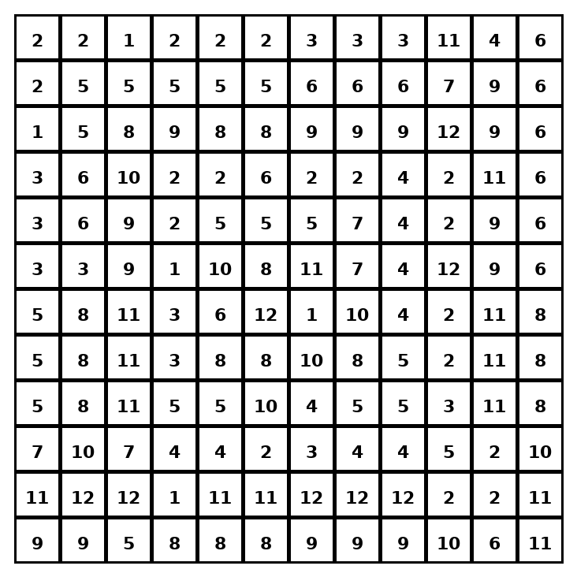

Early finisher writing: Choose one problem and explain your thinking in one complete sentence: Because ___, I ___.
____________________________________________________________________________________________

Teacher Answer Key
# | Answer | Color | Teacher Tip
1 | 2 | red | Find the mean, distances from the mean, then average the distances.
2 | 2 | red | Find the mean, distances from the mean, then average the distances.
3 | 2 | red | Find the mean, distances from the mean, then average the distances.
4 | 2 | red | Find the mean, distances from the mean, then average the distances.
5 | 2 | red | Find the mean, distances from the mean, then average the distances.
6 | 2 | red | Find the mean, distances from the mean, then average the distances.
7 | 3 | orange | Find the mean, distances from the mean, then average the distances.
8 | 2 | red | Find the mean, distances from the mean, then average the distances.
9 | 4 | yellow | Find the mean, distances from the mean, then average the distances.
10 | 5 | green | Find the mean, distances from the mean, then average the distances.
11 | 3 | orange | Find the mean, distances from the mean, then average the distances.
12 | 4 | yellow | Find the mean, distances from the mean, then average the distances.

Use note: This file is original practice aligned to the lesson skill. It is designed for low-prep review, centers, sub plans, or early finishers.

