8-4 Appropriate Measures
Sports Analytics Lab | Standard: 6.SP.5d | Color-by-Number Practice

Learning Goal: I can choose the best measure of center for a data set based on its shape. | Directions: Solve each problem. Match each answer to the Color Code. On the next page, color every box with that problem number using the matching color.

Vocabulary: measure of center, outlier, median | Explain one: I solved problem ___ by ___. Because ___, my answer is ___.

Solve First
1. Best measure of center for [2, 3, 4, 5, 100]: mean, median, or mode?  Work: ________________________________________  Answer: ________________ | 2. Best measure of center for [6, 7, 8, 9, 10]: mean, median, or mode?  Work: ________________________________________  Answer: ________________
3. Best measure of center for [1, 1, 2, 3, 9]: mean, median, or mode?  Work: ________________________________________  Answer: ________________ | 4. Best measure of center for [50, 52, 53, 54, 100]: mean, median, or mode?  Work: ________________________________________  Answer: ________________
5. Best measure of center for [10, 12, 14, 16, 18]: mean, median, or mode?  Work: ________________________________________  Answer: ________________ | 6. Best measure of center for [3, 3, 3, 7, 9]: mean, median, or mode?  Work: ________________________________________  Answer: ________________
7. Best measure of center for [5, 6, 7, 8, 50]: mean, median, or mode?  Work: ________________________________________  Answer: ________________ | 8. Best measure of center for [20, 21, 22, 23, 24]: mean, median, or mode?  Work: ________________________________________  Answer: ________________
9. Best measure of center for [4, 4, 5, 6, 7]: mean, median, or mode?  Work: ________________________________________  Answer: ________________ | 10. Best measure of center for [1, 2, 2, 2, 9]: mean, median, or mode?  Work: ________________________________________  Answer: ________________
11. Best measure of center for [11, 12, 13, 14, 15]: mean, median, or mode?  Work: ________________________________________  Answer: ________________ | 12. Best measure of center for [8, 9, 10, 11, 99]: mean, median, or mode?  Work: ________________________________________  Answer: ________________

Quick check: Before coloring, make sure every answer appears in the Color Code on the next page.

8-4 Mystery Picture: Scoreboard Mosaic
Solve a problem, match the answer to a color, then color every box with that problem number.
Color Code | Color Code | Color Code | Color Code
median = red | mean = orange | mode = yellow

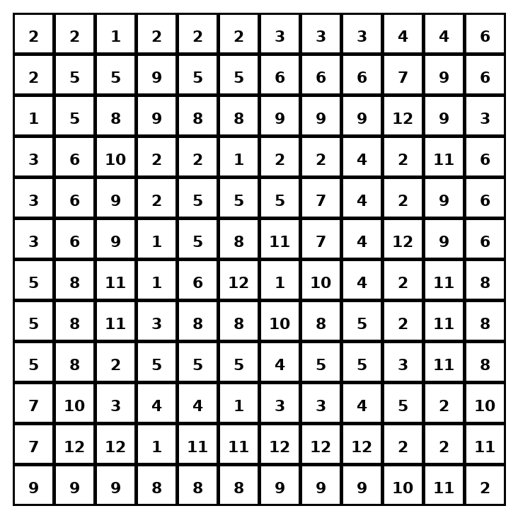

Early finisher writing: Choose one problem and explain your thinking in one complete sentence: Because ___, I ___.
____________________________________________________________________________________________

Teacher Answer Key
# | Answer | Color | Teacher Tip
1 | median | red | Outliers often make the median better.
2 | mean | orange | Outliers often make the median better.
3 | mode | yellow | Outliers often make the median better.
4 | median | red | Outliers often make the median better.
5 | mean | orange | Outliers often make the median better.
6 | mode | yellow | Outliers often make the median better.
7 | median | red | Outliers often make the median better.
8 | mean | orange | Outliers often make the median better.
9 | mode | yellow | Outliers often make the median better.
10 | mode | yellow | Outliers often make the median better.
11 | mean | orange | Outliers often make the median better.
12 | median | red | Outliers often make the median better.

Use note: This file is original practice aligned to the lesson skill. It is designed for low-prep review, centers, sub plans, or early finishers.

