8-5 Display Data: Box Plots
Sports Analytics Lab | Standard: 6.SP.4 | Color-by-Number Practice

Learning Goal: I can make and read a box plot to summarize a data set. | Directions: Solve each problem. Match each answer to the Color Code. On the next page, color every box with that problem number using the matching color.

Vocabulary: median, quartile, minimum, maximum | Explain one: I solved problem ___ by ___. Because ___, my answer is ___.

Solve First
1. Find the median of this data set for a box plot: [2, 4, 6, 8, 10].  Work: ________________________________________  Answer: ________________ | 2. Find the median of this data set for a box plot: [1, 3, 5, 7, 9].  Work: ________________________________________  Answer: ________________
3. Find the median of this data set for a box plot: [4, 5, 6, 7, 8, 9].  Work: ________________________________________  Answer: ________________ | 4. Find the median of this data set for a box plot: [10, 12, 14, 16, 18].  Work: ________________________________________  Answer: ________________
5. Find the median of this data set for a box plot: [3, 6, 9, 12, 15].  Work: ________________________________________  Answer: ________________ | 6. Find the median of this data set for a box plot: [5, 8, 11, 14, 17].  Work: ________________________________________  Answer: ________________
7. Find the median of this data set for a box plot: [20, 22, 24, 26, 28].  Work: ________________________________________  Answer: ________________ | 8. Find the median of this data set for a box plot: [7, 10, 13, 16, 19].  Work: ________________________________________  Answer: ________________
9. Find the median of this data set for a box plot: [2, 5, 8, 11, 14].  Work: ________________________________________  Answer: ________________ | 10. Find the median of this data set for a box plot: [6, 12, 18, 24, 30].  Work: ________________________________________  Answer: ________________
11. Find the median of this data set for a box plot: [1, 4, 9, 16, 25].  Work: ________________________________________  Answer: ________________ | 12. Find the median of this data set for a box plot: [8, 9, 10, 11, 12].  Work: ________________________________________  Answer: ________________

Quick check: Before coloring, make sure every answer appears in the Color Code on the next page.

8-5 Mystery Picture: Scoreboard Mosaic
Solve a problem, match the answer to a color, then color every box with that problem number.
Color Code | Color Code | Color Code | Color Code
6 = red | 5 = orange | 6 1/2 = yellow | 14 = green
9 = blue | 11 = purple | 24 = pink | 13 = brown
8 = gray | 18 = teal | 10 = black

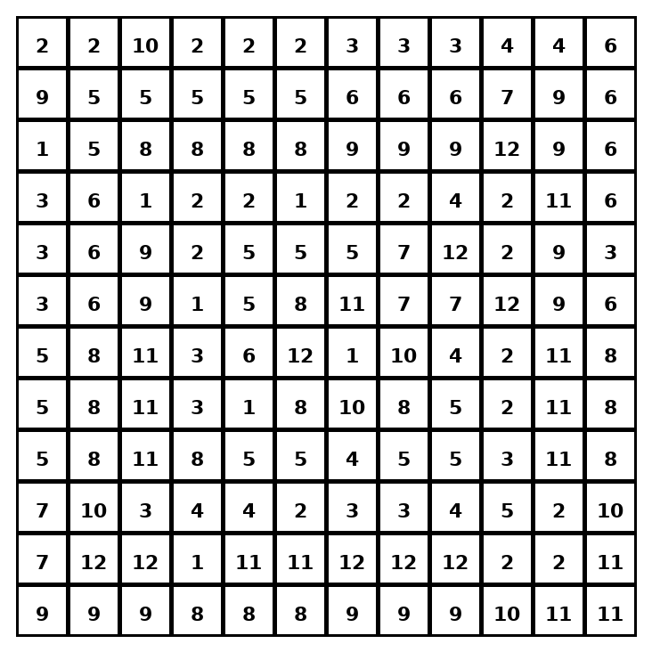

Early finisher writing: Choose one problem and explain your thinking in one complete sentence: Because ___, I ___.
____________________________________________________________________________________________

Teacher Answer Key
# | Answer | Color | Teacher Tip
1 | 6 | red | Order the values, then find the middle.
2 | 5 | orange | Order the values, then find the middle.
3 | 6 1/2 | yellow | Order the values, then find the middle.
4 | 14 | green | Order the values, then find the middle.
5 | 9 | blue | Order the values, then find the middle.
6 | 11 | purple | Order the values, then find the middle.
7 | 24 | pink | Order the values, then find the middle.
8 | 13 | brown | Order the values, then find the middle.
9 | 8 | gray | Order the values, then find the middle.
10 | 18 | teal | Order the values, then find the middle.
11 | 9 | blue | Order the values, then find the middle.
12 | 10 | black | Order the values, then find the middle.

Use note: This file is original practice aligned to the lesson skill. It is designed for low-prep review, centers, sub plans, or early finishers.

