8-6 Display Data: Histograms
Sports Analytics Lab | Standard: 6.SP.4 | Color-by-Number Practice

Learning Goal: I can make and read a histogram to display data in intervals. | Directions: Solve each problem. Match each answer to the Color Code. On the next page, color every box with that problem number using the matching color.

Vocabulary: interval, frequency, data display | Explain one: I solved problem ___ by ___. Because ___, my answer is ___.

Solve First
1. For data [2, 3, 5, 7, 8, 12, 14, 18], how many values are in the interval 0-9?  Work: ________________________________________  Answer: ________________ | 2. For data [10, 11, 15, 19, 22, 24, 28, 31], how many values are in the interval 10-19?  Work: ________________________________________  Answer: ________________
3. For data [5, 6, 8, 15, 17, 21, 24, 26], how many values are in the interval 20-29?  Work: ________________________________________  Answer: ________________ | 4. For data [30, 32, 33, 37, 39, 41, 45, 48], how many values are in the interval 30-39?  Work: ________________________________________  Answer: ________________
5. For data [1, 4, 9, 10, 12, 18, 20, 25], how many values are in the interval 0-9?  Work: ________________________________________  Answer: ________________ | 6. For data [7, 13, 14, 16, 29, 31, 35, 38], how many values are in the interval 10-19?  Work: ________________________________________  Answer: ________________
7. For data [2, 11, 21, 22, 23, 27, 33, 42], how many values are in the interval 20-29?  Work: ________________________________________  Answer: ________________ | 8. For data [6, 8, 15, 18, 28, 29, 30, 31], how many values are in the interval 30-39?  Work: ________________________________________  Answer: ________________
9. For data [0, 5, 10, 15, 20, 25, 30, 35], how many values are in the interval 0-9?  Work: ________________________________________  Answer: ________________ | 10. For data [3, 13, 23, 33, 43, 53, 63, 73], how many values are in the interval 20-29?  Work: ________________________________________  Answer: ________________
11. For data [12, 14, 16, 18, 22, 24, 26, 28], how many values are in the interval 10-19?  Work: ________________________________________  Answer: ________________ | 12. For data [1, 2, 3, 31, 32, 33, 40, 41], how many values are in the interval 30-39?  Work: ________________________________________  Answer: ________________

Quick check: Before coloring, make sure every answer appears in the Color Code on the next page.

8-6 Mystery Picture: Scoreboard Mosaic
Solve a problem, match the answer to a color, then color every box with that problem number.
Color Code | Color Code | Color Code | Color Code
5 = red | 4 = orange | 3 = yellow | 2 = green
1 = blue

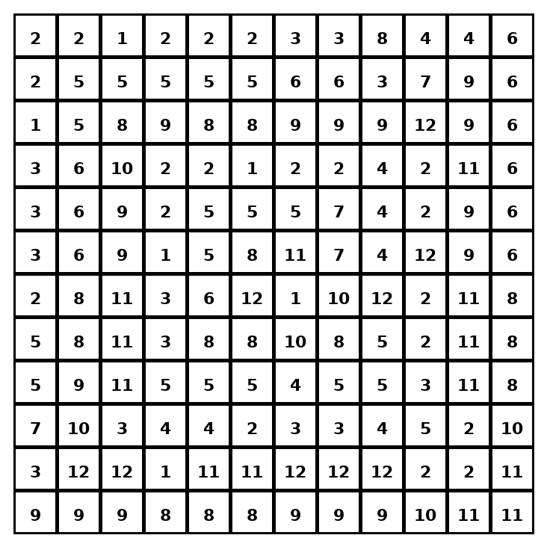

Early finisher writing: Choose one problem and explain your thinking in one complete sentence: Because ___, I ___.
____________________________________________________________________________________________

Teacher Answer Key
# | Answer | Color | Teacher Tip
1 | 5 | red | Count the values that fall inside the interval.
2 | 4 | orange | Count the values that fall inside the interval.
3 | 3 | yellow | Count the values that fall inside the interval.
4 | 5 | red | Count the values that fall inside the interval.
5 | 3 | yellow | Count the values that fall inside the interval.
6 | 3 | yellow | Count the values that fall inside the interval.
7 | 4 | orange | Count the values that fall inside the interval.
8 | 2 | green | Count the values that fall inside the interval.
9 | 2 | green | Count the values that fall inside the interval.
10 | 1 | blue | Count the values that fall inside the interval.
11 | 4 | orange | Count the values that fall inside the interval.
12 | 3 | yellow | Count the values that fall inside the interval.

Use note: This file is original practice aligned to the lesson skill. It is designed for low-prep review, centers, sub plans, or early finishers.

