8-7 Shape of Data Distributions
Sports Analytics Lab | Standard: 6.SP.2 | Color-by-Number Practice

Learning Goal: I can describe the shape of a data distribution as symmetric, skewed, or having clusters and gaps. | Directions: Solve each problem. Match each answer to the Color Code. On the next page, color every box with that problem number using the matching color.

Vocabulary: symmetric, skewed, cluster, gap | Explain one: I solved problem ___ by ___. Because ___, my answer is ___.

Solve First
1. Describe the shape of the data: [2, 3, 4, 5, 6].  Work: ________________________________________  Answer: ________________ | 2. Describe the shape of the data: [1, 2, 3, 4, 20].  Work: ________________________________________  Answer: ________________
3. Describe the shape of the data: [1, 18, 19, 20, 21].  Work: ________________________________________  Answer: ________________ | 4. Describe the shape of the data: [5, 5, 6, 7, 7].  Work: ________________________________________  Answer: ________________
5. Describe the shape of the data: [2, 4, 6, 8, 30].  Work: ________________________________________  Answer: ________________ | 6. Describe the shape of the data: [1, 20, 22, 23, 24].  Work: ________________________________________  Answer: ________________
7. Describe the shape of the data: [10, 11, 12, 13, 14].  Work: ________________________________________  Answer: ________________ | 8. Describe the shape of the data: [3, 4, 4, 5, 19].  Work: ________________________________________  Answer: ________________
9. Describe the shape of the data: [2, 15, 16, 17, 18].  Work: ________________________________________  Answer: ________________ | 10. Describe the shape of the data: [7, 8, 9, 10, 11].  Work: ________________________________________  Answer: ________________
11. Describe the shape of the data: [1, 2, 2, 3, 15].  Work: ________________________________________  Answer: ________________ | 12. Describe the shape of the data: [4, 18, 19, 19, 20].  Work: ________________________________________  Answer: ________________

Quick check: Before coloring, make sure every answer appears in the Color Code on the next page.

8-7 Mystery Picture: Scoreboard Mosaic
Solve a problem, match the answer to a color, then color every box with that problem number.
Color Code | Color Code | Color Code | Color Code
symmetric = red | skewed right = orange | skewed left = yellow

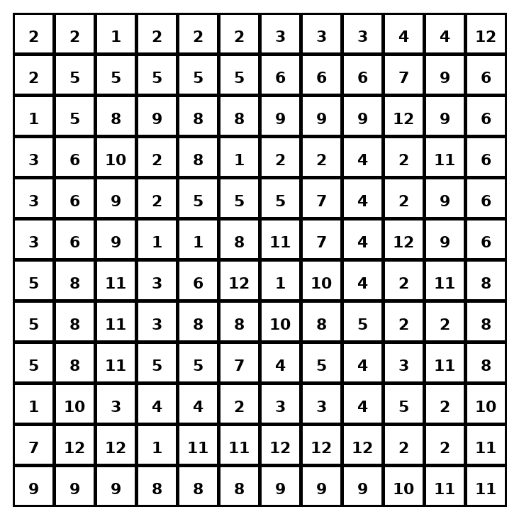

Early finisher writing: Choose one problem and explain your thinking in one complete sentence: Because ___, I ___.
____________________________________________________________________________________________

Teacher Answer Key
# | Answer | Color | Teacher Tip
1 | symmetric | red | Look for balance or a tail to the left/right.
2 | skewed right | orange | Look for balance or a tail to the left/right.
3 | skewed left | yellow | Look for balance or a tail to the left/right.
4 | symmetric | red | Look for balance or a tail to the left/right.
5 | skewed right | orange | Look for balance or a tail to the left/right.
6 | skewed left | yellow | Look for balance or a tail to the left/right.
7 | symmetric | red | Look for balance or a tail to the left/right.
8 | skewed right | orange | Look for balance or a tail to the left/right.
9 | skewed left | yellow | Look for balance or a tail to the left/right.
10 | symmetric | red | Look for balance or a tail to the left/right.
11 | skewed right | orange | Look for balance or a tail to the left/right.
12 | skewed left | yellow | Look for balance or a tail to the left/right.

Use note: This file is original practice aligned to the lesson skill. It is designed for low-prep review, centers, sub plans, or early finishers.

