9-1 Graph on the Coordinate Plane
Treasure Map Navigator | Standard: 6.NS.6 | Color-by-Number Practice

Learning Goal: I can plot and identify points on the coordinate plane using ordered pairs. | Directions: Solve each problem. Match each answer to the Color Code. On the next page, color every box with that problem number using the matching color.

Vocabulary: x-axis, y-axis, quadrant, ordered pair | Explain one: I solved problem ___ by ___. Because ___, my answer is ___.

Solve First
1. Where is the point (3, 4) located?  Work: ________________________________________  Answer: ________________ | 2. Where is the point (-2, 5) located?  Work: ________________________________________  Answer: ________________
3. Where is the point (-6, -1) located?  Work: ________________________________________  Answer: ________________ | 4. Where is the point (7, -3) located?  Work: ________________________________________  Answer: ________________
5. Where is the point (0, 5) located?  Work: ________________________________________  Answer: ________________ | 6. Where is the point (4, 0) located?  Work: ________________________________________  Answer: ________________
7. Where is the point (-5, 2) located?  Work: ________________________________________  Answer: ________________ | 8. Where is the point (6, -6) located?  Work: ________________________________________  Answer: ________________
9. Where is the point (-8, -4) located?  Work: ________________________________________  Answer: ________________ | 10. Where is the point (9, 1) located?  Work: ________________________________________  Answer: ________________
11. Where is the point (-3, -7) located?  Work: ________________________________________  Answer: ________________ | 12. Where is the point (2, -9) located?  Work: ________________________________________  Answer: ________________

Quick check: Before coloring, make sure every answer appears in the Color Code on the next page.

9-1 Mystery Picture: Treasure Map Mosaic
Solve a problem, match the answer to a color, then color every box with that problem number.
Color Code | Color Code | Color Code | Color Code
Quadrant I = red | Quadrant II = orange | Quadrant III = yellow | Quadrant IV = green
y-axis = blue | x-axis = purple

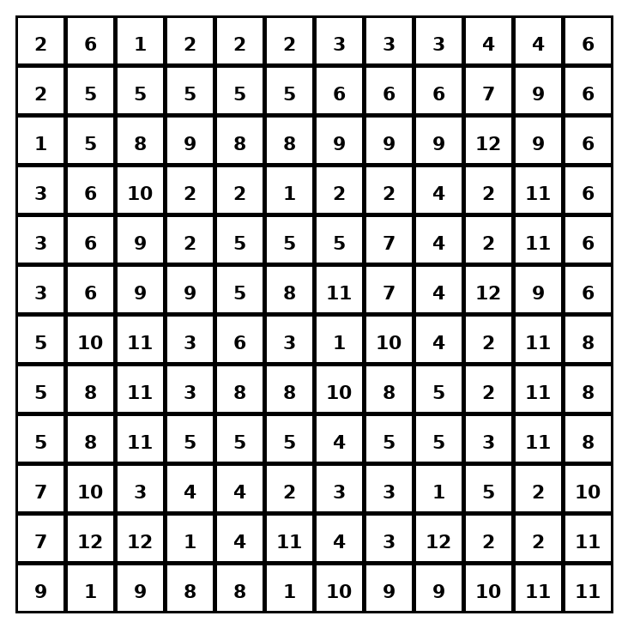

Early finisher writing: Choose one problem and explain your thinking in one complete sentence: Because ___, I ___.
____________________________________________________________________________________________

Teacher Answer Key
# | Answer | Color | Teacher Tip
1 | Quadrant I | red | Use the signs of x and y.
2 | Quadrant II | orange | Use the signs of x and y.
3 | Quadrant III | yellow | Use the signs of x and y.
4 | Quadrant IV | green | Use the signs of x and y.
5 | y-axis | blue | Use the signs of x and y.
6 | x-axis | purple | Use the signs of x and y.
7 | Quadrant II | orange | Use the signs of x and y.
8 | Quadrant IV | green | Use the signs of x and y.
9 | Quadrant III | yellow | Use the signs of x and y.
10 | Quadrant I | red | Use the signs of x and y.
11 | Quadrant III | yellow | Use the signs of x and y.
12 | Quadrant IV | green | Use the signs of x and y.

Use note: This file is original practice aligned to the lesson skill. It is designed for low-prep review, centers, sub plans, or early finishers.

