9-2 Integers and Absolute Value
Treasure Map Navigator | Standard: 6.NS.7 | Color-by-Number Practice

Learning Goal: I can identify integers and find their absolute value. | Directions: Solve each problem. Match each answer to the Color Code. On the next page, color every box with that problem number using the matching color.

Vocabulary: integer, opposite, absolute value | Explain one: I solved problem ___ by ___. Because ___, my answer is ___.

Solve First
1. Find |-3|.  Work: ________________________________________  Answer: ________________ | 2. Find |5|.  Work: ________________________________________  Answer: ________________
3. Find |-8|.  Work: ________________________________________  Answer: ________________ | 4. Find |0|.  Work: ________________________________________  Answer: ________________
5. Find |-12|.  Work: ________________________________________  Answer: ________________ | 6. Find |14|.  Work: ________________________________________  Answer: ________________
7. Find |-20|.  Work: ________________________________________  Answer: ________________ | 8. Find |7|.  Work: ________________________________________  Answer: ________________
9. Find |-1|.  Work: ________________________________________  Answer: ________________ | 10. Find |16|.  Work: ________________________________________  Answer: ________________
11. Find |-25|.  Work: ________________________________________  Answer: ________________ | 12. Find |30|.  Work: ________________________________________  Answer: ________________

Quick check: Before coloring, make sure every answer appears in the Color Code on the next page.

9-2 Mystery Picture: Treasure Map Mosaic
Solve a problem, match the answer to a color, then color every box with that problem number.
Color Code | Color Code | Color Code | Color Code
3 = red | 5 = orange | 8 = yellow | 0 = green
12 = blue | 14 = purple | 20 = pink | 7 = brown
1 = gray | 16 = teal | 25 = black | 30 = light blue

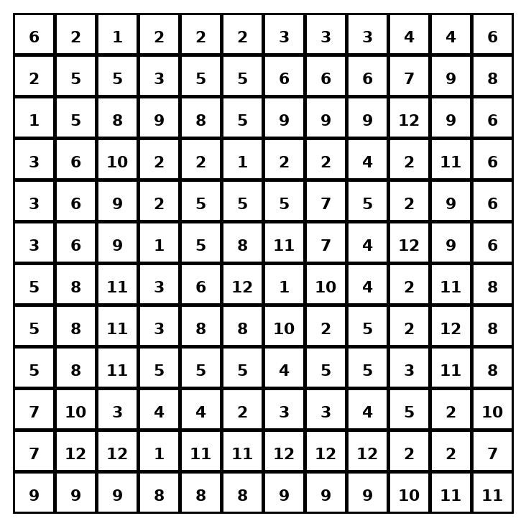

Early finisher writing: Choose one problem and explain your thinking in one complete sentence: Because ___, I ___.
____________________________________________________________________________________________

Teacher Answer Key
# | Answer | Color | Teacher Tip
1 | 3 | red | Absolute value is distance from 0.
2 | 5 | orange | Absolute value is distance from 0.
3 | 8 | yellow | Absolute value is distance from 0.
4 | 0 | green | Absolute value is distance from 0.
5 | 12 | blue | Absolute value is distance from 0.
6 | 14 | purple | Absolute value is distance from 0.
7 | 20 | pink | Absolute value is distance from 0.
8 | 7 | brown | Absolute value is distance from 0.
9 | 1 | gray | Absolute value is distance from 0.
10 | 16 | teal | Absolute value is distance from 0.
11 | 25 | black | Absolute value is distance from 0.
12 | 30 | light blue | Absolute value is distance from 0.

Use note: This file is original practice aligned to the lesson skill. It is designed for low-prep review, centers, sub plans, or early finishers.

