9-3 Compare and Order Integers
Treasure Map Navigator | Standard: 6.NS.7 | Color-by-Number Practice

Learning Goal: I can compare and order integers using a number line. | Directions: Solve each problem. Match each answer to the Color Code. On the next page, color every box with that problem number using the matching color.

Vocabulary: compare, order, integer, number line | Explain one: I solved problem ___ by ___. Because ___, my answer is ___.

Solve First
1. Compare: -3 __ 5.  Work: ________________________________________  Answer: ________________ | 2. Compare: -8 __ -2.  Work: ________________________________________  Answer: ________________
3. Compare: 0 __ -4.  Work: ________________________________________  Answer: ________________ | 4. Compare: 7 __ -9.  Work: ________________________________________  Answer: ________________
5. Compare: -12 __ -15.  Work: ________________________________________  Answer: ________________ | 6. Compare: 6 __ 6.  Work: ________________________________________  Answer: ________________
7. Compare: -1 __ 1.  Work: ________________________________________  Answer: ________________ | 8. Compare: 10 __ -10.  Work: ________________________________________  Answer: ________________
9. Compare: -20 __ -5.  Work: ________________________________________  Answer: ________________ | 10. Compare: 4 __ 9.  Work: ________________________________________  Answer: ________________
11. Compare: -7 __ 3.  Work: ________________________________________  Answer: ________________ | 12. Compare: 12 __ -14.  Work: ________________________________________  Answer: ________________

Quick check: Before coloring, make sure every answer appears in the Color Code on the next page.

9-3 Mystery Picture: Treasure Map Mosaic
Solve a problem, match the answer to a color, then color every box with that problem number.
Color Code | Color Code | Color Code | Color Code
< = red | > = orange | = = yellow

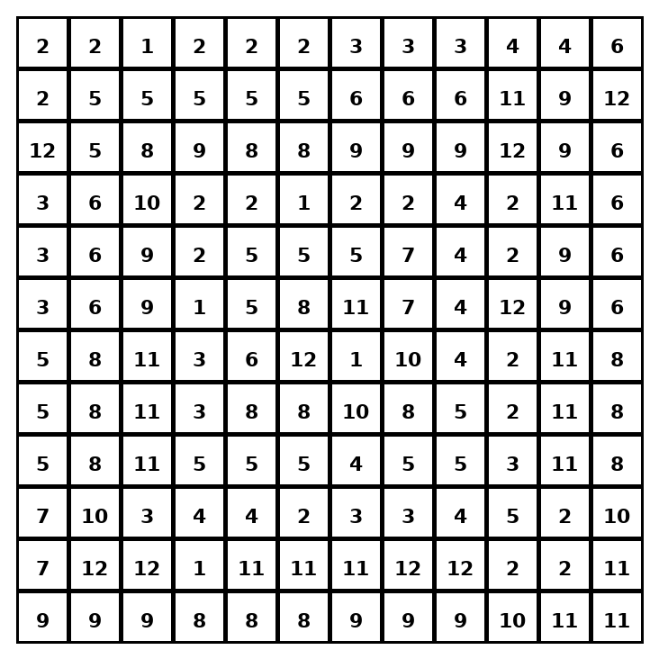

Early finisher writing: Choose one problem and explain your thinking in one complete sentence: Because ___, I ___.
____________________________________________________________________________________________

Teacher Answer Key
# | Answer | Color | Teacher Tip
1 | < | red | On a number line, numbers farther right are greater.
2 | < | red | On a number line, numbers farther right are greater.
3 | > | orange | On a number line, numbers farther right are greater.
4 | > | orange | On a number line, numbers farther right are greater.
5 | > | orange | On a number line, numbers farther right are greater.
6 | = | yellow | On a number line, numbers farther right are greater.
7 | < | red | On a number line, numbers farther right are greater.
8 | > | orange | On a number line, numbers farther right are greater.
9 | < | red | On a number line, numbers farther right are greater.
10 | < | red | On a number line, numbers farther right are greater.
11 | < | red | On a number line, numbers farther right are greater.
12 | > | orange | On a number line, numbers farther right are greater.

Use note: This file is original practice aligned to the lesson skill. It is designed for low-prep review, centers, sub plans, or early finishers.

