9-4 Rational Numbers on the Number Line
Treasure Map Navigator | Standard: 6.NS.6 | Color-by-Number Practice

Learning Goal: I can place rational numbers, including fractions and decimals, on a number line. | Directions: Solve each problem. Match each answer to the Color Code. On the next page, color every box with that problem number using the matching color.

Vocabulary: fraction, decimal, rational number | Explain one: I solved problem ___ by ___. Because ___, my answer is ___.

Solve First
1. Write 1/2 as a decimal to place it on the number line.  Work: ________________________________________  Answer: ________________ | 2. Write 3/4 as a decimal to place it on the number line.  Work: ________________________________________  Answer: ________________
3. Write 1/4 as a decimal to place it on the number line.  Work: ________________________________________  Answer: ________________ | 4. Write 2/5 as a decimal to place it on the number line.  Work: ________________________________________  Answer: ________________
5. Write 3/5 as a decimal to place it on the number line.  Work: ________________________________________  Answer: ________________ | 6. Write 1/10 as a decimal to place it on the number line.  Work: ________________________________________  Answer: ________________
7. Write 7/10 as a decimal to place it on the number line.  Work: ________________________________________  Answer: ________________ | 8. Write 4/5 as a decimal to place it on the number line.  Work: ________________________________________  Answer: ________________
9. Write 1/8 as a decimal to place it on the number line.  Work: ________________________________________  Answer: ________________ | 10. Write 3/8 as a decimal to place it on the number line.  Work: ________________________________________  Answer: ________________
11. Write 5/8 as a decimal to place it on the number line.  Work: ________________________________________  Answer: ________________ | 12. Write 7/8 as a decimal to place it on the number line.  Work: ________________________________________  Answer: ________________

Quick check: Before coloring, make sure every answer appears in the Color Code on the next page.

9-4 Mystery Picture: Treasure Map Mosaic
Solve a problem, match the answer to a color, then color every box with that problem number.
Color Code | Color Code | Color Code | Color Code
0.5 = red | 0.75 = orange | 0.25 = yellow | 0.4 = green
0.6 = blue | 0.1 = purple | 0.7 = pink | 0.8 = brown
0.12 = gray | 0.38 = teal | 0.62 = black | 0.88 = light blue

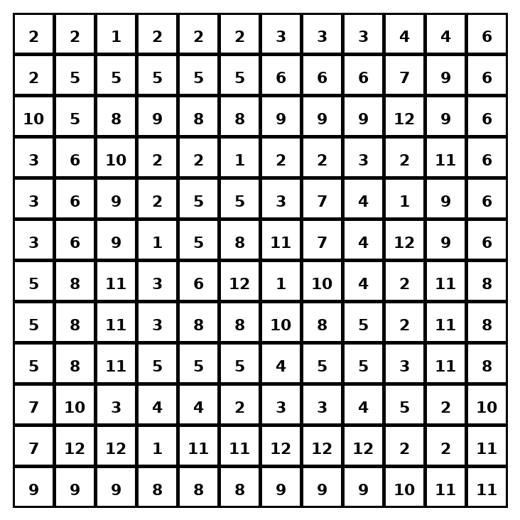

Early finisher writing: Choose one problem and explain your thinking in one complete sentence: Because ___, I ___.
____________________________________________________________________________________________

Teacher Answer Key
# | Answer | Color | Teacher Tip
1 | 0.5 | red | Divide numerator by denominator.
2 | 0.75 | orange | Divide numerator by denominator.
3 | 0.25 | yellow | Divide numerator by denominator.
4 | 0.4 | green | Divide numerator by denominator.
5 | 0.6 | blue | Divide numerator by denominator.
6 | 0.1 | purple | Divide numerator by denominator.
7 | 0.7 | pink | Divide numerator by denominator.
8 | 0.8 | brown | Divide numerator by denominator.
9 | 0.12 | gray | Divide numerator by denominator.
10 | 0.38 | teal | Divide numerator by denominator.
11 | 0.62 | black | Divide numerator by denominator.
12 | 0.88 | light blue | Divide numerator by denominator.

Use note: This file is original practice aligned to the lesson skill. It is designed for low-prep review, centers, sub plans, or early finishers.

