9-5 Ordered Pairs in All Four Quadrants
Treasure Map Navigator | Standard: 6.NS.6b | Color-by-Number Practice

Learning Goal: I can plot ordered pairs in all four quadrants of the coordinate plane. | Directions: Solve each problem. Match each answer to the Color Code. On the next page, color every box with that problem number using the matching color.

Vocabulary: ordered pair, quadrant, coordinate plane | Explain one: I solved problem ___ by ___. Because ___, my answer is ___.

Solve First
1. Identify the quadrant for (2, 3).  Work: ________________________________________  Answer: ________________ | 2. Identify the quadrant for (-4, 5).  Work: ________________________________________  Answer: ________________
3. Identify the quadrant for (-6, -7).  Work: ________________________________________  Answer: ________________ | 4. Identify the quadrant for (8, -1).  Work: ________________________________________  Answer: ________________
5. Identify the quadrant for (1, 9).  Work: ________________________________________  Answer: ________________ | 6. Identify the quadrant for (-3, 4).  Work: ________________________________________  Answer: ________________
7. Identify the quadrant for (-5, -2).  Work: ________________________________________  Answer: ________________ | 8. Identify the quadrant for (7, -8).  Work: ________________________________________  Answer: ________________
9. Identify the quadrant for (9, 6).  Work: ________________________________________  Answer: ________________ | 10. Identify the quadrant for (-8, 1).  Work: ________________________________________  Answer: ________________
11. Identify the quadrant for (-9, -9).  Work: ________________________________________  Answer: ________________ | 12. Identify the quadrant for (4, -6).  Work: ________________________________________  Answer: ________________

Quick check: Before coloring, make sure every answer appears in the Color Code on the next page.

9-5 Mystery Picture: Treasure Map Mosaic
Solve a problem, match the answer to a color, then color every box with that problem number.
Color Code | Color Code | Color Code | Color Code
I = red | II = orange | III = yellow | IV = green

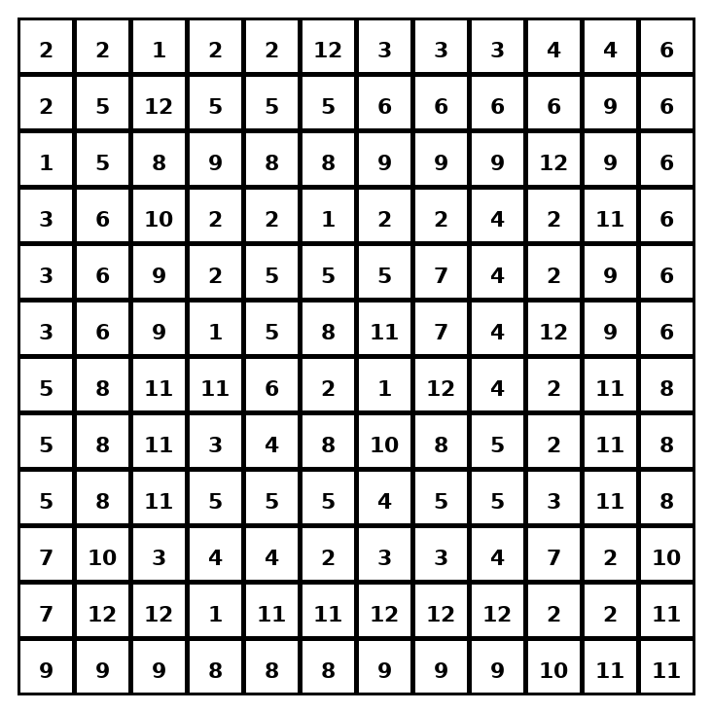

Early finisher writing: Choose one problem and explain your thinking in one complete sentence: Because ___, I ___.
____________________________________________________________________________________________

Teacher Answer Key
# | Answer | Color | Teacher Tip
1 | I | red | Check the signs of x and y.
2 | II | orange | Check the signs of x and y.
3 | III | yellow | Check the signs of x and y.
4 | IV | green | Check the signs of x and y.
5 | I | red | Check the signs of x and y.
6 | II | orange | Check the signs of x and y.
7 | III | yellow | Check the signs of x and y.
8 | IV | green | Check the signs of x and y.
9 | I | red | Check the signs of x and y.
10 | II | orange | Check the signs of x and y.
11 | III | yellow | Check the signs of x and y.
12 | IV | green | Check the signs of x and y.

Use note: This file is original practice aligned to the lesson skill. It is designed for low-prep review, centers, sub plans, or early finishers.

