9-6 Distance on the Coordinate Plane
Treasure Map Navigator | Standard: 6.NS.8 | Color-by-Number Practice

Learning Goal: I can find the distance between two points on the coordinate plane using absolute value. | Directions: Solve each problem. Match each answer to the Color Code. On the next page, color every box with that problem number using the matching color.

Vocabulary: distance, absolute value, coordinate plane | Explain one: I solved problem ___ by ___. Because ___, my answer is ___.

Solve First
1. Find the distance between (2, 3) and (8, 3).  Work: ________________________________________  Answer: ________________ | 2. Find the distance between (-4, 5) and (-4, 1).  Work: ________________________________________  Answer: ________________
3. Find the distance between (-6, -7) and (-1, -7).  Work: ________________________________________  Answer: ________________ | 4. Find the distance between (8, -1) and (8, -9).  Work: ________________________________________  Answer: ________________
5. Find the distance between (1, 9) and (7, 9).  Work: ________________________________________  Answer: ________________ | 6. Find the distance between (-3, 4) and (-3, -2).  Work: ________________________________________  Answer: ________________
7. Find the distance between (-5, -2) and (5, -2).  Work: ________________________________________  Answer: ________________ | 8. Find the distance between (7, -8) and (7, 0).  Work: ________________________________________  Answer: ________________
9. Find the distance between (9, 6) and (1, 6).  Work: ________________________________________  Answer: ________________ | 10. Find the distance between (-8, 1) and (-8, 9).  Work: ________________________________________  Answer: ________________
11. Find the distance between (-9, -9) and (-2, -9).  Work: ________________________________________  Answer: ________________ | 12. Find the distance between (4, -6) and (4, 3).  Work: ________________________________________  Answer: ________________

Quick check: Before coloring, make sure every answer appears in the Color Code on the next page.

9-6 Mystery Picture: Treasure Map Mosaic
Solve a problem, match the answer to a color, then color every box with that problem number.
Color Code | Color Code | Color Code | Color Code
6 = red | 4 = orange | 5 = yellow | 8 = green
10 = blue | 7 = purple | 9 = pink

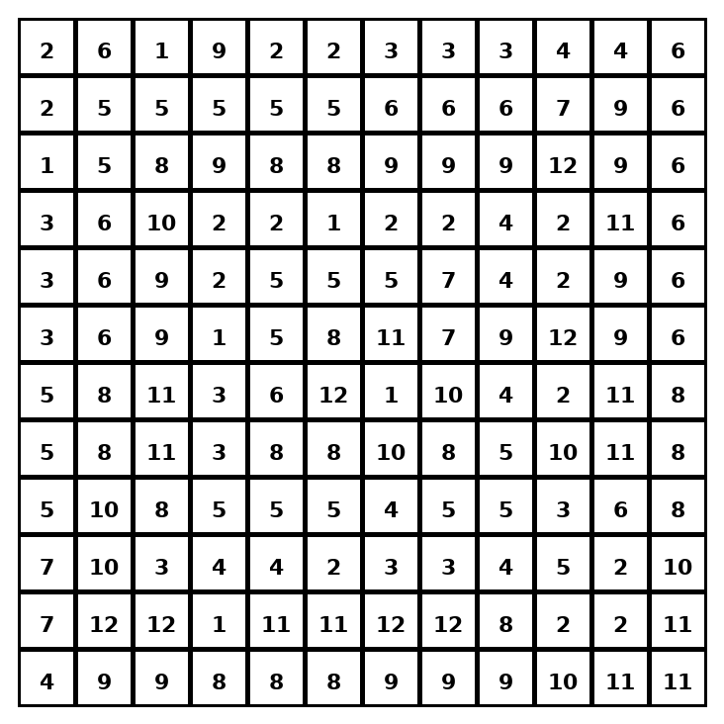

Early finisher writing: Choose one problem and explain your thinking in one complete sentence: Because ___, I ___.
____________________________________________________________________________________________

Teacher Answer Key
# | Answer | Color | Teacher Tip
1 | 6 | red | If only one coordinate changes, use absolute value of the difference.
2 | 4 | orange | If only one coordinate changes, use absolute value of the difference.
3 | 5 | yellow | If only one coordinate changes, use absolute value of the difference.
4 | 8 | green | If only one coordinate changes, use absolute value of the difference.
5 | 6 | red | If only one coordinate changes, use absolute value of the difference.
6 | 6 | red | If only one coordinate changes, use absolute value of the difference.
7 | 10 | blue | If only one coordinate changes, use absolute value of the difference.
8 | 8 | green | If only one coordinate changes, use absolute value of the difference.
9 | 8 | green | If only one coordinate changes, use absolute value of the difference.
10 | 8 | green | If only one coordinate changes, use absolute value of the difference.
11 | 7 | purple | If only one coordinate changes, use absolute value of the difference.
12 | 9 | pink | If only one coordinate changes, use absolute value of the difference.

Use note: This file is original practice aligned to the lesson skill. It is designed for low-prep review, centers, sub plans, or early finishers.

