9-7 Reflect Points Across Axes
Treasure Map Navigator | Standard: 6.NS.6b | Color-by-Number Practice

Learning Goal: I can reflect points across the x-axis and y-axis on the coordinate plane. | Directions: Solve each problem. Match each answer to the Color Code. On the next page, color every box with that problem number using the matching color.

Vocabulary: reflection, x-axis, y-axis | Explain one: I solved problem ___ by ___. Because ___, my answer is ___.

Solve First
1. Reflect (2, 3) across the x-axis.  Work: ________________________________________  Answer: ________________ | 2. Reflect (-4, 5) across the y-axis.  Work: ________________________________________  Answer: ________________
3. Reflect (-6, -7) across the x-axis.  Work: ________________________________________  Answer: ________________ | 4. Reflect (8, -1) across the y-axis.  Work: ________________________________________  Answer: ________________
5. Reflect (1, 9) across the x-axis.  Work: ________________________________________  Answer: ________________ | 6. Reflect (-3, 4) across the y-axis.  Work: ________________________________________  Answer: ________________
7. Reflect (-5, -2) across the x-axis.  Work: ________________________________________  Answer: ________________ | 8. Reflect (7, -8) across the y-axis.  Work: ________________________________________  Answer: ________________
9. Reflect (9, 6) across the x-axis.  Work: ________________________________________  Answer: ________________ | 10. Reflect (-8, 1) across the y-axis.  Work: ________________________________________  Answer: ________________
11. Reflect (-9, -9) across the x-axis.  Work: ________________________________________  Answer: ________________ | 12. Reflect (4, -6) across the y-axis.  Work: ________________________________________  Answer: ________________

Quick check: Before coloring, make sure every answer appears in the Color Code on the next page.

9-7 Mystery Picture: Treasure Map Mosaic
Solve a problem, match the answer to a color, then color every box with that problem number.
Color Code | Color Code | Color Code | Color Code
(2, -3) = red | (4, 5) = orange | (-6, 7) = yellow | (-8, -1) = green
(1, -9) = blue | (3, 4) = purple | (-5, 2) = pink | (-7, -8) = brown
(9, -6) = gray | (8, 1) = teal | (-9, 9) = black | (-4, -6) = light blue

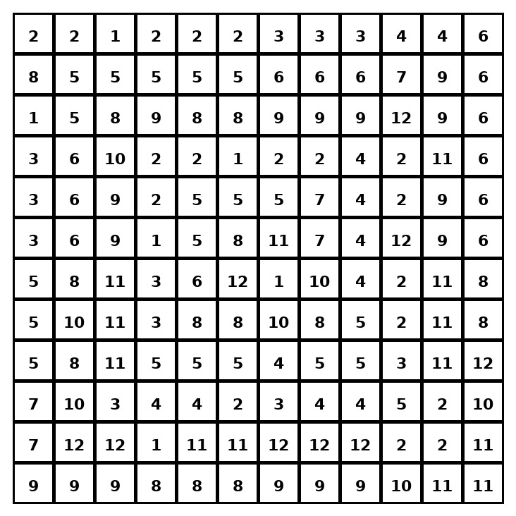

Early finisher writing: Choose one problem and explain your thinking in one complete sentence: Because ___, I ___.
____________________________________________________________________________________________

Teacher Answer Key
# | Answer | Color | Teacher Tip
1 | (2, -3) | red | Across x-axis changes y; across y-axis changes x.
2 | (4, 5) | orange | Across x-axis changes y; across y-axis changes x.
3 | (-6, 7) | yellow | Across x-axis changes y; across y-axis changes x.
4 | (-8, -1) | green | Across x-axis changes y; across y-axis changes x.
5 | (1, -9) | blue | Across x-axis changes y; across y-axis changes x.
6 | (3, 4) | purple | Across x-axis changes y; across y-axis changes x.
7 | (-5, 2) | pink | Across x-axis changes y; across y-axis changes x.
8 | (-7, -8) | brown | Across x-axis changes y; across y-axis changes x.
9 | (9, -6) | gray | Across x-axis changes y; across y-axis changes x.
10 | (8, 1) | teal | Across x-axis changes y; across y-axis changes x.
11 | (-9, 9) | black | Across x-axis changes y; across y-axis changes x.
12 | (-4, -6) | light blue | Across x-axis changes y; across y-axis changes x.

Use note: This file is original practice aligned to the lesson skill. It is designed for low-prep review, centers, sub plans, or early finishers.

