Name Date Period
Lesson 2-1 · Session 2 · Practice · Form A
Dot Plots and Shape
Learning target — I can build a dot plot and describe the shape of the data it shows. · 6.SP.B.4

REMEMBER  • A dot plot shows one dot for each data value. Repeated values stack up.  • The peak (tallest stack) is the most common value. Total dots = number of values.  • Symmetric: both sides match. Skewed left/right: the long tail points that way. | WORKED EXAMPLE  Six students read 3, 1, 2, 3, 3, 5 books. Make a dot plot and read it.  Step 1 Draw a line from 1 to 5.  Step 2 Stack dots: one at 1, one at 2, three at 3, one at 5.  Step 3 Check: 6 dots for 6 students.  Answer Most common value 3; least 1; greatest 5
WORDS dot plot (diagrama de puntos) · symmetric (simétrico) · skewed (sesgado) · most common value (valor más común)
PRACTICE show your work · label units

1. Water Bottles. Mr. Lang asked 9 students how many bottles they filled on Friday: 2, 4, 1, 3, 2, 5, 2, 3, 2. Make a dot plot.  Hint Cross off each value as you draw its dot.  a. Most common value:  b. Shape: | 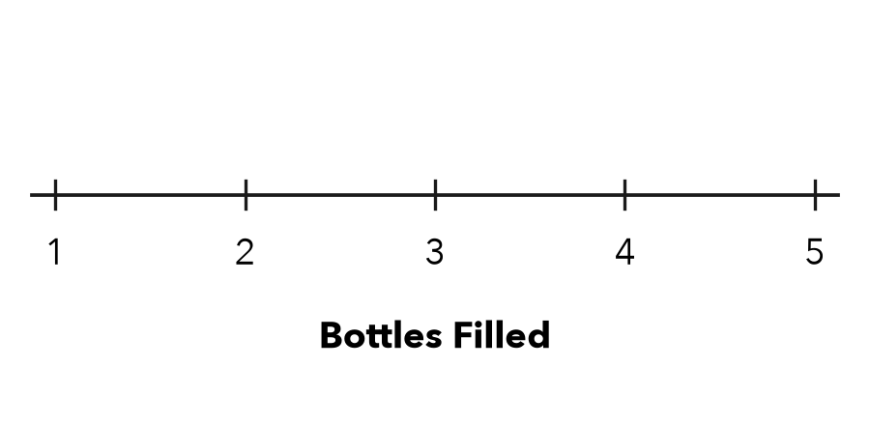

2. Free Throws. Seven players made these free throws: 6, 9, 7, 6, 8, 6, 10. Make a dot plot. What is the most common value?  Most common | 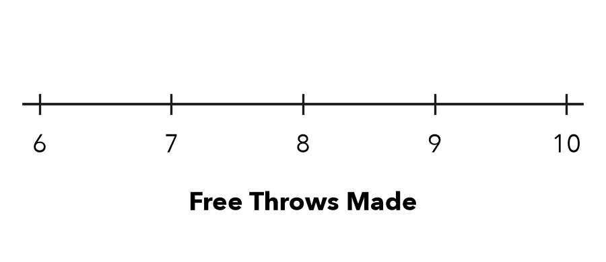

3. Read the Stacks. On a dot plot, 6 has 5 dots and 7 has 2 dots.  Hint Each dot stands for one student.  a. Students who chose 6:  b. Students in both stacks: | 4. Count the Dots. A dot plot has stacks of 3, 4, 2 and 1 dots. How many data values does it show?  Hint Add the stack heights.  Values
  Show your work.

5. Shape Claim. Jonas says this plot of quiz scores is symmetric. Is he right? Explain.  Hint Compare the stacks on each side of the tallest stack.  Right? | 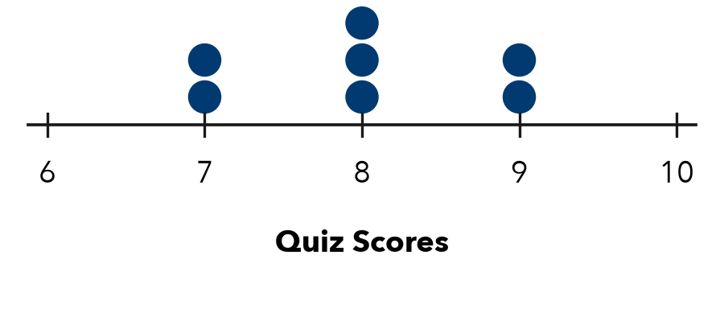

6. One More Reader. The plot shows pages read. Then one more student reads 18 pages. Find the new most common value. Does the greatest value change?  Hint Add the new dot first, then compare stack heights.  Most common | 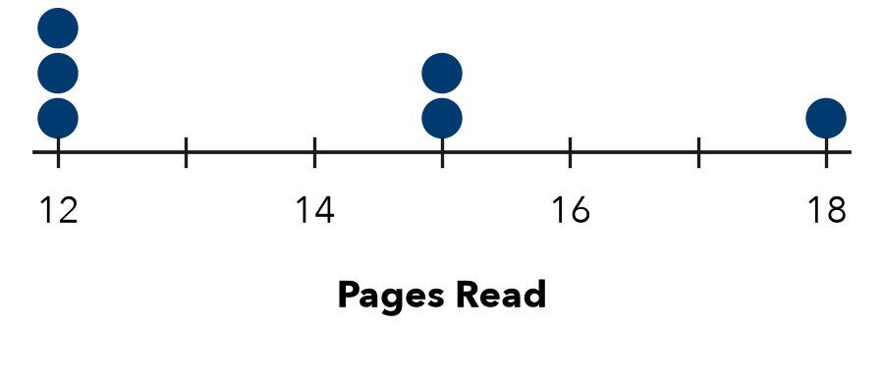

7. Bracelet Beads. The plot shows bead counts. Name the most common value and the shape.  Value; shape | 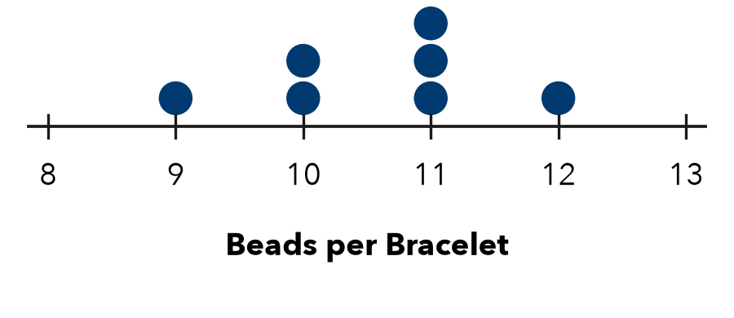

8. Library Books. Ten students finished these numbers of books: 1, 3, 2, 3, 4, 3, 2, 5, 3, 2. Make a dot plot. Name the most common value.  Hint Tally each value before you draw.  Most common | 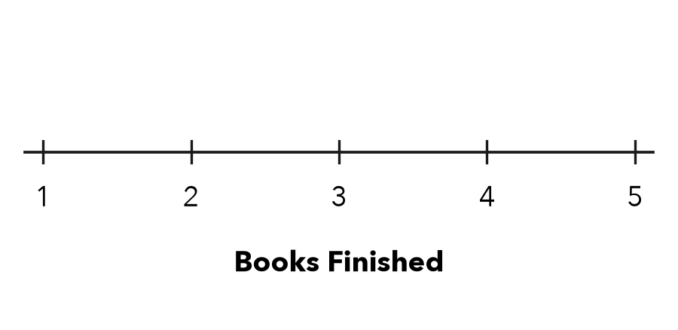

FIND THE ERROR explain the mistake, then fix it

9. Marcus’s Work. For the data 3, 3, 6, 9, Marcus drew one dot above each of 3, 6 and 9. Explain the mistake and tell what the plot should show.

TEST PRACTICE choose the best answer

10. On a dot plot, the height of a stack tells you —
A the greatest value | B how many times that value appears
C the number of values in all | D the shape

11. Data: 2, 2, 3, 5, 5, 5. Which stack is tallest?
A over 5 | B over 2 | C over 3 | D over 15

SELF-CHECK CODE find your answer · copy its letter into that problem’s box · spell a math word
7  A | 12  K | 6  T | 4  Q | 10  C | 11  E | 1  X | 15  Z | 2  S | 3  D

#1a | #2 | #3b | #4 | #6 | #7 | #8

CHECK YOURSELF | □ I can do this on my own | □ I need a little help | □ I have a question about #

