Name Date Period
Lesson 2-1 · Homework Packet · Sheet 1 of 2
Statistical Questions
Maryland Standard 6.SP.A.1 · Learning target — I can tell whether a question is statistical by deciding if the answers will vary.

REMEMBER  • A statistical question expects answers that vary. You collect data to answer it.  • A non-statistical question has one fixed answer, like a fact you can look up.  • A number answer alone does not make a question statistical. Ask: “Will the answers be different?” | WORKED EXAMPLE  Is “How many minutes does each student in Room 12 ride the bus?” statistical?  Step 1 Who answers? Every student in Room 12.  Step 2 Will the answers differ? Yes: 5 min, 12 min, 25 min …  Step 3 The answers vary, so you need data.  Answer Statistical
PRACTICE show your work · label units
1. Write S if the question is statistical or N if it is non-statistical.
Question | S or N
How many feet are in one yard?
How many hours did each sixth grader sleep last night?
What is the price of a bus ticket in Baltimore today?
How many glasses of water does each person in my family drink a day?

2. Name Lengths. Ms. Adeyemi asks each student, “How many letters are in your first name?” Five students answer 5, 4, 7, 5, and 6. Is her question statistical? Use the answers to explain.
□ Statistical | □ Not statistical
Because

3. Survey Plan. Is “How far does each player live from the field?” statistical?
□ Statistical | □ Not statistical

4. Rewrite It. Carlos asks, “How tall is the oak tree in front of our school?” Explain why this is not statistical. Then rewrite it as a statistical question.
Sentence Frame: "I know this because..."

5. Your Turn. Write a statistical question you could ask the people in your family. Then list three answers you might get.

CHECK YOURSELF | □ I can do this on my own | □ I need a little help | □ I have a question about #
AT HOME Ask a family member one statistical question and one non-statistical question. Can they tell which is which?
Name Date Period
Lesson 2-1 · Homework Packet · Sheet 2 of 2
Dot Plots and Shape
Maryland Standard 6.SP.B.4 · Learning target — I can build a dot plot and describe the shape of the data it shows.

REMEMBER  • A dot plot shows one dot per data value.  • Peak: tallest stack. Gap: no dots. Outlier: far away.  • Symmetric: the sides match. Skewed right/left: the tail goes that way. | WORKED EXAMPLE  Pets owned: 0, 0, 1, 1, 1, 1, 2, 2, 3, 5. Name the shape.  Step 1 Stacks: 2 dots at 0, 4 at 1, 2 at 2, 1 at 3, 1 at 5.  Step 2 Peak at 1. The tail stretches right to 5.  Answer Skewed right
PRACTICE show your work · label units

1. Books Read. Books read in May by 12 students: 2, 3, 1, 3, 4, 2, 3, 5, 3, 2, 4, 4. Make a dot plot.  a. Peak:  b. Shape: | 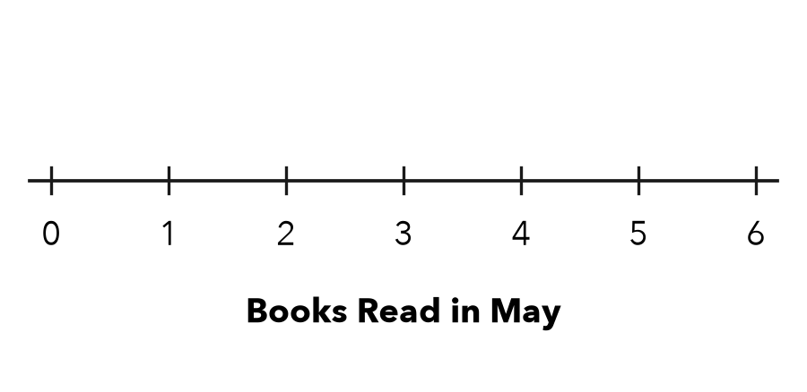

2. Arcade Tickets. Tickets won by 9 friends: 5, 3, 4, 5, 2, 5, 4, 6, 5. Picture the dot plot.
a. Dots at 5: | b. Peak: | c. Shape:

3. Soccer Goals. The dot plot shows the goals a team scored in each game.  a. Games played:  b. Most common:  c. Where is the gap? | 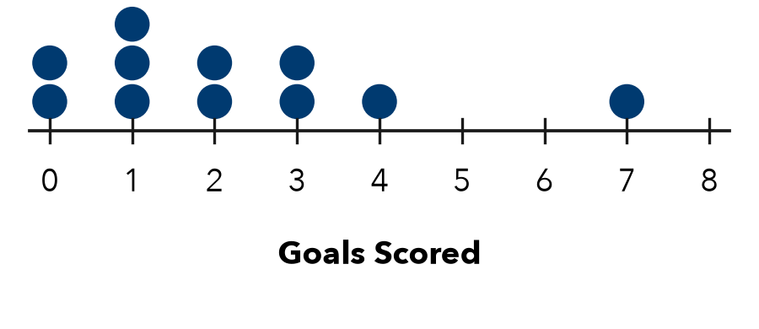

4. Find the Error. Leah says the Soccer Goals plot is skewed left. Explain her error.

5. Quiz Scores. 1 dot at 5, 1 at 6, 2 at 7, 4 at 8, 5 at 9, and 3 at 10. Name the shape.
□ Symmetric | □ Skewed left | □ Skewed right

TEST PRACTICE choose the best answer
6. Stacks of 1, 3, 5, 3, and 1 dots sit above 2, 3, 4, 5, and 6. Which word describes the shape?
A Symmetric | B Skewed left | C Skewed right | D Has a gap

7. A dot plot has 4 dots above 10, 6 above 11, 2 above 12, and 3 above 13. How many values?
A 4 | B 6 | C 13 | D 15

CHECK YOURSELF | □ I can do this on my own | □ I need a little help | □ I have a question about #
AT HOME Count the letters in each family member’s first name. Make a dot plot and name its shape.

