Name Date Period
Lesson 2-1 · Session 1 · Prerequisite Practice B · Skill 1 of 2
Read Survey Results
Builds on Grade 3 · 3.MD.B.3
TODAY’S LESSON | You will read survey answers, like 15, 40, 0, 35, 20, 10, and tell how many people answered.
YOU NEED TO | Read a results table: find how many gave one answer, then add to find how many were asked. You will use it in Practice Form A, problems 2 and 5.
STEPS TO FOLLOW use these same steps on every problem
1 | Find the answer in the table.
2 | Read how many people gave that answer.
3 | Add all the counts to find how many were asked.
WATCH ME the steps in action
Favorite season: spring 6, summer 11, fall 4, winter 3. How many chose summer? How many were asked?
Step 1 Find summer in the table.
Step 2 11 people chose summer.
Step 3 Add: 6 + 11 + 4 + 3 = 24 people were asked.
Answer 11 chose summer. 24 people were asked.
TRY IT WITH HELP fill in each step
1. Favorite fruit: apple 5, grape 8, pear 2. How many chose grape? How many were asked?
Step 1 Find in the table.
Step 2 people chose grape.
Step 3 Add: 5 + 8 + 2 = people were asked.

2. Favorite color: red 7, blue 9, green 4, yellow 5. How many chose green? How many were asked?
Step 1 Find in the table.
Step 2 people chose green.
Step 3 Add: + + + = people.

YOUR TURN use the steps on your own

3. Favorite pet: dog 9, cat 6, fish 3, bird 4, rabbit 2.
a. Chose cat: | b. Chose bird: | c. Most chosen:
d. Least chosen: | e. Dog or cat: | f. People asked:

Lesson 2-1 · Session 1 · Prerequisite Practice B · Skill 2 of 2
Read a Line Plot
Builds on Grade 5 · 5.MD.B.2
TODAY’S LESSON | Each dot is one answer. If 6 has 5 dots, then 5 people answered 6.
YOU NEED TO | Count the dots above a number, then all the dots. You will use it in Session 2 Practice Form A, problems 3 and 4.
STEPS TO FOLLOW use these same steps on every problem
1 | Find the number on the line.
2 | Count the dots above it. Each dot is one answer.
3 | Count all the dots to find how many answered.
WATCH ME the steps in action
How many have 3 pets? How many answered?  Step 1 Find 3 on the line.  Step 2 2 dots above 3. So 2 students have 3 pets.  Step 3 All dots: 1 + 2 + 2 + 1 = 6.  Answer 2 students; 6 in all. | 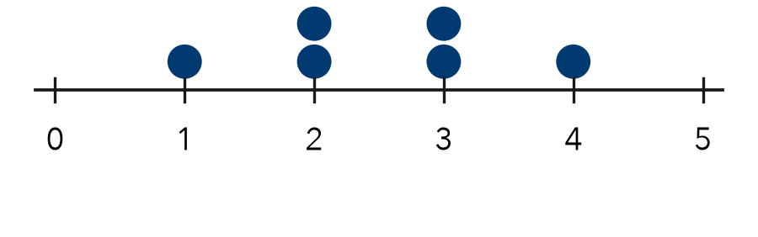

TRY IT WITH HELP fill in each step
4. A dot plot has 4 dots above 8 and 3 dots above 9. How many chose 8? How many in all?
Step 1 Find on the line.
Step 2 There are dots above 8. So students chose 8.
Step 3 All dots: 4 + 3 = students.

5. A dot plot has stacks of 2, 5, and 1 dots. How many students answered?
Step 1 Find each on the line.
Step 2 The stacks have , , and dots.
Step 3 All dots: 2 + 5 + 1 = students.

YOUR TURN use the steps on your own

6. Use the dot plot of goals scored. | 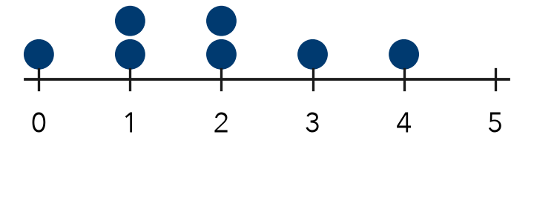
  a. Dots above 2:
  b. Dots above 4:
  c. Total dots:

READY CHECK a problem like the one in today’s lesson

7. A dot plot has stacks of 2, 4, 3, and 1 dots. How many people answered?
A 4 | B 10 | C 9 | D 3

CHECK YOURSELF | □ I can do this on my own | □ I need a little help | □ I have a question about #

