Name Date Period
Lesson 2-1 · Session 2 · Prerequisite Practice A · Skill 1 of 2
Read a Scaled Number Line
Builds on Grade 4 · 4.MD.A.2
TODAY’S LESSON | You will draw a dot plot on a number line. In problem 6 only every other number is labeled.
YOU NEED TO | Find what one jump is worth, then name each tick mark. You will use it in Practice Form A, problems 2 and 6.
STEPS TO FOLLOW use these same steps on every problem
1 | Subtract the two labels.
2 | Count the jumps between them. Divide to find one jump.
3 | Count on by one jump to name each tick.
WATCH ME the steps in action
Labels are 0 and 20. There are 4 equal jumps. What is point A?  Step 1 20 − 0 = 20.  Step 2 4 jumps. 20 ÷ 4 = 5. One jump is 5.  Step 3 Count on: 5, 10, 15. Point A is 15.  Answer One jump is 5. A = 15. | 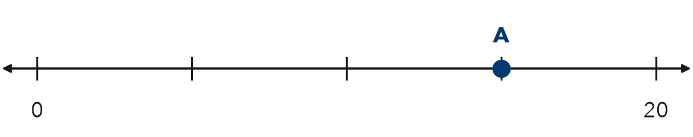

TRY IT WITH HELP fill in each step
1. Labels are 0 and 50. What is point B?
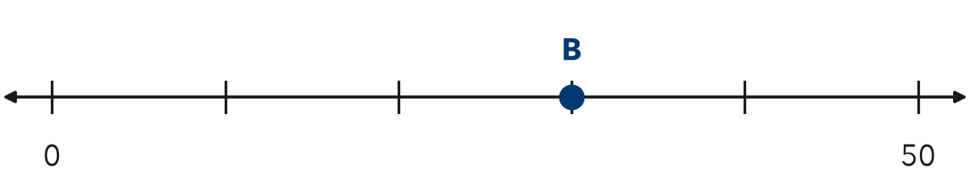
Step 1 50 − 0 = .
Step 2 jumps. One jump is .
Step 3 Count on: 10, 20, . B = .

2. Labels are 12 and 18. There are 3 equal jumps. Name the ticks.
Step 1 18 − 12 = .
Step 2 3 jumps. One jump is .
Step 3 Count on: 12, , , 18.

YOUR TURN use the steps on your own

3. Find what one jump is worth.
a. 0 to 20, 4 jumps: | b. 0 to 50, 10 jumps: | c. 0 to 100, 4 jumps:
d. 20 to 30, 5 jumps: | e. 10 to 40, 3 jumps: | f. 50 to 100, 5 jumps:

Lesson 2-1 · Session 2 · Prerequisite Practice A · Skill 2 of 2
Spot Line Symmetry
Builds on Grade 4 · 4.G.A.3
TODAY’S LESSON | You will tell if a dot plot is symmetric. In problem 5 the stacks are 2, 3, 2.
YOU NEED TO | Check whether the stacks on the left match the stacks on the right. You will use it in Practice Form A, problems 5 and 7.
STEPS TO FOLLOW use these same steps on every problem
1 | Find the middle stack.
2 | Compare stacks the same distance out on each side.
3 | If every pair matches, it is symmetric.
WATCH ME the steps in action
Stack heights, left to right: 1, 3, 5, 3, 1. Is the plot symmetric?  Step 1 The middle stack is 5.  Step 2 Pairs: 3 and 3. 1 and 1.  Step 3 Every pair matches. It is symmetric.  Answer Yes, it is symmetric. | 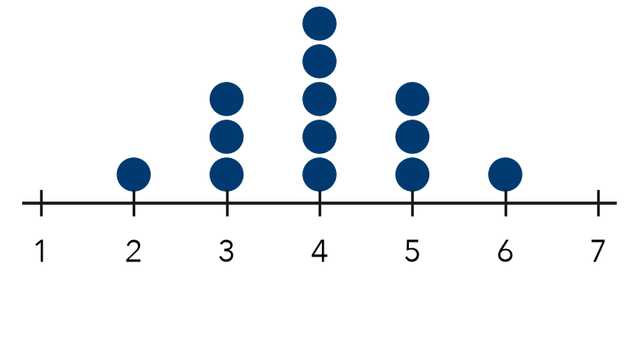

TRY IT WITH HELP fill in each step
4. Stack heights: 2, 4, 6, 4, 2. Is the plot symmetric?
Step 1 The middle stack is .
Step 2 Pairs: and . and .
Step 3 Do all pairs match?

5. Stack heights: 1, 3, 5, 2, 1. Is the plot symmetric?
Step 1 The middle stack is .
Step 2 Pairs: and . and .
Step 3 Do all pairs match?

YOUR TURN use the steps on your own

6. Write S if the stacks are symmetric. Write N if not.
a. 1, 4, 6, 4, 1 | b. 1, 4, 6, 3, 1 | c. 3, 5, 8, 5, 3
d. 2, 2, 7, 2, 1 | e. 1, 2, 3, 2, 1 | f. 5, 3, 2, 1, 1

READY CHECK a problem like the one in today’s lesson

7. Which stack heights make a symmetric dot plot?
A 1, 3, 6, 4, 1 | B 2, 5, 8, 5, 2 | C 4, 3, 2, 1, 1 | D 1, 2, 3, 2, 2

CHECK YOURSELF | □ I can do this on my own | □ I need a little help | □ I have a question about #

