Name Date Period
Lesson 2-10 · Session 2 · Practice · Form B
Matching Center and Spread
Learning target — I can match a measure of center and a measure of spread to the shape of a data set. · 6.SP.B.5d

REMEMBER  • Symmetric, no outlier: mean and MAD. Skewed or outlier: median and IQR.  • Never mix the pairs. MAD is built from the mean; IQR is built from the median.  • A long tail to the right means skewed right; to the left means skewed left. | WORKED EXAMPLE  Set C: 20, 22, 24, 26, 28. Set D: 20, 22, 24, 26, 150. Pick a pair for each.  Step 1 C is symmetric: mean 24, MAD 12 ÷ 5 = 2.4.  Step 2 D has an outlier (150): median 24, with the IQR.  Answer C: mean and MAD. D: median and IQR.
WORDS symmetric (simétrico) · skewed (asimétrico) · mean and MAD (media y DMA) · median and IQR (mediana y rango intercuartil)
PRACTICE show your work · label units

1. Write the pair you would report: mean and MAD, or median and IQR.
a. 52, 54, 56, 58, 60 | b. 52, 54, 56, 58, 310
c. 63, 65, 67, 69, 71, 73, 75 | d. 1, 45, 47, 49, 51

2. Test Scores. The histogram shows the scores of 22 students.  a. Shape:  b. Pair to report: | 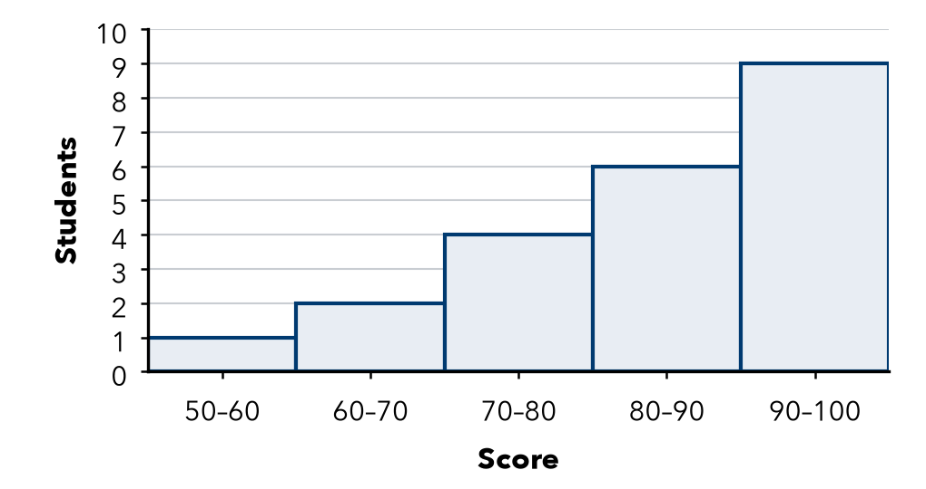

3. Balanced Scores. Set R is 40, 43, 45, 47, 50. It is symmetric.  Hint Find the mean first. MAD = average distance from it.  a. Mean:  b. MAD: | 4. One Big Night. Ticket sales for seven shows were 14, 16, 17, 19, 22, 24 and 350.  Hint Q1 is the middle of the lower half; Q3 of the upper half.  a. Median:  b. IQR:
  Show your work.
  Show your work.

5. Mismatched Pair. Ana reports a mean of 64 for a symmetric set, with the IQR for spread. What spread should she use?  Hint Which center is the IQR built from?  Spread | 6. Book Fair. Daily sales: 63, 65, 67, 69, 71, 73, 75. Name the pair to report. Find the center.  Center
  Show your work.
  Show your work.

7. One New Value. The set 60, 62, 64, 66, 68 is symmetric. Then a new value, 400, joins the set.
a. Pair to report before:
b. Pair to report after:
c. New median:

Show your work.

8. Deli Wait Times. The box plot shows wait times, in minutes.
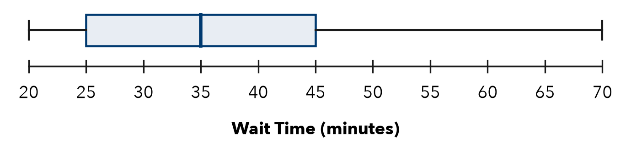
a. Shape:
b. Median: min
c. IQR: min

FIND THE ERROR explain the mistake, then fix it

9. Priya’s Work. Priya saw a set with one huge outlier and chose the mean and MAD, saying “the mean always uses every value.” Explain her mistake.

TEST PRACTICE choose the best answer

10. A long tail to the right means the data is —
A symmetric | B skewed right | C skewed left | D clustered

11. An outlier makes you switch from the mean to the —
A MAD | B range | C total | D median

SELF-CHECK CODE find your answer · copy its letter into that problem’s box · spell a math word
20  D | 19  L | 45  B | 2.8  A | 8  A | 69  N | 14  Q | 65  C | 64  Z | 35  E

#3a | #3b | #4a | #4b | #6 | #7c | #8b | #8c

CHECK YOURSELF | □ I can do this on my own | □ I need a little help | □ I have a question about #

