Name Date Period
Lesson 2-10 · Homework Packet · Level 1 · Sheet 1 of 2
Mean or Median?
Maryland Standard 6.SP.B.5d · Learning target — I can choose the mean or the median to describe a data set based on its shape.

REMEMBER  • Symmetric data with no outliers: the mean and median are close. Use the mean.  • Skewed data or data with an outlier: the mean is pulled toward the tail. Use the median. If the mean and median are far apart, the median is safer. | WORKED EXAMPLE  Eight commutes took 12, 14, 15, 15, 16, 17, 18, and 61 minutes. Which center is better?  Step 1 61 is an outlier, so the data is skewed right.  Step 2 Median: (15 + 16) ÷ 2 = 15.5. Mean: 168 ÷ 8 = 21, greater than 7 of the 8 times.  Answer The median, 15.5 minutes

WORD BANK  outlier — a value far from the others  symmetric — both sides look about the same | skewed — a long tail on one side  median — the middle value in order
PRACTICE show your work · label units

1. Write mean or median for the better measure of center.
Step 1 Look for a value far from the others.
Step 2 No outlier: mean. Outlier: median.
a. 40, 42, 44, 46, 48 | b. 3, 40, 42, 44, 46, 48 | c. 8, 9, 10, 11, 12, 13, 75

2. Shoe Sizes. The dot plot shows the shoe sizes of 9 students. Each dot is one student.  a. Shape:  b. Mean:  c. Median:  d. Better center: | 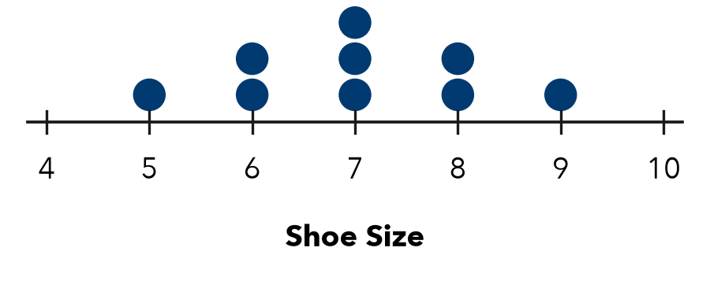

3. Used Bikes. The histogram shows the prices of 20 used bikes.  Step 1 Find where the tall bars are and where the tail is.  Step 2 A long tail pulls the mean toward it.  a. Shape:  b. Greater, mean or median?  c. Better center: | 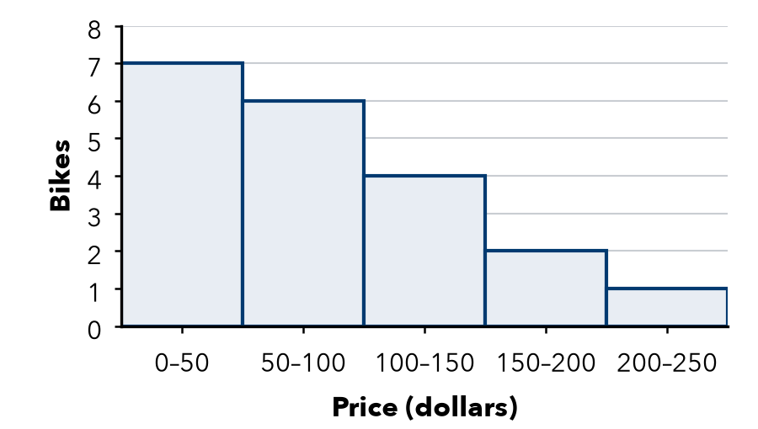

4. Allowances. Six friends get weekly allowances of $5, $6, $8, $8, $10, and $41.
Step 1 Mean: add all six, then divide by 6.
Step 2 Median: average the two middle values.
a. Mean: $ | b. Median: $ | c. Better center:

5. Honest Ads. A shop pays its 5 workers $30,000, $32,000, $34,000, $36,000, and $178,000 a year. Its ad says, “Average pay: $62,000!” Why is this misleading? What center is better?
Frame The ad is misleading because . A better center is .

CHECK YOURSELF | □ I can do this on my own | □ I need a little help | □ I have a question about #
AT HOME Ask someone at home: for house prices, is the mean or the median greater? Why?
Name Date Period
Lesson 2-10 · Homework Packet · Level 1 · Sheet 2 of 2
Matching Center and Spread
Maryland Standard 6.SP.B.5d · Learning target — I can match a measure of center and a measure of spread to the shape of a data set.

REMEMBER  • Symmetric, no outliers: mean and MAD. Skewed or outliers: median and IQR.  • Do not mix the pairs. A summary names the shape, center, and spread. | WORKED EXAMPLE  Seven friends sent 3, 4, 5, 6, 7, 8, and 40 texts. Summarize the data.  Step 1 40 is an outlier: use the median and IQR.  Step 2 Median = 6. Q1 = 4, Q3 = 8, IQR = 4  Answer Median 6 texts, IQR 4 texts

WORD BANK  mean and MAD — the pair for symmetric data  median and IQR — the pair for skewed data or outliers | IQR — Q3 − Q1
PRACTICE show your work · label units

1. Write the pair you would report: mean and MAD, or median and IQR.
Step 1 Look for an outlier.
Step 2 No outlier: mean and MAD. Outlier: median and IQR.
a. 15, 16, 17, 18, 19 | b. 15, 16, 17, 18, 19, 20, 95

2. Books Read. Books read by 8 students in a month.  a. Pair to report:  b. Center: books  c. Spread: books | 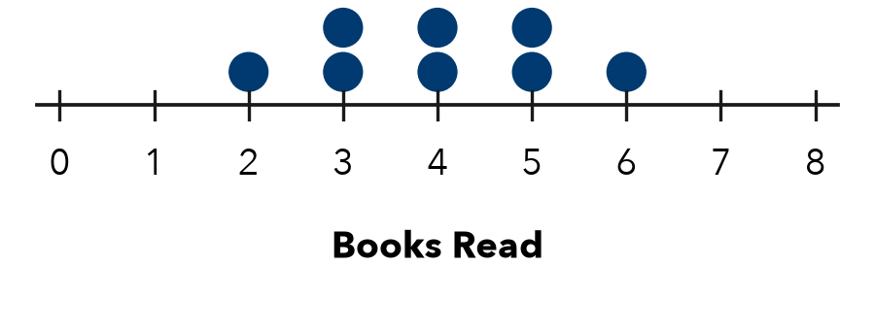

3. Wait Times. The box plot shows deli wait times in minutes. Read the median and the quartiles from the box.  a. Shape:  b. Median: min  c. IQR: min | 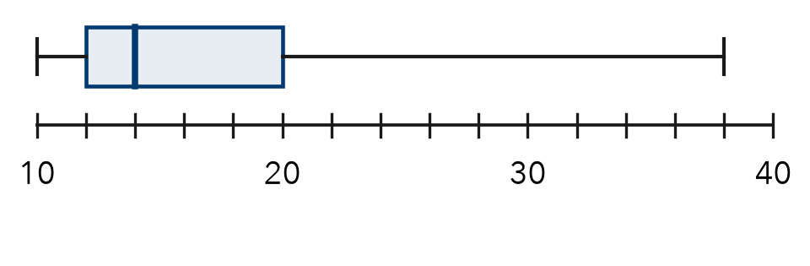

4. Phone Calls. Seven calls lasted 12, 15, 16, 18, 20, 22, and 70 minutes.
Step 1 70 is an outlier, so use the median and IQR.
Step 2 Q1 = middle of the lower 3; Q3 = middle of the upper 3.
a. Pair: | b. Median: min | c. IQR: min

5. Find the Error. Kenji says 2, 20, 21, 22, 23, 24, 25 is not skewed because no value is far above the rest. He reports the mean and MAD. Explain his error.
Frame Kenji is wrong because 2 is . He should report .

TEST PRACTICE choose the best answer

6. Which pair best describes 21, 23, 24, 25, 26, 27, 80?
A mean and MAD | B median and IQR | C mean and IQR | D median and MAD

7. A histogram is tall in the middle, with short, equal bars on both ends. Which pair should you report?
A mean and MAD | B median and IQR | C mean and IQR | D median and MAD

CHECK YOURSELF | □ I can do this on my own | □ I need a little help | □ I have a question about #
AT HOME Ask someone at home: for the prices of all cars on a street, would you report the mean or the median? Why?

