Name Date Period
Lesson 2-2 · Session 2 · Practice · Form A
Describing Histogram Shape
Learning target — I can describe the shape of a histogram using its peak, spread, and balance. · 6.SP.B.4

REMEMBER  • The peak is the interval with the tallest bar. It shows where a typical value falls.  • Symmetric: both sides match. Skewed right/left: the long tail points that way.  • A bar shows how many values are in an interval, not one exact value. | WORKED EXAMPLE  Bars of 9, 5, 2, 1, 1 sit over 0–9, 10–19, 20–29, 30–39, 40–49. Describe the shape.  Step 1 The tallest bar is over 0–9, so 0–9 is the peak.  Step 2 The bars shrink toward the greater values: the tail is on the right.  Answer Skewed right; most values are 0–9
WORDS peak (pico) · symmetric (simétrico) · skewed right (sesgado a la derecha) · skewed left (sesgado a la izquierda)
PRACTICE show your work · label units

1. Tomato Plants. Heights (cm): 14, 22, 18, 26, 17, 21, 12, 20, 24. Find each frequency. Then name the peak and the shape.
Hint Tally first, then find the tallest bar.
a. 10–14: | b. 15–19: | c. 20–24:
d. 25–29: | e. Peak: | f. Shape:

2. Cabbage Weights. The histogram shows the weights of the cabbages in a garden.  a. Peak interval: lb  b. Cabbages in all:  c. Shape: | 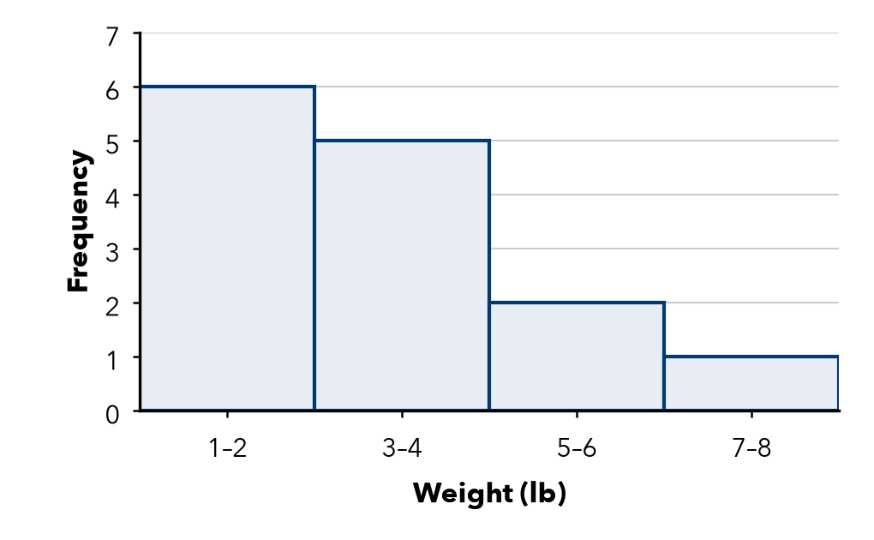

3. Museum Visitors. Each bar counts days. Which interval holds a typical day? Describe the shape.  Hint The tallest bar shows a typical day.  a. Typical day:  b. Shape: | 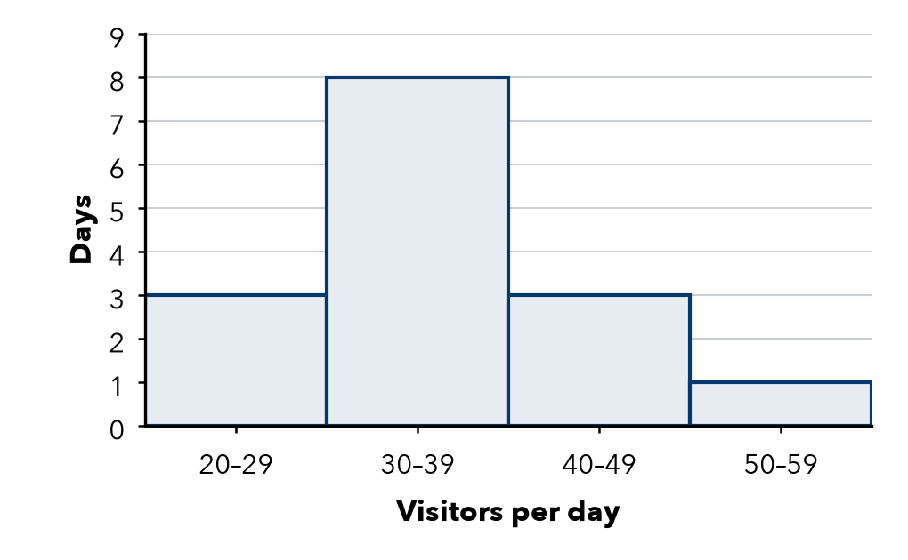

4. Read the Bars. Bars of 2, 7, 3 sit over 60–69, 70–79, 80–89.  Hint Add every bar height for the total. | 5. Name the Shape. Bar heights, left to right:
  a. Peak:
  b. Values in all:
  a. 1, 4, 8, 4, 1
  b. 9, 5, 2, 1, 1
  c. 1, 2, 4, 7

6. Ramona’s Claim. Ramona says this histogram is symmetric. Is she right? Explain.  Hint Match each bar left of the peak with one on the right.  Right? | 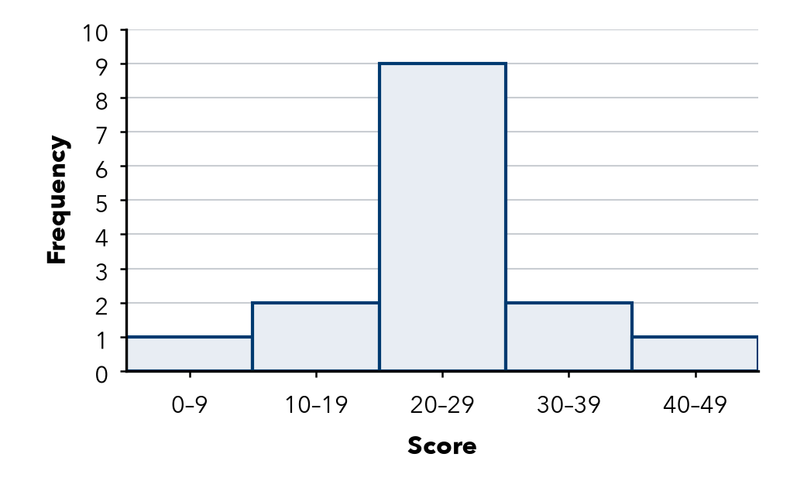

7. Ticket Prices. How many peaks does this histogram have? Explain why it is not symmetric.  Peaks | 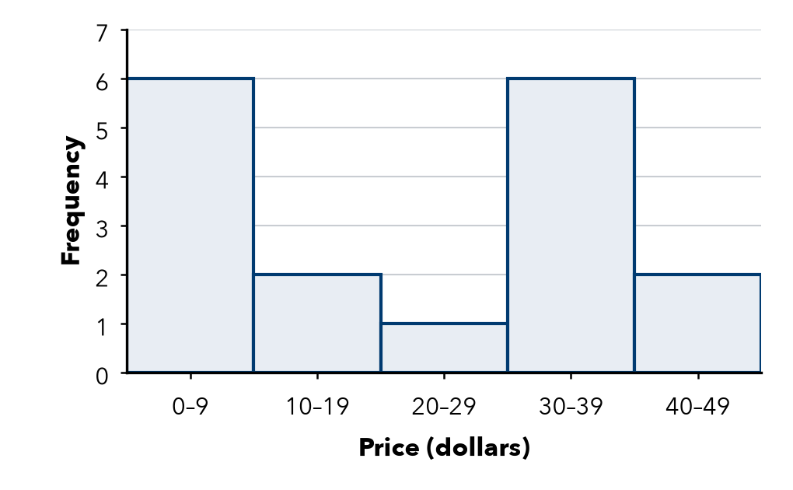

8. Display Choice. Tariq recorded 120 temperatures to the nearest tenth of a degree. Should he use a dot plot or a histogram? Explain.

FIND THE ERROR explain the mistake, then fix it

9. Colette’s Work. A histogram has bars of 2, 9, 2. Colette says, “The tallest bar means one value showed up 9 times.” Explain the mistake.

TEST PRACTICE choose the best answer

10. Bars of height 8, 4, 2, 1 from left to right describe a shape that is —
A symmetric | B skewed left | C skewed right | D flat

11. The peak of a histogram is the interval with the —
A shortest bar | B tallest bar | C widest bar | D last bar

SELF-CHECK CODE find your answer · copy its letter into that problem’s box · spell a math word
20–24  S | 80–89  X | 30–39  E | 70–79  W | 6  Q | 14  K | 7  Z | 12  E | 2  D

#1e | #2b | #3a | #4a | #4b | #7

CHECK YOURSELF | □ I can do this on my own | □ I need a little help | □ I have a question about #

