Name Date Period
Lesson 2-2 · Session 2 · Practice · Form B
Describing Histogram Shape
Learning target — I can describe the shape of a histogram using its peak, spread, and balance. · 6.SP.B.4

REMEMBER  • The peak is the interval with the tallest bar. It shows where a typical value falls.  • Symmetric: both sides match. Skewed right/left: the long tail points that way.  • A bar shows how many values are in an interval, not one exact value. | WORKED EXAMPLE  Bars of 9, 5, 2, 1, 1 sit over 0–9, 10–19, 20–29, 30–39, 40–49. Describe the shape.  Step 1 The tallest bar is over 0–9, so 0–9 is the peak.  Step 2 The bars shrink toward the greater values: the tail is on the right.  Answer Skewed right; most values are 0–9
WORDS peak (pico) · symmetric (simétrico) · skewed right (sesgado a la derecha) · skewed left (sesgado a la izquierda)
PRACTICE show your work · label units

1. Pepper Plants. Heights (cm): 13, 27, 18, 24, 26, 11, 22, 28, 17, 25. Find each frequency. Then name the peak and the shape.
Hint Tally first, then find the tallest bar.
a. 10–14: | b. 15–19: | c. 20–24:
d. 25–29: | e. Peak: | f. Shape:

2. Melon Weights. The histogram shows the weights of the melons in a garden.  a. Peak interval: lb  b. Melons in all:  c. Shape: | 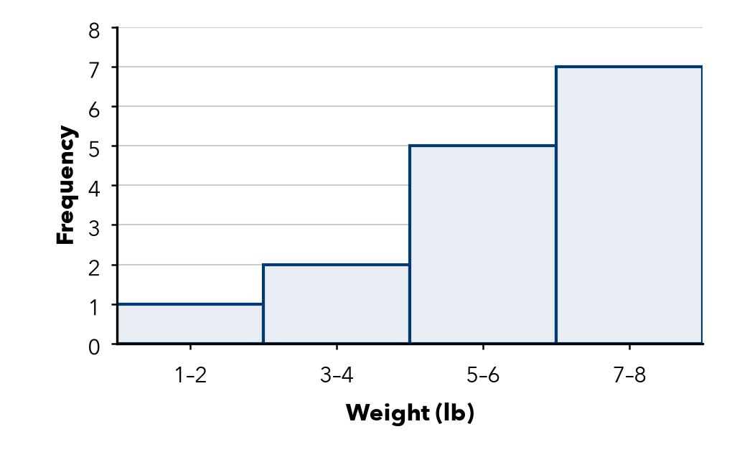

3. Library Visitors. Each bar counts days. Which interval holds a typical day? Describe the shape.  Hint The tallest bar shows a typical day.  a. Typical day:  b. Shape: | 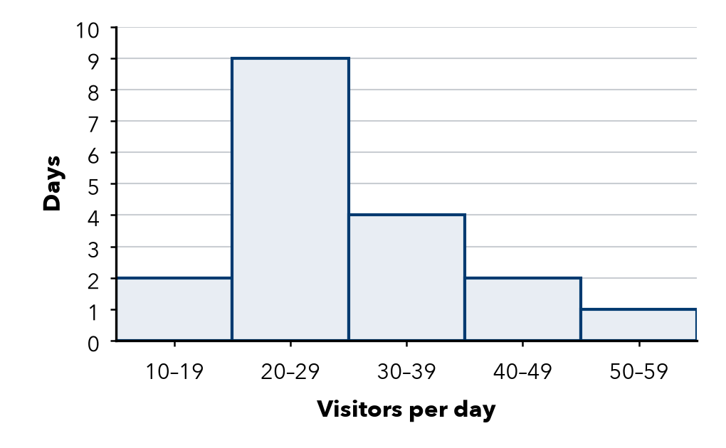

4. Read the Bars. Bars of 4, 8, 5 sit over 50–59, 60–69, 70–79.  Hint Add every bar height for the total. | 5. Name the Shape. Bar heights, left to right:
  a. Peak:
  b. Values in all:
  a. 2, 5, 9, 5, 2
  b. 1, 1, 3, 6, 10
  c. 8, 6, 3, 1

6. Desmond’s Claim. Desmond says this histogram is symmetric. Is he right? Explain.  Hint Match each bar left of the peak with one on the right.  Right? | 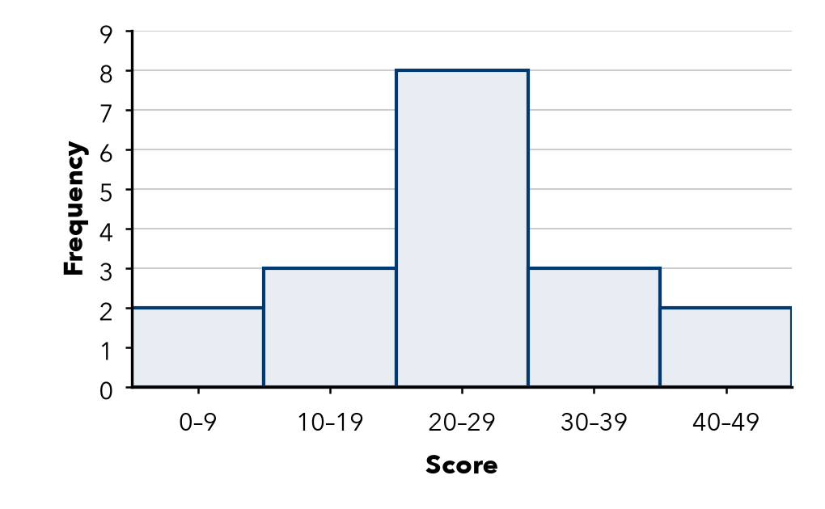

7. Ticket Prices. How many peaks does this histogram have? Explain why it is not symmetric.  Peaks | 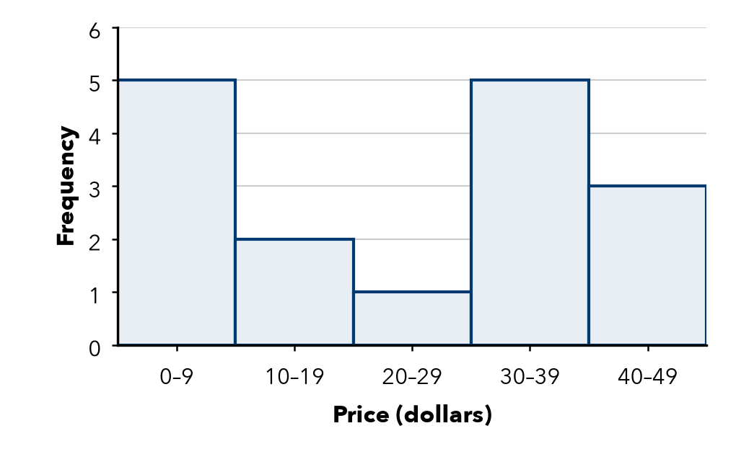

8. Display Choice. Amaya measured 150 seedlings to the nearest tenth of a centimeter. Should she use a dot plot or a histogram? Explain.

FIND THE ERROR explain the mistake, then fix it

9. Deshawn’s Work. A histogram has bars of 3, 7, 4. Deshawn says, “The tallest bar means one value showed up 7 times.” Explain the mistake.

TEST PRACTICE choose the best answer

10. A histogram with matching left and right sides is —
A skewed left | B skewed right | C symmetric | D a gap

11. Bars of height 2, 3, 5, 9 from left to right describe a shape that is —
A skewed left | B skewed right | C symmetric | D two-peaked

SELF-CHECK CODE find your answer · copy its letter into that problem’s box · spell a math word
30–39  X | 7  Q | 2  S | 25–29  S | 20–29  A | 15  H | 9  Z | 60–69  P | 17  E

#1e | #2b | #3a | #4a | #4b | #7

CHECK YOURSELF | □ I can do this on my own | □ I need a little help | □ I have a question about #

