Name Date Period
Lesson 2-2 · Homework Packet · Level 1 · Sheet 1 of 2
Building a Histogram
Maryland Standard 6.SP.B.4 · Learning target — I can group data into equal intervals and build a histogram from a frequency table.

REMEMBER  • A histogram groups data into equal intervals, like 0–9, 10–19, 20–29.  • The frequency is how many values fall in an interval. It sets the bar height.  • Intervals do not overlap, and the bars touch. | WORKED EXAMPLE  Minutes of practice: 4, 15, 22, 9, 18, 27, 13, 16, 21, 11. Make a frequency table.  Step 1 0–9: 4, 9, so the frequency is 2.  Step 2 10–19: 15, 18, 13, 16, 11, so it is 5.  Step 3 20–29: 22, 27, 21, so it is 3.  Answer 2, 5, 3

WORD BANK  interval — a group of numbers, like 10–19  frequency — how many numbers are in a group | histogram — a graph with bars that touch  overlap — share the same number
PRACTICE show your work · label units

1. Points Scored. A player scored these points in 12 games: 8, 14, 21, 5, 17, 12, 25, 19, 11, 23, 16, 9. Complete the frequency table.
Step 1 Find the numbers from 0 to 9. Count them.
Step 2 Do the same for 10–19 and 20–29.
Step 3 Check: the counts add up to 12.
Points | Tally | Frequency
0–9
10–19
20–29

2. Draw the histogram for Problem 1. Bars should touch.  Step 1 Use the counts from Problem 1 for the bar heights.  Step 2 Draw the bars so they touch.  a. Which interval has the tallest bar?  b. Games with 10 or more points: | 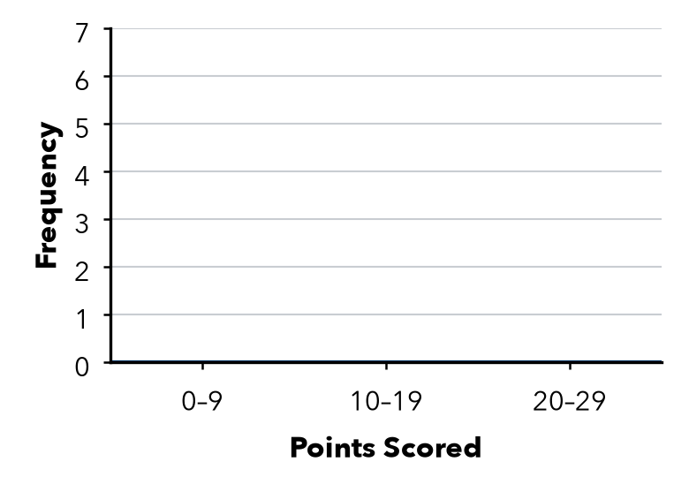

3. Picnic Ages. 34, 22, 41, 38, 27, 45, 31, 36, 29, 48 years. Find each frequency.
a. 20–29: | b. 30–39: | c. 40–49:

4. Missing Bar. A histogram shows 24 students. Three bars are 5, 9 and 3 tall. There is one more bar. How tall is it?
Step 1 Add the three bars you know.
Step 2 Subtract that sum from 24.
Answer students

5. Find the Error. Marcus used the intervals 0–9, 10–14, and 15–29. Explain his mistake and fix it.
Frame Marcus’s intervals are not . Better intervals are , and .

CHECK YOURSELF | □ I can do this on my own | □ I need a little help | □ I have a question about #
AT HOME Ask family members how many minutes they read today. Group the answers in intervals of 10.
Name Date Period
Lesson 2-2 · Homework Packet · Level 1 · Sheet 2 of 2
Describing Histogram Shape
Maryland Standard 6.SP.B.4 · Learning target — I can describe the shape of a histogram using its peak, spread, and balance.

REMEMBER  • Peak: the tallest bar. Symmetric: sides match.  • Skewed right: the tail stretches right. Skewed left: the tail stretches left.  • A histogram shows counts, not exact values. | WORKED EXAMPLE  Bars of height 2, 7, 4, 2, 1 over 0–9, 10–19, 20–29, 30–39, 40–49. Shape?  Step 1 The peak is 10–19, near the left.  Step 2 The bars shrink to the right: a tail on the right.  Answer Skewed right

WORD BANK  peak — the tallest bar  symmetric — both sides match | skewed right — long tail on the right  skewed left — long tail on the left
PRACTICE show your work · label units

1. Test Scores. The histogram shows the scores on a class test.  Step 1 Add all the bar heights for a.  Step 2 The tallest bar is the peak.  Step 3 Look for the long tail to name the shape.  a. Number of students:  b. Peak interval:  c. Shape:  d. Scores of 80 or more: | 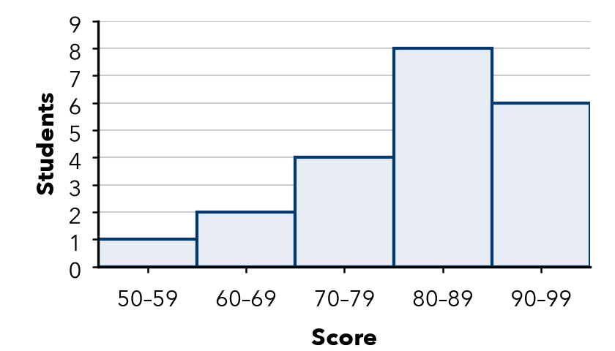

2. Bar heights are listed from left to right. Name each shape.
Step 1 Find the biggest number in each list.
Step 2 Look at which side has the small numbers: that is the tail.
a. 1, 4, 8, 4, 1 | b. 9, 6, 3, 2, 1 | c. 1, 2, 3, 6, 10
d. 3, 5, 9, 5, 3 | e. 12, 8, 5, 3, 2 | f. 2, 3, 5, 8, 12

3. Race Times. 30 runners. Bars of 3, 8, 11, 6, 2 show times of 20–24, 25–29, 30–34, 35–39, 40–44 minutes.
a. How many runners finished in less than 30 minutes?
b. How many finished in 35 minutes or more?

4. Stretch. Write 5 bar heights, from left to right, for a histogram of 20 values that is skewed left.
Bar heights

5. Explain. Ramon says the Test Scores histogram shows a score of 85. Is he right? Explain.
Frame Ramon is because a histogram only shows .

TEST PRACTICE choose the best answer

6. Bar heights are listed from left to right. Which histogram is skewed right?
A 2, 5, 9, 5, 2 | B 10, 7, 4, 2, 1 | C 1, 2, 4, 7, 10 | D 5, 5, 5, 5, 5

7. Bars of height 4, 7, and 5 sit over 0–9, 10–19, and 20–29. How many values are 10 or more?
A 7 | B 11 | C 12 | D 16

CHECK YOURSELF | □ I can do this on my own | □ I need a little help | □ I have a question about #

