Name Date Period
Lesson 2-2 · Session 1 · Prerequisite Practice A · Skill 1 of 2
Add a Column of Numbers
Builds on Grade 4 · 4.NBT.B.4
TODAY’S LESSON | You will check that bars add to the total. In problem 4, bars of 2 and 4 and one more bar make 9.
YOU NEED TO | Add three to five numbers quickly and correctly. You will use it in Practice Form A, problems 2 and 4.
STEPS TO FOLLOW use these same steps on every problem
1 | Look for pairs that make 10.
2 | Add the pairs first.
3 | Add the rest of the numbers.
WATCH ME the steps in action
Add 7 + 5 + 3 + 5 + 2.
Step 1 Pairs: 7 + 3 = 10 and 5 + 5 = 10.
Step 2 10 + 10 = 20.
Step 3 20 + 2 = 22.
Answer 22
TRY IT WITH HELP fill in each step
1. Add 6 + 3 + 4.
Step 1 Pair: 6 + = 10.
Step 2 The pair makes .
Step 3 10 + = .

2. Add 8 + 5 + 2 + 5 + 1.
Step 1 Pairs: 8 + and 5 + .
Step 2 10 + 10 = .
Step 3 20 + = .

YOUR TURN use the steps on your own

3. Add. Look for pairs that make 10.
a. 9 + 4 + 1 = | b. 7 + 6 + 3 = | c. 4 + 8 + 6 + 2 =
d. 5 + 9 + 5 + 1 = | e. 2 + 7 + 3 + 8 + 4 = | f. 3 + 6 + 7 + 8 =

Lesson 2-2 · Session 1 · Prerequisite Practice A · Skill 2 of 2
Read a Graph Scale
Builds on Grade 3 · 3.MD.B.3
TODAY’S LESSON | You will draw histogram bars, like 2, 4, and 3, to the right height.
YOU NEED TO | Read how tall a bar is from the scale. You will use it in Practice Form A, problems 1 and 8.
STEPS TO FOLLOW use these same steps on every problem
1 | Find what each line on the scale counts by.
2 | Find the label at or just below the bar top.
3 | Count on from that label to the bar top.
WATCH ME the steps in action
The scale counts by 2. How tall is the 10–19 bar?  Step 1 Each line counts by 2.  Step 2 The label just below the top is 6.  Step 3 The top is halfway to 8. 6 + 1 = 7.  Answer 7 | 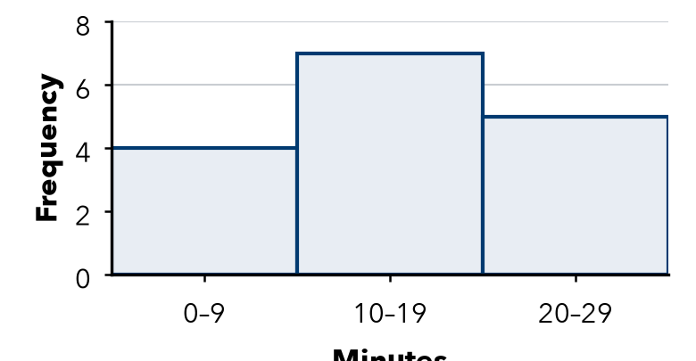

TRY IT WITH HELP fill in each step
4. A scale counts by 2. A bar ends halfway between 4 and 6. How tall is it?
Step 1 Each line counts by .
Step 2 The label just below the top is .
Step 3 Halfway: 4 + 1 = .

5. A scale counts by 10. A bar ends halfway between 20 and 30. How tall is it?
Step 1 Each line counts by .
Step 2 The label just below the top is .
Step 3 Halfway: 20 + 5 = .

YOUR TURN use the steps on your own

6. Find the value halfway between the two labels.
a. 2 and 4: | b. 10 and 20: | c. 0 and 10:
d. 8 and 10: | e. 30 and 40: | f. 60 and 80:

READY CHECK a problem like the one in today’s lesson

7. A scale counts by 2. A bar ends halfway between 6 and 8. How tall is the bar?
A 6 | B 7 | C 8 | D 14

CHECK YOURSELF | □ I can do this on my own | □ I need a little help | □ I have a question about #

