EXIT TICKET · LESSON 2-3 · SESSION 1 Name
Finding the Median

1. Find each median.
a. 9, 3, 6 | b. 20, 14, 18, 11, 16

2. The dot plot shows goals scored. Find the median.
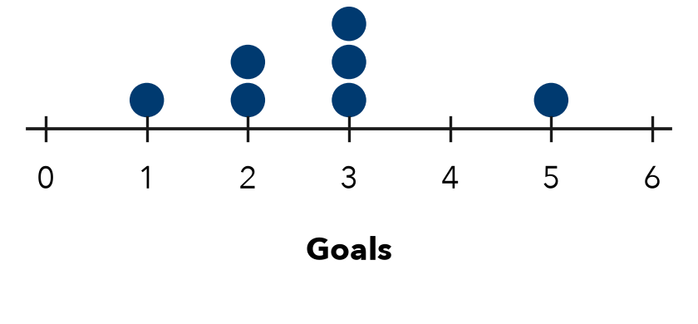
Median

3. Before you find a median, you must always —
A add the values | B order the values
C find the largest value | D divide by 2

HOW DID IT GO? □ I got it □ Almost □ I need help
cut here
EXIT TICKET · LESSON 2-3 · SESSION 1 Name
Finding the Median

1. Find each median.
a. 9, 3, 6 | b. 20, 14, 18, 11, 16

2. The dot plot shows goals scored. Find the median.
Median

3. Before you find a median, you must always —
A add the values | B order the values
C find the largest value | D divide by 2

HOW DID IT GO? □ I got it □ Almost □ I need help
EXIT TICKET · LESSON 2-3 · SESSION 2 Name
Median of an Even Data Set

1. Find each median.
a. 10, 4, 8, 14 | b. 6, 3, 9, 1, 7, 5

2. The dot plot shows pets owned. Find the median.
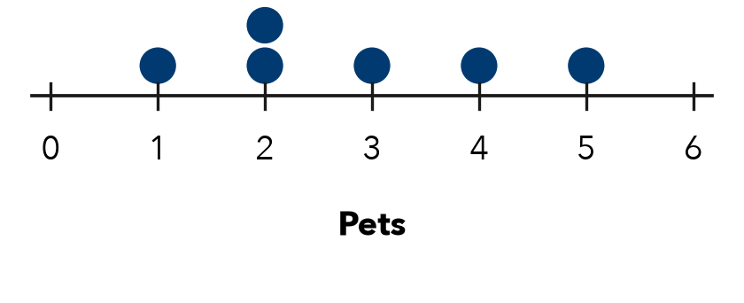
Median

3. Six values have a median of 30. Which could be the two middle values?
A 28 and 32 | B 30 and 34 | C 25 and 30 | D 15 and 15

HOW DID IT GO? □ I got it □ Almost □ I need help
cut here
EXIT TICKET · LESSON 2-3 · SESSION 2 Name
Median of an Even Data Set

1. Find each median.
a. 10, 4, 8, 14 | b. 6, 3, 9, 1, 7, 5

2. The dot plot shows pets owned. Find the median.
Median

3. Six values have a median of 30. Which could be the two middle values?
A 28 and 32 | B 30 and 34 | C 25 and 30 | D 15 and 15

HOW DID IT GO? □ I got it □ Almost □ I need help

