Name Date Period
Lesson 2-4 · Session 1 · Practice · Form A
Building a Box Plot
Learning target — I can find the five-number summary of a data set and use it to build a box plot. · 6.SP.B.4

REMEMBER  • Five-number summary: min, Q1, median, Q3, max. Order the data first.  • Q1 = median of the lower half; Q3 = median of the upper half. Odd count: leave the median out.  • The box runs from Q1 to Q3 (the middle half). Each section holds about 1/4 of the data. | WORKED EXAMPLE  Times (min): 14, 5, 20, 9, 23, 11, 16.  Step 1 Order: 5, 9, 11, 14, 16, 20, 23. Median = 14.  Step 2 Lower half 5, 9, 11: Q1 = 9. Upper half 16, 20, 23: Q3 = 20.  Step 3 Box from 9 to 20, line at 14, whiskers to 5 and 23.  Answer 5, 9, 14, 20, 23
WORDS box plot (diagrama de caja) · quartile (cuartil) · five-number summary (resumen de cinco números)
PRACTICE show your work · label units

1. Pumpkins. Seven pumpkins weigh 12, 26, 18, 30, 15, 24, 21 pounds. Find the five-number summary. Then draw the box plot.
Hint Leave the median out of both halves.
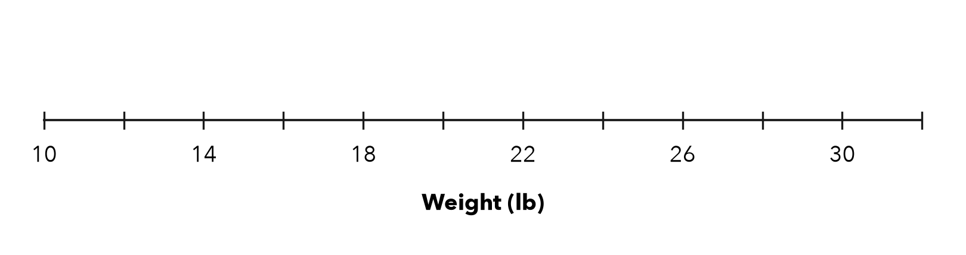
a. Min: | b. Q1: | c. Median: | d. Q3: | e. Max:

2. Bird Counts. Seven mornings brought 9, 17, 13, 25, 11, 20, 15 birds. Find the five-number summary and the box width (Q3 − Q1).
a. Min: | b. Q1: | c. Median: | d. Q3: | e. Max: | f. Width:

3. Kai’s Claim. A box plot shows 20, 27, 31, 35, 46 (min, Q1, median, Q3, max). Kai says half the data is between 20 and 27. Is Kai right?  Hint Each section of a box plot holds the same share.  Fraction | 4. Ticket Prices. A box plot shows 16, 23, 28, 34, 50 (min, Q1, median, Q3, max).  Hint The box holds the middle half.
  □ Yes | □ No
  a. Box width:
  b. Share of prices in the box:

5. Guitar Practice. Seven sessions lasted 25, 40, 18, 47, 33, 29, 52 minutes. Find the five-number summary.
a. Min: | b. Q1: | c. Median: | d. Q3: | e. Max:

6. Build the Box. A data set has min 12, Q1 18, median 24, Q3 31 and max 40. Draw the box plot.
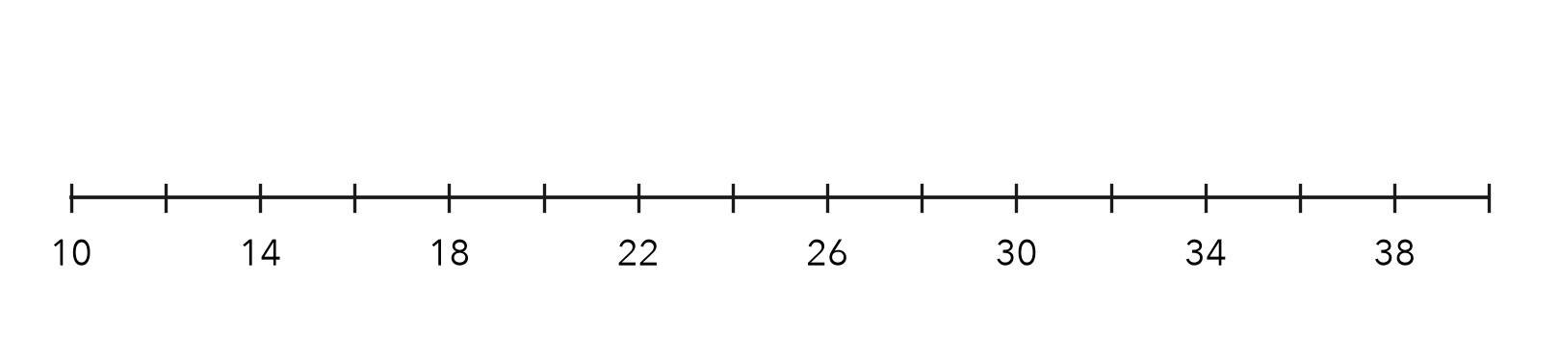
a. Left edge of the box:
b. End of the right whisker:

7. Eight Scores. 44, 52, 61, 48, 57, 65, 50, 59. Find the five-number summary.
Hint Eight values: split into two halves of four.
a. Min: | b. Q1: | c. Median: | d. Q3: | e. Max:

8. Field Trip Costs. Nine costs (dollars) are 18, 25, 12, 30, 22, 27, 15, 33, 20.
a. Find the five-number summary.
b. Where does the middle half of the costs fall?
c. What does the length of the box tell a reader?

Show your work.

FIND THE ERROR explain the mistake, then fix it

9. Yusuf’s Work. For 5, 9, 12, 16, 20, 24, 30, Yusuf marked Q1 at 12 and Q3 at 20. Explain the mistake and find the correct quartiles.

TEST PRACTICE choose the best answer

10. The box in a box plot stretches from —
A min to max | B Q1 to Q3 | C min to median | D median to max

11. For 4, 8, 12, 16, 20, Q1 is —
A 4 | B 8 | C 6 | D 12

SELF-CHECK CODE find your answer · copy its letter into that problem’s box · spell a math word
33  T | 40  L | 52  X | 18  I | 3/4  Z | 11  R | 9  U | 54.5  E | 21  Q | 1/4  A

#1c | #2f | #3 | #4a | #5c | #6a | #6b | #7c

CHECK YOURSELF | □ I can do this on my own | □ I need a little help | □ I have a question about #

