Name Date Period
Lesson 2-4 · Session 1 · Practice · Form B
Building a Box Plot
Learning target — I can find the five-number summary of a data set and use it to build a box plot. · 6.SP.B.4

REMEMBER  • Five-number summary: min, Q1, median, Q3, max. Order the data first.  • Q1 = median of the lower half; Q3 = median of the upper half. Odd count: leave the median out.  • The box runs from Q1 to Q3 (the middle half). Each section holds about 1/4 of the data. | WORKED EXAMPLE  Times (min): 14, 5, 20, 9, 23, 11, 16.  Step 1 Order: 5, 9, 11, 14, 16, 20, 23. Median = 14.  Step 2 Lower half 5, 9, 11: Q1 = 9. Upper half 16, 20, 23: Q3 = 20.  Step 3 Box from 9 to 20, line at 14, whiskers to 5 and 23.  Answer 5, 9, 14, 20, 23
WORDS box plot (diagrama de caja) · quartile (cuartil) · five-number summary (resumen de cinco números)
PRACTICE show your work · label units

1. Pumpkins. Seven pumpkins weigh 12, 27, 16, 30, 19, 23, 14 pounds. Find the five-number summary. Then draw the box plot.
Hint Leave the median out of both halves.
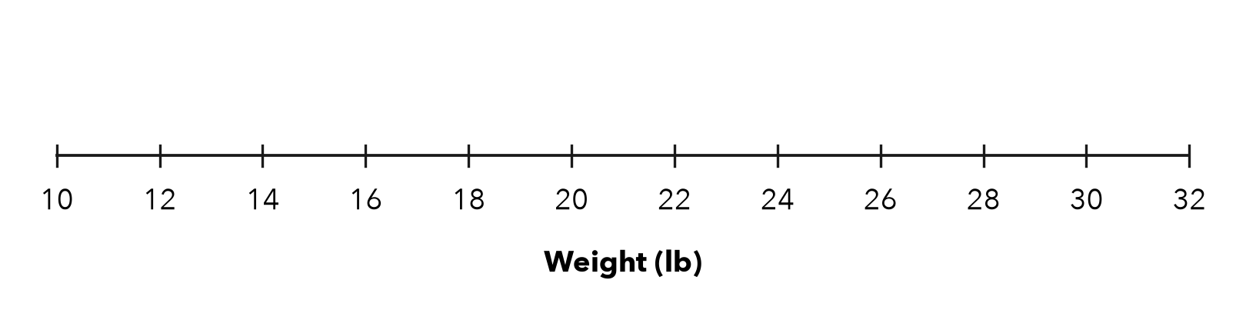
a. Min: | b. Q1: | c. Median: | d. Q3: | e. Max:

2. Bird Counts. Seven mornings brought 8, 19, 12, 24, 10, 21, 16 birds. Find the five-number summary and the box width (Q3 − Q1).
a. Min: | b. Q1: | c. Median: | d. Q3: | e. Max: | f. Width:

3. Lena’s Claim. A box plot shows 15, 22, 26, 31, 44 (min, Q1, median, Q3, max). Lena says half the data is between 31 and 44. Is Lena right?  Hint Each section of a box plot holds the same share.  Fraction | 4. Ticket Prices. A box plot shows 12, 20, 26, 35, 48 (min, Q1, median, Q3, max).  Hint The box holds the middle half.
  □ Yes | □ No
  a. Box width:
  b. Share of prices in the box:

5. Piano Practice. Seven sessions lasted 22, 36, 15, 44, 30, 27, 49 minutes. Find the five-number summary.
a. Min: | b. Q1: | c. Median: | d. Q3: | e. Max:

6. Build the Box. A data set has min 10, Q1 16, median 23, Q3 29 and max 38. Draw the box plot.
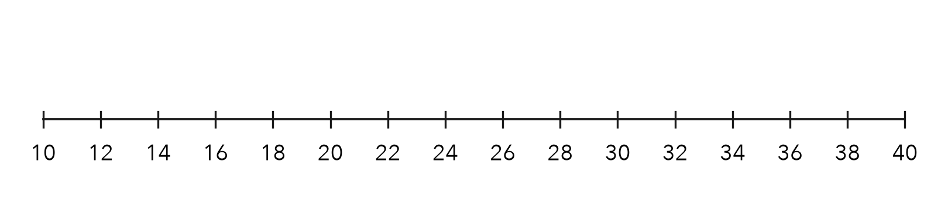
a. Right edge of the box:
b. End of the left whisker:

7. Eight Scores. 42, 55, 60, 46, 53, 67, 49, 58. Find the five-number summary.
Hint Eight values: split into two halves of four.
a. Min: | b. Q1: | c. Median: | d. Q3: | e. Max:

8. Field Trip Costs. Nine costs (dollars) are 16, 27, 14, 32, 21, 29, 11, 35, 24.
a. Find the five-number summary.
b. Where does the middle half of the costs fall?
c. What does the length of the box tell a reader?

Show your work.

FIND THE ERROR explain the mistake, then fix it

9. Marisol’s Work. For 4, 7, 11, 15, 18, 23, 28, Marisol marked Q1 at 11 and Q3 at 18. Explain the mistake and find the correct quartiles.

TEST PRACTICE choose the best answer

10. Q1 is the median of the —
A whole data set | B lower half | C upper half | D box

11. For 6, 9, 13, 18, 22, 25, 31, Q3 is —
A 18 | B 22 | C 25 | D 31

SELF-CHECK CODE find your answer · copy its letter into that problem’s box · spell a math word
19  B | 30  L | 3/4  Q | 54  S | 1/4  X | 10  T | 29  O | 53  Z | 15  P | 11  O

#1c | #2f | #3 | #4a | #5c | #6a | #6b | #7c

CHECK YOURSELF | □ I can do this on my own | □ I need a little help | □ I have a question about #

