Name Date Period
Lesson 2-4 · Session 1 · Guided Notes
Building a Box Plot
Learning target — I can find the five-number summary of a data set and use it to build a box plot. · 6.SP.B.4
WORDS TO KNOW fill in the missing words
WORD | WHAT IT MEANS | EXAMPLE
five-number summary  resumen de cinco números | Min, Q1, , Q3 and max. | 5, 9, 14, 20, 23
quartile  cuartil | Q1 is the median of the half; Q3 is the median of the upper half. | lower half 5, 9, 11: Q1 = 9
box plot  diagrama de caja | A graph of the five-number summary: a box from Q1 to Q3 and two . | box 9 to 20, line at 14
KEY IDEA complete each sentence
• With an odd number of values, leave the out of both halves.
• Each of the four sections of a box plot holds about one of the data.
WORKED EXAMPLE fill in the blanks as we solve
Times (min): 14, 5, 20, 9, 23, 11, 16. Find the five-number summary.
Step 1 Order: 5, 9, 11, 14, 16, 20, 23. Median = .
Step 2 Lower half 5, 9, 11: Q1 = . Upper half 16, 20, 23: Q3 = .
Answer 5, 9, 14, 20,
YOU TRY use the example as a model

1. Data: 3, 8, 5, 12, 10, 7, 15. Find each value.
a. Q1: | b. Median: | c. Q3:

2. Read the box plot.
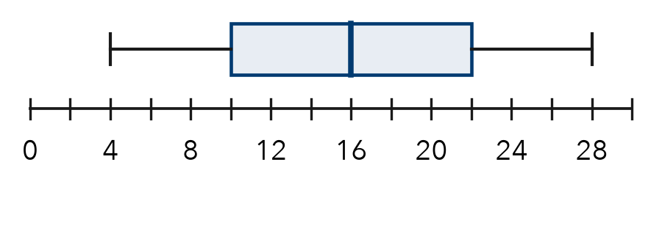
Q1; median; Q3

SUM IT UP in your own words
To build a box plot, I first , then .
Name Date Period
Lesson 2-4 · Session 2 · Guided Notes
Comparing Box Plots
Learning target — I can compare two groups by reading the medians and box widths of their box plots. · 6.SP.B.4
WORDS TO KNOW fill in the missing words
WORD | WHAT IT MEANS | EXAMPLE
center  centro | A typical value; on a box plot, the line. | median 20 min
box width  ancho de la caja | Q3 Q1; the spread of the middle half. | 22 − 18 = 4
consistent  constante | Values are together; the box is narrow. | box 18 to 22
KEY IDEA complete each sentence
• Compare to see which group has the higher typical value.
• Compare box widths: the box is more spread out.
WORKED EXAMPLE fill in the blanks as we solve
Trail X: Q1 18, median 20, Q3 22. Trail Y: Q1 19, median 26, Q3 33 (minutes).
Step 1 Medians: 26 − 20 = , so Y is higher by 6 min.
Step 2 Box widths: X is , Y is .
Answer Trail is more consistent.
YOU TRY use the example as a model

1. Which plot has the higher median? Which is more spread out?  Median; spread | 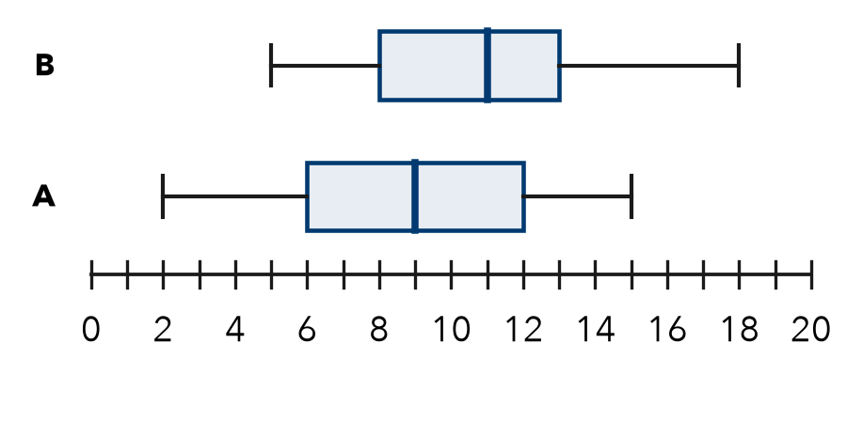

2. Find each box width.
a. Q1 = 12, Q3 = 30: | b. Q1 = 41, Q3 = 47:

SUM IT UP in your own words
To compare two box plots, I look at and .

