Name Date Period
Lesson 2-4 · Session 2 · Prerequisite Practice A · Skill 1 of 2
Find How Much Greater
Builds on Grade 4 · 4.NBT.B.4
TODAY’S LESSON | In problem 6, Group B’s median is 57 and Group A’s is 53. You find by how much.
YOU NEED TO | Subtract to find how much greater one value is. You will use it in Practice Form A, problems 1 and 6.
STEPS TO FOLLOW use these same steps on every problem
1 | Find the two values to compare.
2 | Subtract: greater minus smaller.
3 | Say which is greater, and by how much.
WATCH ME the steps in action
Team A’s median is 47. Team B’s median is 39. How much greater is Team A’s?
Step 1 Compare 47 and 39.
Step 2 47 − 39 = 8.
Step 3 Team A’s median is greater by 8.
Answer 8 points greater
TRY IT WITH HELP fill in each step
1. Median X is 57. Median Y is 53. How much greater is X?
Step 1 Compare and .
Step 2 57 − 53 = .
Step 3 X is greater by .

2. Median P is 125. Median Q is 98. How much greater is P?
Step 1 Compare and .
Step 2 125 − 98 = .
Step 3 P is greater by .

YOUR TURN use the steps on your own

3. How much greater is the first number?
a. 53 and 38: | b. 70 and 46: | c. 64 and 59:
d. 210 and 175: | e. 88 and 49: | f. 150 and 112:

Lesson 2-4 · Session 2 · Prerequisite Practice A · Skill 2 of 2
Read a Scaled Number Line
Builds on Grade 4 · 4.MD.A.2
TODAY’S LESSON | In problem 6, the box plot scale has a tick every 2 points from 36 to 72.
YOU NEED TO | Find what one jump is worth, then read a point. You will use it in Practice Form A, problems 1, 6, and 8.
STEPS TO FOLLOW use these same steps on every problem
1 | Subtract two labels that are next to each other.
2 | Count the jumps between them. Divide.
3 | Count on from a label to the point.
WATCH ME the steps in action
What is point A?  Step 1 60 − 50 = 10.  Step 2 5 jumps. 10 ÷ 5 = 2. One jump is 2.  Step 3 Count on from 50: 52, 54, 56.  Answer A = 56 | 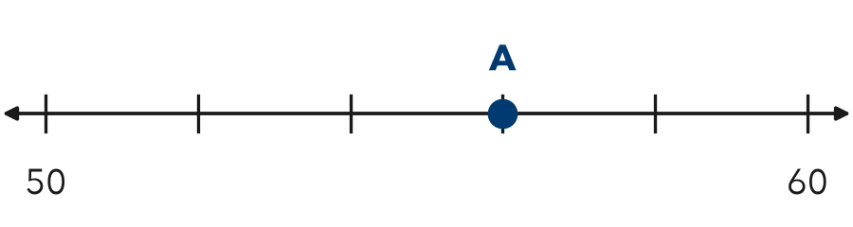

TRY IT WITH HELP fill in each step
4. Labels 20 and 30 have 5 jumps. What is 2 ticks past 20?
Step 1 30 − 20 = .
Step 2 10 ÷ 5 = .
Step 3 Count on from 20: 22, .

5. Labels 0 and 20 have 4 jumps. What is 3 ticks past 0?
Step 1 20 − 0 = .
Step 2 20 ÷ 4 = .
Step 3 Count on from 0: 5, 10, .

YOUR TURN use the steps on your own

6. Labels and jumps are given. Find the value.
a. 0 and 10, 5 jumps. 3 ticks past 0: | b. 40 and 60, 4 jumps. 1 tick past 40:
c. 100 and 150, 5 jumps. 2 ticks past 100: | d. 30 and 36, 3 jumps. 2 ticks past 30:

READY CHECK a problem like the one in today’s lesson

7. Labels 20 and 30 have 5 equal jumps between them. What value is 2 ticks right of 20?
A 22 | B 24 | C 25 | D 40

CHECK YOURSELF | □ I can do this on my own | □ I need a little help | □ I have a question about #

