Name Date Period
Lesson 2-5 · Homework Packet · Level 1 · Sheet 1 of 2
Range and IQR
Maryland Standard 6.SP.B.5c · Learning target — I can find the range and the interquartile range of a data set.

REMEMBER  • Range = maximum − minimum. It is the spread of all the data.  • IQR (interquartile range) = Q3 − Q1. It is the spread of the middle half.  • One extreme value changes the range a lot but the IQR very little. | WORKED EXAMPLE  Find the range and IQR of 3, 7, 8, 10, 12, 15, 20.  Step 1 Range: 20 − 3 = 17  Step 2 Median 10. Q1 = 7 (of 3, 7, 8). Q3 = 15 (of 12, 15, 20).  Step 3 IQR: 15 − 7 = 8  Answer Range 17, IQR 8

WORD BANK  range — biggest number − smallest number  IQR — Q3 − Q1 | Q1, Q3 — the middles of the lower and upper halves  minimum — the smallest value
PRACTICE show your work · label units

1. Find each measure.
a. Range of 14, 6, 21, 9: | b. Range of 52, 38, 47, 60:
c. IQR when Q1 = 18, Q3 = 31: | d. IQR when Q1 = 40, Q3 = 56:
e. Range of 75, 90, 68, 83: | f. IQR when Q1 = 7, Q3 = 25:

2. Pages Read. The box plot shows pages read by students in one week.  Step 1 Read the ends of the whiskers: max − min = range.  Step 2 Read the box edges: Q3 − Q1 = IQR.  a. Range: pages  b. IQR: pages | 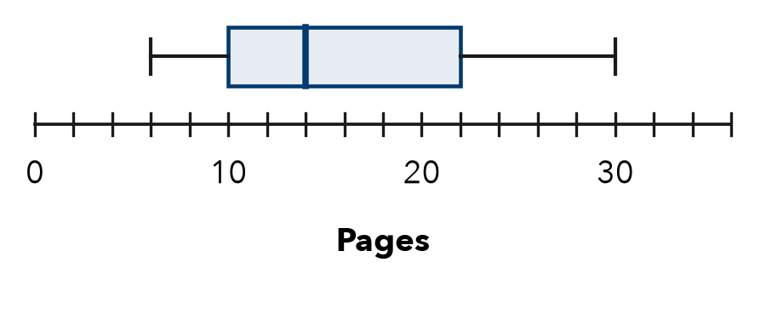

3. Jump Rope. Seven students jumped rope 35, 52, 41, 60, 28, 47, and 55 times. Find the range and the IQR.
Step 1 Put the 7 numbers in order.
Step 2 Range = last − first.
Step 3 Find Q1 and Q3, then subtract.
a. Range:
b. IQR:

Show your work.

4. Work Backward. A data set has a minimum of 14 and a range of 29. Its Q1 is 20 and its IQR is 11.
Step 1 Maximum = minimum + range.
Step 2 Q3 = Q1 + IQR.
a. Maximum:
b. Q3:

5. Find the Error. Mateo says the IQR is always half of the range. Use the Jump Rope data to explain why he is wrong.
Frame Half of the range is , but the IQR is , so Mateo is .

CHECK YOURSELF | □ I can do this on my own | □ I need a little help | □ I have a question about #
AT HOME Ask family members their ages. Find the range of the ages.
Name Date Period
Lesson 2-5 · Homework Packet · Level 1 · Sheet 2 of 2
Comparing Variability
Maryland Standard 6.SP.B.5c · Learning target — I can compare the variability of two data sets using range and IQR.

REMEMBER  • More range or IQR = more variability.  • Less variability = more consistent. Compare range with range, IQR with IQR.  • With an extreme value, use the IQR. | WORKED EXAMPLE  Team P: IQR 6 points. Team Q: IQR 15 points. Which is more consistent?  Step 1 6 < 15, so Team P’s middle half is closer.  Answer Team P

WORD BANK  consistent — close together  variability — how spread out the data are | range — max − min  IQR — Q3 − Q1
PRACTICE show your work · label units

1. Find each IQR.
a. Set P: Q1 = 30, Q3 = 42 | b. Set Q: Q1 = 33, Q3 = 39

2. Basketball. Points per game: Player 1: 8, 10, 11, 12, 13, 14, 16. Player 2: 2, 6, 9, 12, 15, 18, 22.
Step 1 Range = greatest − least for each player.
Step 2 IQR = Q3 − Q1 for each player.
Step 3 Smaller numbers mean more consistent.
 | Range | IQR
Player 1
Player 2
More consistent player

3. Spelling Scores. Group A scored 70, 72, 75, 78, 80. Group B scored 55, 65, 75, 85, 95.
Ranges: A B More consistent group:

4. Bus Routes. The box plots show ride times in minutes.  Step 1 Read the whisker ends for each range.  Step 2 Read the box edges for each IQR.  a. Ranges: 1 2  b. IQRs: 1 2 | 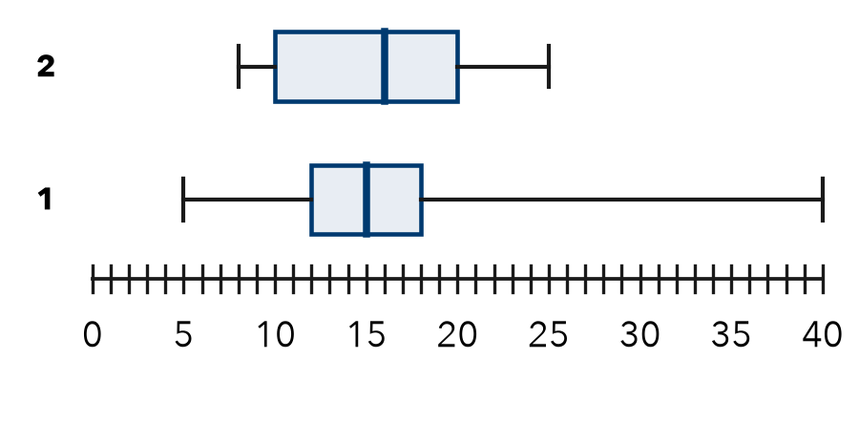

5. Jada says Route 2 is more consistent. Kwame says Route 1 is. Who is right? Why?
Frame is right because Route 1’s range is big only because , and its IQR is .

TEST PRACTICE choose the best answer

6. Class A’s scores have a range of 12. Class B’s have a range of 30. Whose scores vary less?
A Class A | B Class B | C Both the same | D Cannot tell

7. What is the IQR of 4, 6, 7, 9, 10, 12, 15?
A 6 | B 11 | C 4.5 | D 9

CHECK YOURSELF | □ I can do this on my own | □ I need a little help | □ I have a question about #

