Name Date Period
Lesson 2-5 · Session 1 · Prerequisite Practice B · Skill 1 of 2
Find Q1 and Q3
Builds on Lesson 2-4 Session 1 · 6.SP.B.4
TODAY’S LESSON | Camp hikes give seven distances. You need Q1 and Q3 before you find the IQR.
YOU NEED TO | Find the middle of the lower half and of the upper half. You will use it in Practice Form A, problems 1 and 3.
STEPS TO FOLLOW use these same steps on every problem
1 | Order the data and find the median.
2 | Split into a lower half and an upper half.
3 | Q1 = middle of the lower half. Q3 = middle of the upper.
WATCH ME the steps in action
Find Q1 and Q3 for 12, 5, 20, 9, 15, 25, 18.
Step 1 5, 9, 12, 15, 18, 20, 25. The median is 15.
Step 2 Lower half: 5, 9, 12. Upper half: 18, 20, 25.
Step 3 Q1 = 9. Q3 = 20.
Answer Q1 = 9, Q3 = 20
TRY IT WITH HELP fill in each step
1. Find Q1 and Q3 for 2, 4, 5, 8, 11, 13, 16.
Step 1 The median is .
Step 2 Lower half: .
Step 3 Q1 = . Q3 = .

2. Find Q1 and Q3 for 10, 15, 20, 25, 30, 35.
Step 1 The median is .
Step 2 Lower half: .
Step 3 Q1 = . Q3 = .

YOUR TURN use the steps on your own

3. Each list is in order. Write Q1 and Q3.
a. 3, 6, 9, 12, 15, 18, 21, 24 | b. 1, 1, 2, 4, 6, 7
c. 20, 24, 26, 31, 33 | d. 41, 44, 46, 50, 53, 57, 60, 62, 65

Lesson 2-5 · Session 1 · Prerequisite Practice B · Skill 2 of 2
Read Box Plot Values
Builds on Lesson 2-4 Session 2 · 6.SP.B.4
TODAY’S LESSON | In problem 8 you read two box plots to find each snack bar’s range and IQR.
YOU NEED TO | Read min, Q1, Q3, and max from a box plot, then subtract. You will use it in Practice Form A, problems 7 and 8.
STEPS TO FOLLOW use these same steps on every problem
1 | Read the whisker ends: min and max.
2 | Read the box edges: Q1 and Q3.
3 | Subtract: range = max − min. IQR = Q3 − Q1.
WATCH ME the steps in action
Find the range and the IQR.  Step 1 Min 12, max 38.  Step 2 Q1 18, Q3 30.  Step 3 Range 38 − 12 = 26. IQR 30 − 18 = 12.  Answer range 26, IQR 12 | 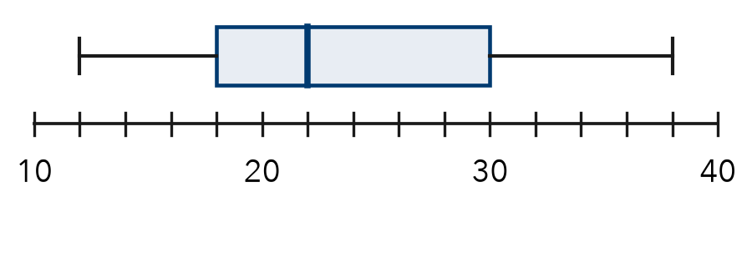

TRY IT WITH HELP fill in each step
4. Whiskers go from 10 to 45. The box goes from 20 to 35.
Step 1 Min = . Max = .
Step 2 Q1 = . Q3 = .
Step 3 Range = . IQR = .

5. Whiskers go from 104 to 140. The box goes from 116 to 132.
Step 1 Min = . Max = .
Step 2 Q1 = . Q3 = .
Step 3 Range = . IQR = .

YOUR TURN use the steps on your own

6. Find the range and the IQR.
a. Min 5, Q1 10, Q3 20, Max 30: | b. Min 12, Q1 20, Q3 26, Max 41:
c. Min 0, Q1 15, Q3 40, Max 60: | d. Min 50, Q1 58, Q3 71, Max 90:

READY CHECK a problem like the one in today’s lesson

7. A box plot shows 11, 14, 16, 19, 62. What is the IQR?
A 51 | B 5 | C 3 | D 16

CHECK YOURSELF | □ I can do this on my own | □ I need a little help | □ I have a question about #

