Name Date Period
Lesson 2-9 · Session 1 · Practice · Form A
Finding Mean Absolute Deviation (MAD)
Learning target — I can find the mean absolute deviation of a data set and explain what it measures. · 6.SP.B.5c

REMEMBER  • MAD (mean absolute deviation) = the mean of the distances from the mean.  • Steps: find the mean, find each value’s distance from it (never negative), then average the distances.  • If all values match, the MAD is 0. A small MAD means values sit close to the mean. | WORKED EXAMPLE  Four plants grew 3, 7, 8 and 10 cm. Find the MAD.  Step 1 Mean: 28 ÷ 4 = 7.  Step 2 Distances from 7: 4, 0, 1, 3.  Step 3 Sum = 8, and 8 ÷ 4 = 2.  Answer MAD = 2 cm
WORDS mean absolute deviation (desviación media absoluta) · deviation (desviación) · absolute value (valor absoluto) · spread (dispersión)
PRACTICE show your work · label units

1. Science Quiz. The mean of 13, 15, 19, 23 and 25 is 19. Complete the table. Then find the MAD:
Value | 13 | 15 | 19 | 23 | 25
Distance from 19

2. Gym Visits. The dot plot shows the visitors to a gym on four evenings.
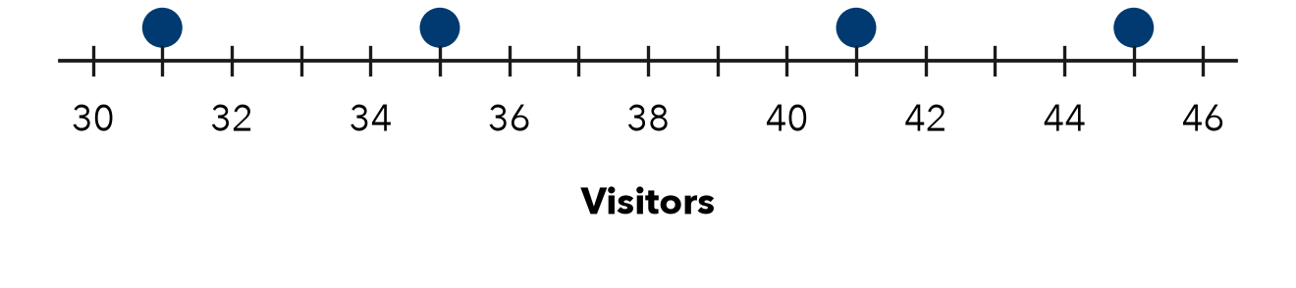
a. Mean: visitors
b. MAD: visitors

3. Afternoon Temps. Four afternoon temperatures were 53, 57, 59 and 63°F. Find the MAD.
Hint Find the mean first. Measure each distance from it.

Show your work.
Answer °F

4. All the Same. Four values are 25, 25, 25, 25. Elise says the MAD cannot be found. Is she right?  Hint Find each value’s distance from the mean.  MAD | 5. Reading a MAD. Six delivery times have a mean of 45 minutes and a MAD of 3 minutes. What does the MAD tell a customer?  Meaning
  Show your work.
  Show your work.

6. Homework Pages. Five students turned in 12, 18, 20, 22 and 28 pages. Find the mean and the MAD.  Hint Measure distances from the mean, not from 0.  Mean, MAD | 7. Missing Distance. Four values have mean 50 and MAD 5. Three distances from the mean are 6, 2 and 4. Find the fourth distance.  Hint MAD × 4 gives the total of the distances.  Distance
  Show your work.
  Show your work.

8. Two Groups. Free throws made — Group 1: 6, 8, 10, 12. Group 2: 4, 9, 10, 13. Both means are 9.
a. MAD of Group 1:
b. MAD of Group 2:
c. What does the MAD tell you that the mean does not?

Show your work.

FIND THE ERROR explain the mistake, then fix it

9. Damaris’s Work. For 17, 19, 25, 27 (mean 22), Damaris added −5, −3, +3, +5 and reported a MAD of 0. Explain her mistake and find the MAD.

TEST PRACTICE choose the best answer

10. MAD stands for —
A middle and difference | B mean added data
C median absolute distance | D mean absolute deviation

11. Distances from the mean are never —
A zero | B negative | C whole numbers | D decimals

SELF-CHECK CODE find your answer · copy its letter into that problem’s box · spell a math word
0  I | 2.5  E | 12  Q | 8  T | 4  D | 25  Z | 20  A | 5  E | 3  V | 10  X

#1 | #2b | #3 | #4 | #6 | #7 | #8b

CHECK YOURSELF | □ I can do this on my own | □ I need a little help | □ I have a question about #

