Name Date Period
Lesson 2-9 · Session 1 · Practice · Form B
Finding Mean Absolute Deviation (MAD)
Learning target — I can find the mean absolute deviation of a data set and explain what it measures. · 6.SP.B.5c

REMEMBER  • MAD (mean absolute deviation) = the mean of the distances from the mean.  • Steps: find the mean, find each value’s distance from it (never negative), then average the distances.  • If all values match, the MAD is 0. A small MAD means values sit close to the mean. | WORKED EXAMPLE  Four plants grew 3, 7, 8 and 10 cm. Find the MAD.  Step 1 Mean: 28 ÷ 4 = 7.  Step 2 Distances from 7: 4, 0, 1, 3.  Step 3 Sum = 8, and 8 ÷ 4 = 2.  Answer MAD = 2 cm
WORDS mean absolute deviation (desviación media absoluta) · deviation (desviación) · absolute value (valor absoluto) · spread (dispersión)
PRACTICE show your work · label units

1. Spelling Quiz. The mean of 11, 14, 18, 22 and 25 is 18. Complete the table. Then find the MAD:
Value | 11 | 14 | 18 | 22 | 25
Distance from 18

2. Gym Visits. The dot plot shows the visitors to a gym on four evenings.
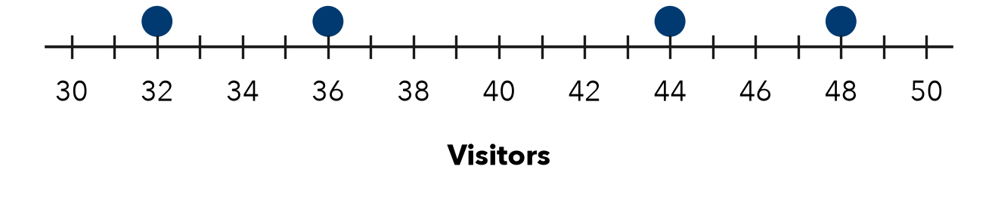
a. Mean: visitors
b. MAD: visitors

3. Afternoon Temps. Four afternoon temperatures were 61, 64, 68 and 71°F. Find the MAD.
Hint Find the mean first. Measure each distance from it.

Show your work.
Answer °F

4. All the Same. Four values are 40, 40, 40, 40. Kenji says the MAD cannot be found. Is he right?  Hint Find each value’s distance from the mean.  MAD | 5. Reading a MAD. Six bus rides have a mean of 30 minutes and a MAD of 2 minutes. What does the MAD tell a rider?  Meaning
  Show your work.
  Show your work.

6. Homework Pages. Five students turned in 10, 16, 22, 24 and 28 pages. Find the mean and the MAD.  Hint Measure distances from the mean, not from 0.  Mean, MAD | 7. Missing Distance. Four values have mean 60 and MAD 6. Three distances from the mean are 3, 7 and 5. Find the fourth distance.  Hint MAD × 4 gives the total of the distances.  Distance
  Show your work.
  Show your work.

8. Two Groups. Free throws made — Group 1: 5, 7, 9, 11. Group 2: 2, 8, 9, 13. Both means are 8.
a. MAD of Group 1:
b. MAD of Group 2:
c. What does the MAD tell you that the mean does not?

Show your work.

FIND THE ERROR explain the mistake, then fix it

9. Tobias’s Work. For 26, 28, 34, 36 (mean 31), Tobias added −5, −3, +3, +5 and reported a MAD of 0. Explain his mistake and find the MAD.

TEST PRACTICE choose the best answer

10. A deviation is the distance between a value and the —
A mean | B median | C greatest value | D range

11. A smaller MAD means the data is —
A more spread out | B larger
C closer to the mean | D negative

SELF-CHECK CODE find your answer · copy its letter into that problem’s box · spell a math word
28  X | 0  R | 5.6  A | 3  E | 4.8  Z | 3.5  E | 4.4  A | 9  G | 6  V | 14  Q

#1 | #2b | #3 | #4 | #6 | #7 | #8b

CHECK YOURSELF | □ I can do this on my own | □ I need a little help | □ I have a question about #

