Name Date Period
Lesson 3-1 · Homework Packet · Level 1 · Sheet 1 of 2
Understanding Ratios
Maryland Standard 6.RP.A.1 · Learning target — I can describe a relationship between two quantities using ratio language.

REMEMBER  • A ratio compares two quantities: 3 to 5, 3 : 5, or 3/5. Order matters — follow the order of the words.  • Part-to-part compares two groups. Part-to-whole compares one group to the total.  • Simplest form: divide both terms by their GCF. | WORKED EXAMPLE  A shelf has 10 science books and 15 history books. Write the ratio of science books to all the books in simplest form.  Step 1 Total: 10 + 15 = 25 books  Step 2 Science first: 10 : 25  Step 3 Divide both terms by 5: 2 : 5  Answer 2 : 5 — for every 2 science books, there are 5 books in all

WORD BANK  ratio — compares two amounts  part-to-part — one group to another group | part-to-whole — one group to the total  simplest form — no number divides both terms
PRACTICE show your work · label units

1. A snack bag has 6 pretzels and 9 crackers. Write each ratio in simplest form.
Step 1 Say the first group, then the second.
Step 2 Divide both terms by the same number.
a. pretzels to crackers | b. crackers to pretzels
c. pretzels to all snacks | d. crackers to all snacks

2. Write each ratio in simplest form.
a. 12 : 18 = | b. 20 : 8 = | c. 15 : 35 =

3. A team has 8 girls and 7 boys. Jada writes 8 : 15. What does the 15 count?
Frame This ratio is part-to- because 15 counts .
□ Part-to-part | □ Part-to-whole
15 counts

4. Class Trip Vote. A class has 24 students. 14 vote for the museum. The rest vote for the aquarium.
Step 1 Find the aquarium votes: 24 − 14.
Step 2 Write museum : aquarium.
Step 3 Divide both terms by the same number.

Show your work.
Ratio

5. Find the Error. An animal shelter has 4 cats and 10 dogs. Marcus says the ratio of dogs to cats is 2 : 5. Explain his mistake and write the correct ratio.
Frame Marcus wrote the ratio in the wrong . Dogs to cats is : , or : in simplest form.

CHECK YOURSELF | □ I can do this on my own | □ I need a little help | □ I have a question about #
AT HOME Count two kinds of things at home, like forks and spoons. Say the ratio both ways.
Name Date Period
Lesson 3-1 · Homework Packet · Level 1 · Sheet 2 of 2
Ratios and Tape Diagrams
Maryland Standard 6.RP.A.1 · Learning target — I can use a tape diagram to share a total according to a given ratio.

REMEMBER  • A tape diagram uses equal boxes; the boxes match the ratio.  • One box = total ÷ total parts. Multiply one box by each term. Check that the amounts add to the total. | WORKED EXAMPLE  Leah and Omar share 35 stickers in the ratio 2 : 5. Find each share.  Step 1 Total parts: 2 + 5 = 7  Step 2 One box: 35 ÷ 7 = 5 stickers  Answer Leah: 2 × 5 = 10. Omar: 5 × 5 = 25.

WORD BANK  tape diagram — equal boxes for a ratio  one box — total ÷ total parts | total parts — add the ratio terms
PRACTICE show your work · label units

1. The tape diagram shows the ratio of red beads to blue beads on a bracelet. There are 48 beads in all.  Step 1 Add the boxes: 3 + 5.  Step 2 Divide 48 by the total boxes.  Step 3 Multiply one box by each term.  a. What is the value of one box? beads  b. Find the red beads and the blue beads. | 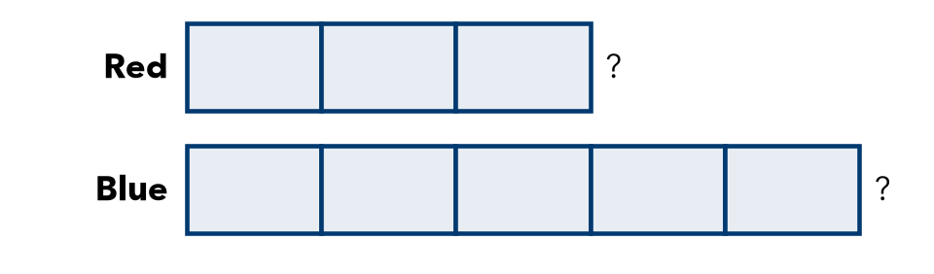

2. Find both amounts.
a. Share 42 in the ratio 3 : 4. | b. Share 66 in the ratio 2 : 9.

3. Work Backward. A fruit cup has grapes and melon pieces in the ratio 3 : 4. It has 12 grapes.
Step 1 12 grapes are 3 boxes. Find one box.
Step 2 Multiply one box by 4 for melon.
Step 3 Add grapes and melon.
a. What is the value of one box?
b. How many melon pieces?
c. How many pieces of fruit are in the cup in all?

4. Stretch. Maya and Theo share stickers in the ratio 2 : 7. Theo has 35 more stickers than Maya.
Step 1 Theo has 7 − 2 = 5 more boxes.
Step 2 5 boxes = 35. Find one box.
a. What is the value of one box? stickers
b. How many stickers do they have in all? stickers

5. Find the Error. Tyrell shared 45 marbles in the ratio 4 : 5 as 36 and 45. Explain his mistake. Find the correct shares.
Frame Tyrell divided by , but he should divide by the total parts, . Shares: and .

TEST PRACTICE choose the best answer

6. Jamal and Rosa share $40 in the ratio 3 : 5. How much money does Rosa get?
A $5 | B $15 | C $24 | D $25

7. A tape diagram shows a ratio of 4 : 3 with a total of 56. What is the value of one box?
A 7 | B 8 | C 14 | D 32

CHECK YOURSELF | □ I can do this on my own | □ I need a little help | □ I have a question about #
AT HOME Show someone at home how to split 30 snacks in the ratio 2 : 3.

