Name Date Period
Lesson 3-1 · Session 2 · Prerequisite Practice B · Skill 1 of 2
Use Tape Diagrams to Compare
Builds on Grade 4 · 4.OA.A.2
TODAY’S LESSON | 3 strawberries for every 2 bananas makes 5 boxes. With 20 fruits, each box is 4.
YOU NEED TO | Read a tape diagram: boxes × the value of one box. You will use it in Practice Form A, problems 2 and 4.
STEPS TO FOLLOW use these same steps on every problem
1 | Count the boxes in each row.
2 | Find the value of one box.
3 | Multiply boxes × value for each row.
WATCH ME the steps in action
Each box is 4 marbles. Find the red and the blue marbles.  Step 1 Red: 3 boxes. Blue: 2 boxes.  Step 2 One box is 4.  Step 3 3 × 4 = 12 and 2 × 4 = 8.  Answer 12 red and 8 blue | 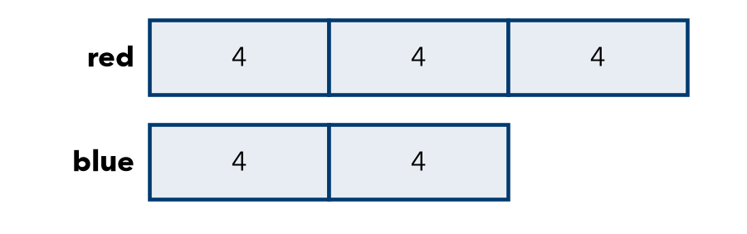

TRY IT WITH HELP fill in each step
1. Each box is 5 cups. Find the granola and the cranberries.
Step 1 Granola: boxes. Cranberries: boxes.
Step 2 One box is .
Step 3 2 × 5 = and 3 × 5 =

2. Cats have 1 box. Dogs have 3 boxes. Each box is 6. Find each.
Step 1 Cats: box. Dogs: boxes.
Step 2 One box is .
Step 3 1 × 6 = and 3 × 6 =

YOUR TURN use the steps on your own

3. Find both amounts.
a. A: 2 boxes, B: 5 boxes, 1 box = 3 | b. A: 4 boxes, B: 1 box, 1 box = 7
c. A: 5 boxes, B: 3 boxes, 1 box = 4 | d. A: 2 boxes, B: 3 boxes, 1 box = 9

Lesson 3-1 · Session 2 · Prerequisite Practice B · Skill 2 of 2
Write and Read Ratios
Builds on Lesson 3-1 Session 1 · 6.RP.A.1
TODAY’S LESSON | Goldfish to guppies is 5 to 3, so goldfish get 5 boxes and guppies get 3.
YOU NEED TO | Write a ratio three ways and draw one box for each part, like 5 to 3. You will use it in Practice Form A, problems 4 and 8.
STEPS TO FOLLOW use these same steps on every problem
1 | Name the first quantity. Its number goes first.
2 | Write the ratio: a to b, a : b, a/b.
3 | Draw one box for each part.
WATCH ME the steps in action
A paint mix uses 4 cups blue for every 1 cup white. Write blue to white.
Step 1 Blue is first: 4.
Step 2 4 to 1, 4 : 1, 4/1.
Step 3 Blue gets 4 boxes. White gets 1 box.
Answer 4 : 1
TRY IT WITH HELP fill in each step
4. A trail mix uses 2 parts raisins for every 5 parts nuts. Write raisins to nuts.
Step 1 Raisins are first:
Step 2 Three ways:
Step 3 Raisins get boxes. Nuts get .

5. A garden has 5 beans for every 3 corn. Write corn to beans.
Step 1 Corn is first:
Step 2 Three ways:
Step 3 Corn gets boxes. Beans get .

YOUR TURN use the steps on your own

6. Write each ratio with a colon.
a. 3 cats, 7 dogs: dogs to cats | b. 2 red, 9 blue: red to blue
c. 5 boys, 4 girls: girls to boys | d. 1 adult, 8 kids: kids to adults

READY CHECK a problem like the one in today’s lesson

7. Goldfish and guppies are in the ratio 5 to 3. How many boxes does the tape diagram have in all?
A 5 | B 3 | C 8 | D 15

CHECK YOURSELF | □ I can do this on my own | □ I need a little help | □ I have a question about #

