Name Date Period
Lesson 3-2 · Session 1 · Practice · Form A
Understanding Unit Rates
Learning target — I can find a unit rate and use rate language such as “per hour” or “each.” · 6.RP.A.2

REMEMBER  • Per means “for each.” A unit rate is the amount for 1 unit.  • Divide the first amount by the second: 90 pages ÷ 6 minutes = 15 pages per minute.  • To predict, multiply the unit rate. To find a time or amount of units, divide. | WORKED EXAMPLE  A printer prints 90 pages in 6 minutes at a steady rate. How many pages in 7 minutes? How long for 45 pages?  Step 1 Divide: 90 ÷ 6 = 15 pages per minute.  Step 2 7 minutes: 15 × 7 = 105 pages.  Step 3 45 pages: 45 ÷ 15 = 3 minutes.  Answer 105 pages; 3 minutes
WORDS rate (tasa) · unit rate (tasa unitaria) · per (por) · constant (constante)
PRACTICE show your work · label units

1. Find each unit rate.
a. 84 words in 7 min = per min | b. $56 for 8 hours = per hour
c. 108 miles on 4 gal = per gal | d. 132 steps in 12 s = per s
e. 96 beads on 6 bracelets = each | f. 138 lb of soil in 6 beds = per bed

2. City Train. A commuter train travels 150 miles in 2 hours at a steady speed. Complete the double number line.
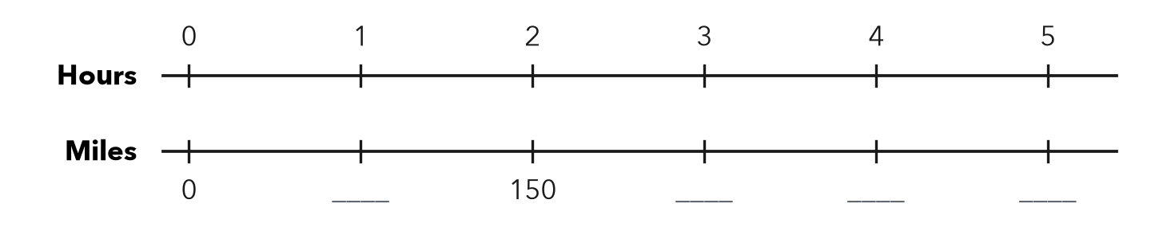
a. Unit rate: mph
b. Miles in 5 hours: miles

3. Lawn Mowing. David earns $45 for mowing 3 lawns. What is his rate per lawn?  Hint Divide dollars by lawns.  Answer per lawn | 4. Juice Cost. A 6-pack of juice costs $7.50. Find the cost per bottle.  Answer per bottle
  Show your work.
  Show your work.

5. Gas Mileage. A car travels 240 miles on 8 gallons of gas.  Hint For part b, divide the miles by the miles per gallon.  a. Miles per gallon: mpg  b. Gallons needed for 360 miles: gal | 6. Running Practice. Carlos runs 12 miles in 2 hours.  Hint Time = distance ÷ speed.  a. Speed: mph  b. Time to run 18 miles at this pace: hours
  Show your work.
  Show your work.

7. Two Jobs. Job A pays $54 for 6 hours. Job B pays $85 for 10 hours.
a. Hourly rate: Job A Job B
b. Which pays more per hour, and by how much?
c. Total pay for 14 hours of Job B: dollars

8. Printer Rate. A printer prints 288 pages in 8 minutes at a steady rate.
Hint Find pages for 1 minute, then multiply by 15.
a. Pages per minute:
b. Pages in 15 minutes:

FIND THE ERROR explain the mistake, then fix it

9. Liam’s Work. A bike goes 45 miles in 3 hours. Liam calculated 45 × 3 = 135 miles per hour. Explain his mistake and find the correct rate.

TEST PRACTICE choose the best answer

10. A car travels 180 miles in 3 hours. The unit rate is —
A 540 miles per hour | B 60 miles per hour
C 183 miles per hour | D 1/60 mile per hour

11. 8 apples cost $4.00. The unit price is —
A $0.50 per apple | B $2.00 per apple | C $32 per apple | D $4.00 per apple

SELF-CHECK CODE find your answer · copy its letter into that problem’s box · spell a math word
27  D | $1.25  I | $15  V | 24  X | 6  E | 75  I | 30  D | 300  Q | 36  S | 135  Z

#1c | #2a | #3 | #4 | #5a | #6a | #8a

CHECK YOURSELF | □ I can do this on my own | □ I need a little help | □ I have a question about #

