Name Date Period
Lesson 3-2 · Session 1 · Practice · Form B
Understanding Unit Rates
Learning target — I can find a unit rate and use rate language such as “per hour” or “each.” · 6.RP.A.2

REMEMBER  • Per means “for each.” A unit rate is the amount for 1 unit.  • Divide the first amount by the second: 90 pages ÷ 6 minutes = 15 pages per minute.  • To predict, multiply the unit rate. To find a time or amount of units, divide. | WORKED EXAMPLE  A printer prints 90 pages in 6 minutes at a steady rate. How many pages in 7 minutes? How long for 45 pages?  Step 1 Divide: 90 ÷ 6 = 15 pages per minute.  Step 2 7 minutes: 15 × 7 = 105 pages.  Step 3 45 pages: 45 ÷ 15 = 3 minutes.  Answer 105 pages; 3 minutes
WORDS rate (tasa) · unit rate (tasa unitaria) · per (por) · constant (constante)
PRACTICE show your work · label units

1. Find each unit rate.
a. 91 words in 7 min = per min | b. $72 for 8 hours = per hour
c. 112 miles on 4 gal = per gal | d. 144 steps in 12 s = per s
e. 84 beads on 6 bracelets = each | f. 156 lb of soil in 6 beds = per bed

2. Charter Bus. A charter bus travels 195 miles in 3 hours at a steady speed. Complete the double number line.
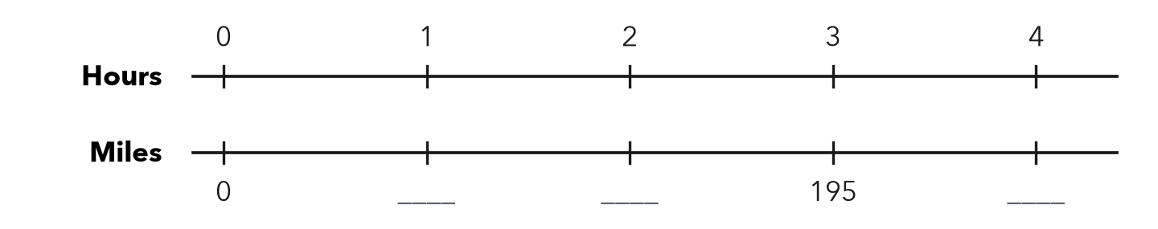
a. Unit rate: mph
b. Miles in 4 hours: miles

3. Lawn Mowing. Dylan earns $52 for mowing 4 lawns. What is his rate per lawn?  Hint Divide dollars by lawns.  Answer per lawn | 4. Juice Cost. A 12-pack of juice costs $9.00. Find the cost per bottle.  Answer per bottle
  Show your work.
  Show your work.

5. Gas Mileage. A car travels 288 miles on 9 gallons of gas.  Hint For part b, divide the miles by the miles per gallon.  a. Miles per gallon: mpg  b. Gallons needed for 352 miles: gal | 6. Running Practice. Mia runs 15 miles in 3 hours.  Hint Time = distance ÷ speed.  a. Speed: mph  b. Time to run 20 miles at this pace: hours
  Show your work.
  Show your work.

7. Two Jobs. Job A pays $60 for 8 hours. Job B pays $72 for 9 hours.
a. Hourly rate: Job A Job B
b. Which pays more per hour, and by how much?
c. Total pay for 12 hours of Job B: dollars

8. Printer Rate. A printer prints 312 pages in 8 minutes at a steady rate.
Hint Find pages for 1 minute, then multiply by 12.
a. Pages per minute:
b. Pages in 12 minutes:

FIND THE ERROR explain the mistake, then fix it

9. Sofia’s Work. A runner goes 24 miles in 4 hours. Sofia calculated 24 × 4 = 96 miles per hour. Explain her mistake and find the correct rate.

TEST PRACTICE choose the best answer

10. A car travels 210 miles in 3 hours. The unit rate is —
A 630 miles per hour | B 70 miles per hour
C 213 miles per hour | D 1/70 mile per hour

11. 5 pens cost $2.00. The unit price is —
A $2.50 per pen | B $10 per pen | C $0.40 per pen | D $2.00 per pen

SELF-CHECK CODE find your answer · copy its letter into that problem’s box · spell a math word
28  C | 5  R | $0.75  P | 585  Z | 32  A | 39  E | 45  Q | $13  M | 65  O | $52  X

#1c | #2a | #3 | #4 | #5a | #6a | #8a

CHECK YOURSELF | □ I can do this on my own | □ I need a little help | □ I have a question about #

