Name Date Period
Lesson 3-4 · Session 1 · Prerequisite Practice A · Skill 1 of 2
Plot Points in Quadrant I
Builds on Grade 5 · 5.G.A.1
TODAY’S LESSON | You will plot points like (2, 6) for 2 hours and 6 miles.
YOU NEED TO | Plot a point like (3, 4): go right 3, then up 4. You will use it in Practice Form A, problems 2 and 5.
STEPS TO FOLLOW use these same steps on every problem
1 | Start at (0, 0).
2 | Move right the first number (x).
3 | Move up the second number (y). Draw a dot.
WATCH ME the steps in action
Plot point A at (4, 3).  Step 1 Start at (0, 0).  Step 2 Move right 4.  Step 3 Move up 3. Draw a dot. Label it A.  Answer A is 4 right and 3 up. | 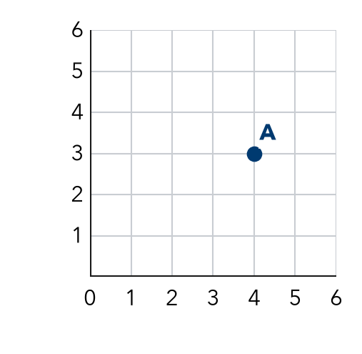

TRY IT WITH HELP fill in each step
1. Plot point B at (2, 5) on the Watch Me grid.
Step 1 Start at .
Step 2 Move right .
Step 3 Move up . Draw a dot.

2. Plot point C at (5, 1) on the same grid.
Step 1 Start at .
Step 2 Move right .
Step 3 Move up . Draw a dot.

YOUR TURN use the steps on your own

3. Write how far right and how far up you move for each point.
a. (3, 7): | b. (6, 2): | c. (0, 4):
d. (5, 0): | e. (1, 6): | f. (4, 4):

Lesson 3-4 · Session 1 · Prerequisite Practice A · Skill 2 of 2
Read Axis Scales
Builds on Grade 5 · 5.G.A.2
TODAY’S LESSON | You will plot Maya’s savings on a graph whose y-axis counts by 4.
YOU NEED TO | Read a skip-count axis, like 7 lines up by 5s is 35. You will use it in Practice Form A, problem 5.
STEPS TO FOLLOW use these same steps on every problem
1 | Find the scale: how much each gridline counts.
2 | Count the gridlines from 0.
3 | Multiply: gridlines × scale = the value.
WATCH ME the steps in action
The y-axis counts by 5. Point P is 7 gridlines up. What is its y-value?  Step 1 The scale is 5.  Step 2 P is 7 gridlines up.  Step 3 7 × 5 = 35.  Answer 35 | 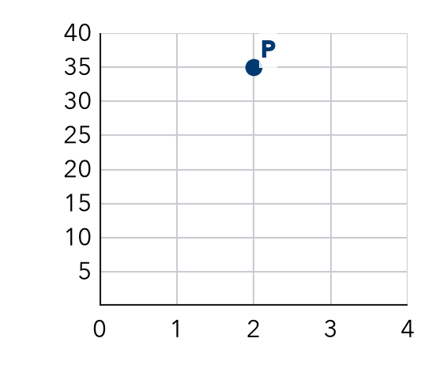

TRY IT WITH HELP fill in each step
4. The y-axis counts by 10. A point is 6 gridlines up. What is its y-value?
Step 1 The scale is .
Step 2 The point is gridlines up.
Step 3 6 × 10 = .

5. The x-axis counts by 2. A point is 4 gridlines right. What is its x-value?
Step 1 The scale is .
Step 2 The point is gridlines right.
Step 3 4 × 2 = .

YOUR TURN use the steps on your own

6. Find each value.
a. by 5s, 4 lines: | b. by 10s, 3 lines: | c. by 25s, 3 lines: | d. by 4s, 9 lines:

READY CHECK a problem like the one in today’s lesson

7. The y-axis counts by 5. A point is 9 gridlines up. What is its y-value?
A 14 | B 45 | C 9 | D 40

CHECK YOURSELF | □ I can do this on my own | □ I need a little help | □ I have a question about #

