Name Date Period
Lesson 3-4 · Session 2 · Prerequisite Practice A · Skill 1 of 2
Name Coordinates of Points
Builds on Grade 5 · 5.G.A.1
TODAY’S LESSON | You will read points like (1, 5) on a graph of bracelets and charms.
YOU NEED TO | Name a point, like 2 right and 10 up is (2, 10). You will use it in Practice Form A, problem 2.
STEPS TO FOLLOW use these same steps on every problem
1 | Count how far right from 0. That is x.
2 | Count how far up from 0. That is y.
3 | Write (x, y). The right number goes first.
WATCH ME the steps in action
Name point P.  Step 1 P is 5 right. x = 5.  Step 2 P is 2 up. y = 2.  Step 3 Write (5, 2).  Answer (5, 2) | 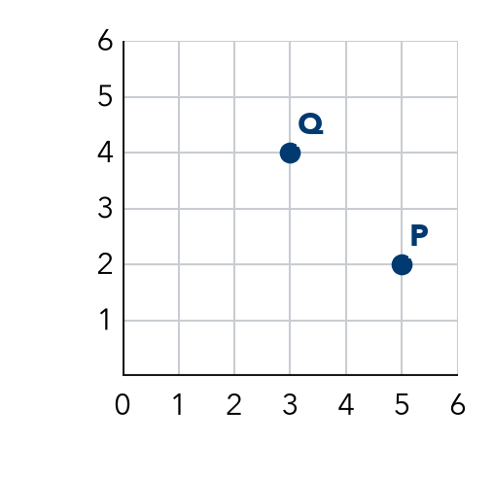

TRY IT WITH HELP fill in each step
1. Name point Q on the Watch Me grid.
Step 1 Q is right.
Step 2 Q is up.
Step 3 Q is at ( , ).

2. A point is 1 right and 5 up. Name it.
Step 1 It is right.
Step 2 It is up.
Step 3 It is at ( , ).

YOUR TURN use the steps on your own

3. Write each point as (x, y).
a. 4 right, 1 up: | b. 0 right, 3 up: | c. 6 right, 6 up:
d. 2 right, 0 up: | e. 1 right, 8 up: | f. 5 right, 7 up:

Lesson 3-4 · Session 2 · Prerequisite Practice A · Skill 2 of 2
Divide Multi-Digit Numbers
Builds on Grade 5 · 5.NBT.B.6
TODAY’S LESSON | You will find a rider’s unit rate, like 36 km in 3 hours is 36 ÷ 3.
YOU NEED TO | Divide a bigger number, like 96 ÷ 8 = 12. You will use it in Practice Form A, problems 1 and 8.
STEPS TO FOLLOW use these same steps on every problem
1 | Break the number into easy parts you can divide.
2 | Divide each part.
3 | Add the answers.
WATCH ME the steps in action
Find 96 ÷ 8.
Step 1 96 = 80 + 16.
Step 2 80 ÷ 8 = 10 and 16 ÷ 8 = 2.
Step 3 10 + 2 = 12.
Answer 12
TRY IT WITH HELP fill in each step
4. Find 72 ÷ 6.
Step 1 72 = 60 + .
Step 2 60 ÷ 6 = and 12 ÷ 6 = .
Step 3 10 + 2 = .

5. Find 135 ÷ 3.
Step 1 135 = 120 + .
Step 2 120 ÷ 3 = and 15 ÷ 3 = .
Step 3 40 + 5 = .

YOUR TURN use the steps on your own

6. Divide.
a. 84 ÷ 7 = | b. 52 ÷ 4 = | c. 78 ÷ 6 =
d. 95 ÷ 5 = | e. 168 ÷ 4 = | f. 250 ÷ 5 =

READY CHECK a problem like the one in today’s lesson

7. A line passes through (5, 75). What is the unit rate?
A 15 | B 70 | C 80 | D 375

CHECK YOURSELF | □ I can do this on my own | □ I need a little help | □ I have a question about #

