Name Date Period
Lesson 4-1 · Session 2 · Practice · Form B
Percents Greater Than 100%
Learning target — I can use percents greater than 100% to describe an amount larger than the whole. · 6.RP.A.3c

REMEMBER  • 100% is one whole. More than 100% means more than one whole. Always name the whole.  • Find 10% of the whole, then count tens: if the whole is 20, 10% is 2, so 30 is 15 tens = 150%.  • “3 times as much” is 300%. 130% means 1.3 times as much. | WORKED EXAMPLE  A puppy weighed 5 lb last month. Now it weighs 8 lb. Last month is the whole.  Step 1 Whole: 5 lb = 100%.  Step 2 1 lb = 100% ÷ 5 = 20%.  Step 3 8 lb = 8 × 20% = 160%.  Answer 8 lb is 160% of last month’s weight
WORDS the whole (el todo) · times as much (veces más) · greater than 100% (mayor que 100%)
PRACTICE show your work · label units

1. Write each amount as a percent of the whole.
a. 5 times as much = % | b. 1.4 times as much = %
c. 3.5 times as much = % | d. 1.1 times as much = %

2. Garden Group. A garden group had 30 members last year (the whole). This year it has 54 members. Fill in the double number line. Write this year as a percent of last year.
Hint 6 members is 20% of 30.
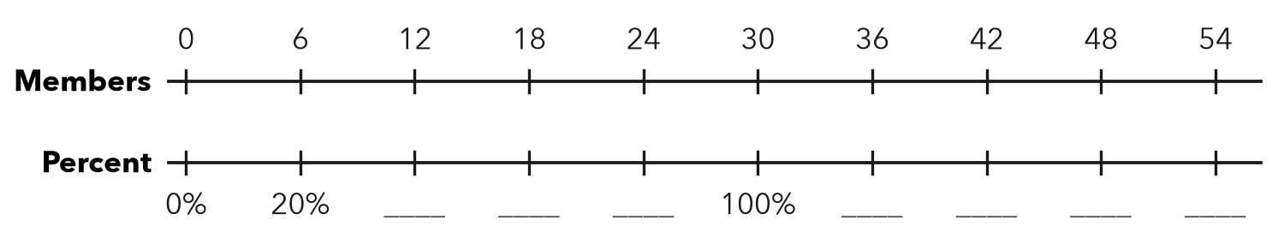
This year %

3. Practice Minutes. Cole practiced piano 25 minutes on Monday and 40 minutes on Tuesday.  a. Tuesday as a % of Monday: %  b. Monday as a % of Tuesday: % | 4. Jump Rope. Deshawn jumped 50 times on Monday (the whole) and 85 times on Friday. Friday is what percent of Monday?  Hint 10% of 50 is 5. Count the 5s up to 85.  Answer %
  Show your work.

5. Video Views. A first video got 400 views. A second video got 1,000 views. The second is what percent of the first?  Answer % | 6. Recipe Tripling. Rosa triples a muffin recipe. She says the new batch is 3% of the first batch. Correct her claim.  Answer %
  Show your work.
  Show your work.

7. Bean Plant. A bean plant grew from 16 cm (the whole) to 20 cm in one week. The new height is what percent of 16 cm?
Hint 20 ÷ 16 tells how many times as tall.

Show your work.
Answer %

8. Plant Growth. A seedling was 10 cm tall in May and 32 cm tall in July. May is the whole.
a. July height as a percent of May height: %
b. By what percent did the height increase? %
c. How are your two answers different?

Show your work.

FIND THE ERROR explain the mistake, then fix it

9. Theo’s Work. A large pumpkin weighs 18 kg; a small one weighs 12 kg. Theo wrote, “The large pumpkin is 18% of the small one.” Explain his mistake and fix it.

TEST PRACTICE choose the best answer

10. A percent greater than 100% means the amount is —
A less than the whole | B equal to the whole
C more than the whole | D zero

11. 150% of a number is the same as —
A 1.5 times it | B 15 times it | C 150 times it | D 0.15 times it

SELF-CHECK CODE find your answer · copy its letter into that problem’s box · spell a math word
220%  S | 180%  A | 170%  U | 25%  X | 250%  N | 320%  T | 18%  Q | 85%  Z | 160%  M | 62.5%  O

#2 | #3a | #3b | #4 | #5 | #8a | #8b

CHECK YOURSELF | □ I can do this on my own | □ I need a little help | □ I have a question about #

