Name Date Period
Lesson 4-2 · Session 1 · Prerequisite Practice A · Skill 1 of 2
Read Tenths and Hundredths
Builds on Grade 4 · 4.NF.C.6
TODAY’S LESSON | You will write decimals like 0.6 and 0.08 as percents.
YOU NEED TO | Read a decimal as hundredths, like 0.08 = 8 hundredths. You will use it in Practice Form A, problems 1 and 4.
STEPS TO FOLLOW use these same steps on every problem
1 | Look at the digits after the decimal point.
2 | If there is only one digit, add a zero to make two.
3 | Read the two digits as hundredths.
WATCH ME the steps in action
Read 0.7 as hundredths.  Step 1 After the point there is one digit: 7.  Step 2 Add a zero: 0.70.  Step 3 0.70 is 70 hundredths.  Answer 0.7 = 70 hundredths | 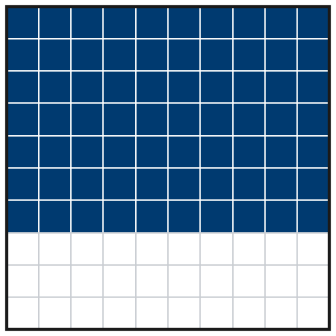

TRY IT WITH HELP fill in each step
1. Read 0.08 as hundredths.
Step 1 Digits after the point: .
Step 2 Do you need a zero?
Step 3 0.08 is hundredths.

2. Read 0.4 as hundredths.
Step 1 Digits after the point: .
Step 2 Add a zero: 0.
Step 3 0.4 is hundredths.

YOUR TURN use the steps on your own

3. Write each decimal as hundredths.
a. 0.3 = hundredths | b. 0.05 = hundredths | c. 0.25 = hundredths
d. 0.9 = hundredths | e. 0.72 = hundredths | f. 0.01 = hundredths

Lesson 4-2 · Session 1 · Prerequisite Practice A · Skill 2 of 2
Simplify Fractions
Builds on Grade 4 · 4.NF.A.1
TODAY’S LESSON | You will write 12 of 16 free throws as a fraction in simplest form.
YOU NEED TO | Simplify a fraction like 45/100 to 9/20. You will use it in Practice Form A, problems 3 and 7.
STEPS TO FOLLOW use these same steps on every problem
1 | Find a number that divides both the top and the bottom.
2 | Divide the top and the bottom by that number.
3 | Repeat until only 1 divides both.
WATCH ME the steps in action
Simplify 18/24.
Step 1 6 divides 18 and 24.
Step 2 18 ÷ 6 = 3 and 24 ÷ 6 = 4.
Step 3 Only 1 divides 3 and 4. Stop.
Answer 18/24 = 3/4
TRY IT WITH HELP fill in each step
4. Simplify 45/100.
Step 1 divides 45 and 100.
Step 2 45 ÷ 5 = and 100 ÷ 5 = .
Step 3 Only 1 divides 9 and 20. Simplest form: .

5. Simplify 8/12.
Step 1 divides 8 and 12.
Step 2 8 ÷ 4 = and 12 ÷ 4 = .
Step 3 Only 1 divides 2 and 3. Simplest form: .

YOUR TURN use the steps on your own

6. Write each fraction in simplest form.
a. 6/8 = | b. 10/15 = | c. 20/100 =
d. 14/21 = | e. 36/48 = | f. 25/40 =

READY CHECK a problem like the one in today’s lesson

7. Ava made 15 of her 20 shots. Which fraction in simplest form shows the shots she made?
A 3/4 | B 15/20 | C 4/3 | D 3/5

CHECK YOURSELF | □ I can do this on my own | □ I need a little help | □ I have a question about #

