Name Date Period
Lesson 4-3 · Session 1 · Practice · Form B
Estimate with Benchmarks
Learning target — I can estimate a percent by comparing an amount to benchmark percents. · 6.RP.A.3c

REMEMBER  • A benchmark is an easy percent: 10%, 25%, 50%, 75%, 100%.  • First name the whole (100%). Then find benchmark amounts: half for 50%, ÷ 4 for 25%, ÷ 10 for 10%.  • Choose the benchmark amount closest to the part. For the percent left, subtract from 100%. | WORKED EXAMPLE  A game download is 80 MB. 41 MB are done. About what percent is done?  Step 1 Whole: 80 MB is 100%.  Step 2 50% of 80 is 40 MB.  Step 3 41 MB is just over 40 MB.  Answer about 50%
WORDS estimate (estimar) · benchmark percent (porcentaje de referencia) · the whole (el todo)
PRACTICE show your work · label units

1. About what percent? Name the closest benchmark: 10%, 25%, 50%, 75%, or 100%.
a. 29 out of 60 ≈ % | b. 21 out of 80 ≈ % | c. 46 out of 60 ≈ %
d. 11 out of 100 ≈ % | e. 39 out of 40 ≈ % | f. 59 out of 120 ≈ %

2. Reading Goal. Malik’s goal is 320 pages this month. He has read 162 pages. Fill in the double number line.
Hint Each jump on the top line is 320 ÷ 4 pages.
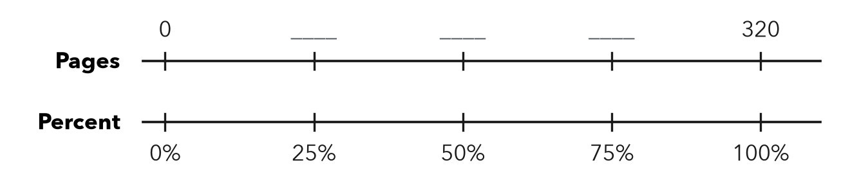
a. Fill in the missing page numbers.
b. About what percent of his goal has he read? %

3. Class Fundraiser. A class wants to raise $600. So far it has raised $452.  Hint Find 75% of $600 and compare.  a. 10% of the goal  b. About what percent? % | 4. Gym Water Jug. A water jug holds 48 cups. It has 23 cups left.  a. Half of the jug, in cups  b. About what percent is left? %

5. Trail Progress. A bike trail is 40 km long. A rider has gone 30 km.
Hint Find one fourth of 40 km first.
a. About what percent is done? %
b. What percent is left? %

Show your work.

6. Estimate Check. Nia says 11 out of 40 is about 50%. Is she right? Use 25% of 40 to find a better estimate.
Hint Find 50% of 40 and 25% of 40.

Show your work.
Better estimate

7. Parking Lot. A parking garage has 120 spaces. 89 are taken. Estimate the percent taken and name the benchmark amount you used.

Show your work.
About

8. Band Tickets. A band printed 360 tickets for its show. It has sold 37 of them.
Hint Divide 360 by 10 to find 10%.
a. About what percent are sold? %
b. About what percent are not sold? %

Show your work.

FIND THE ERROR explain the mistake, then fix it

9. Marcus’s Work. A drive holds 400 GB. Marcus has used 300 GB, and 40 GB of that is photos. He says photos are about 75% of the drive. Explain his mistake. Then estimate the percent of the drive that is photos.

TEST PRACTICE choose the best answer

10. 50% of an amount is the same as —
A one tenth | B one half | C one fourth | D twice it

11. 9 out of 40 is about —
A 10% | B 25% | C 50% | D 75%

SELF-CHECK CODE find your answer · copy its letter into that problem’s box · spell a math word
24  C | 25%  E | $60  E | 37%  Q | 75%  R | 10%  N | 90%  T | $6  Z | 50%  P | 70%  X

#2b | #3a | #3b | #4a | #5b | #8a | #8b

CHECK YOURSELF | □ I can do this on my own | □ I need a little help | □ I have a question about #

